Unseen Poetry Revision:

Revision Resources:
- Copy and paste the link below into your web browser. Make notes as you read through.
https://www.bbc.co.uk/bitesize/guides/z3gfg82/revision/1
- Type ‘Mr Bruff Unseen Poetry’ into YouTube and watch his videos
- Go to the ‘Unseen Poetry’ section on GCSE Pod and watch those videos

Terminology to Learn:

- Alliteration: words that begin with the same letter sound, e.g. ‘flowing flakes that flock’
- Allusion: reference to another text or idea, e.g. ‘the valley of Death’
- Ambiguous: when something is left deliberately unclear, e.g. the final lines of Bayonet Charge.
- Anaphora: repetition of a phrase at the start of a line or sentence, e.g. “Cannon to”, “Dem tell me”
- Assonance: words that share the same vowel sound, e.g. ‘wearied we keep awake because’
- Caesura: a pause in a line of poetry, e.g. ‘Nothing beside remains. Round the decay’
- Connotations: what a word or phrase suggests, e.g. ‘black’ usually connotes darkness, evil or death.
- End stopped line: opposite of enjambment, where a line stops, e.g. ‘We are bombarded by the empty air.’
- Enjambment: where a line has no punctuation at the end and breaks onto a new line, but carries on an idea, e.g. ‘One of my mates goes by / and tosses his guts back into his body.’
- Hyperbole: deliberate exaggeration, used to emphasise a point.
- Iambic pentameter: a line of poetry with 10 syllables, e.g. ‘The lone and level sands stretch far away.’
- Metaphor: describing something by saying it is something else, e.g. ‘mind-forged manacles’, ‘an ornamental stitch’, ‘the gelled / blackthorns of your hair.’
- Monologue: one person speaking (dramatic monologue), e.g. My Last Duchess.
- Motif: a repeated idea or theme.
- Narrative: writing that tells a story.
- Onomatopoeia: use of words which echo their meaning in sound, e.g. ‘thunder’d’
- Oxymoron: two words that seem to contradict each other, e.g. ‘exploding comfortably’
- Personification: giving an object or animal human characteristics, e.g. ‘the wind’s nonchalance’
- Poetic Persona: when the poet takes on a voice in the poem.
- Refrain: repeating of a single line in a poem, e.g. ‘Rode the six hundred.’ ‘But nothing happens.’
- Repetition: repeating the same word or phrase, e.g. ‘a huge peak, black and huge’, ‘I struck and struck again’, ‘Half a league, half a league / Half a league’, ‘his bloody life in my bloody hands’
- Rhyme Scheme: abbcca etc
- Rhyming couplets: Two lines that rhyme next to each other, e.g. ‘Plunged in the battery-smoke / Right thro’ the line they broke’
- Rhythm: is the beat or pace of the words. It can be regular or irregular, slow or fast, depending on the effect the poet wants to create.
- Sibilance- repetition of ‘s’ or ‘sh’ sounds, e.g. ‘Storm’d at with shot and shell’
- Simile – imagery comparison using as or like, e.g. ‘little fishing boats / strung out like bunting’, ‘spits like a tame cat’, ‘He lugged a rifle numb as a smashed arm’, ‘his foot hung like / Statuary in mid-stride’
- Stanza: is a section of a poem sometimes referred to as a verse.
- Symbolism: when object stands for something else, e.g. ‘ dove’ = peace and hope.
- Tone: mood or feelings suggested by the poem.

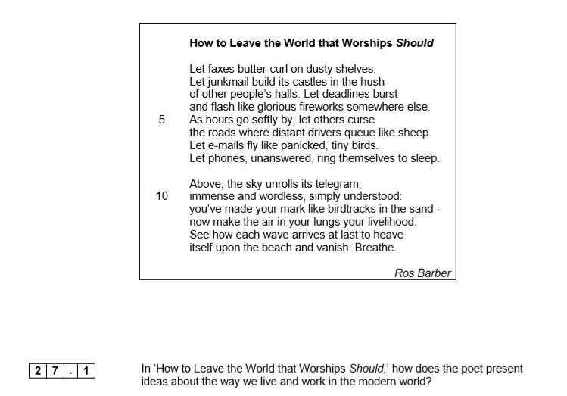
Practice Questions:
