NAME
TUTOR GROUP
LESSON DAY AND TIME
TEACHER

YEAR 11
RESPECT
1
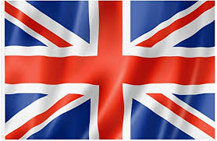
Rules And Expectations For The RESPECT Classroom

1
2
3
4
5
6
7
8
9
10

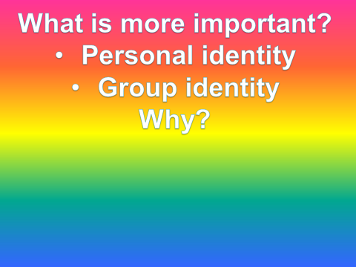

ID

Things in common | Individual things

What do you identify with?

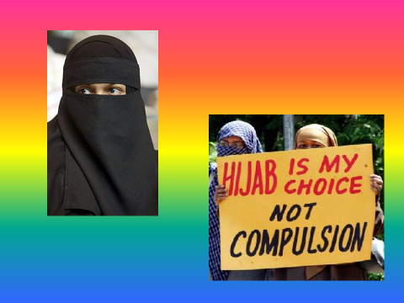

DOES RELIGION PROVIDE AN IDENTITY FOR PEOPLE?

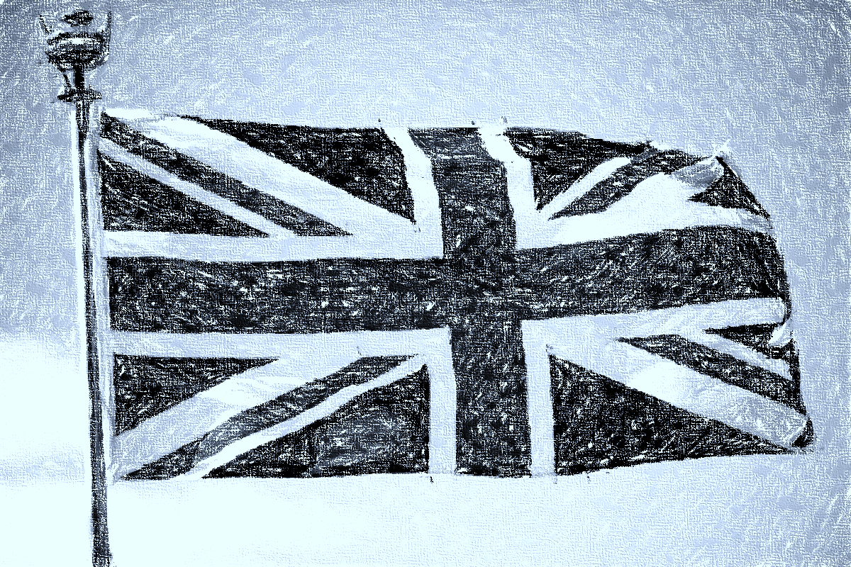
What does it mean to be British?
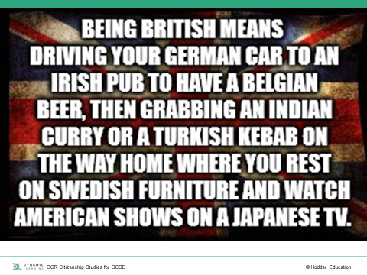
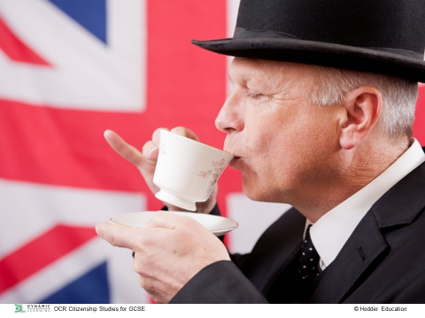
Create a list what it actually means to be British
For example – loves tea, was born in England, Wales, Scotland, Northern Ireland

The British Citizenship Test
1.Which landmark is a prehistoric monument which still stands in the English county of Wiltshire?
Stonehenge
Hadrian’s Wall
Offa’s Dyke
Fountains Abbey

2.What is the name of the admiral who died in a sea battle in 1805 and has a monument in Trafalgar Square, London?
Cook
Drake
Nelson
Raleigh

3.In 1801, a new version of the official flag of the United Kingdom was created. What is it often called?
British standard
Royal banner
St George cross
Union jack

4.Who is the patron saint of Scotland?
St Andrew
St David
St George
St Patrick

5.What flower is traditionally worn by people on Remembrance Day?
Poppy
Lily
Daffodil
Iris

6.Which of these sporting events was hosted in London in 2012?
Commonwealth Games
Cricket World Cup
European Football Championship
Paralympic Games

7.At her jubilee in 2012, how many years as queen did Queen Elizabeth II celebrate?
25
40
50
60

8.The second largest party in the House of Commons is usually known by what name?
Senate
Opposition
Lords
The other side

9.From what age can you be asked to serve on a jury?
16
18
21
25

10.What is the title given to the person who chairs the debates in the House of Commons

Chairman
Speaker

Leader of the House

Prime minister

11: Who served as prime minister during WWII?

12: How many houses make up the U.K. Parliament?

13: What is the official flower of England?

14: In what year did British women win the right to vote at the same age as men?

15: How often are UK general elections held?

Personal Freedom | Tolerance And Respect For Diversity
Equality Of Opportunity | Representative Democracy And The Rule Of Law

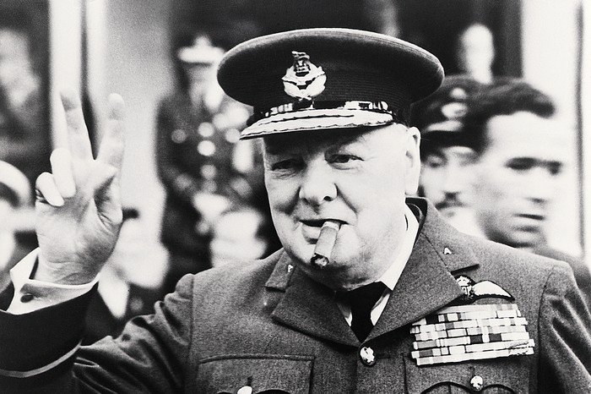
"I do not admit for instance, that a great wrong has been done to the Red Indians of America or the black people of Australia. I do not admit that a wrong has been done to these people by the fact that a stronger race, a higher-grade race, a more worldly wise race to put it that way, has come in and taken their place."

TONYPANDY
LIVERPOOL
GLASGOW
IRELAND

The national anthem

CHALLENGE: Can you write down all the words to the National Anthem?

Your New National Anthem

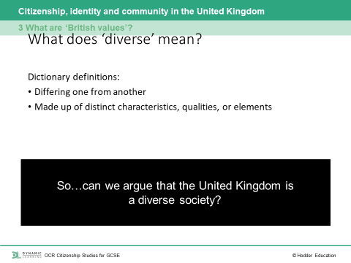
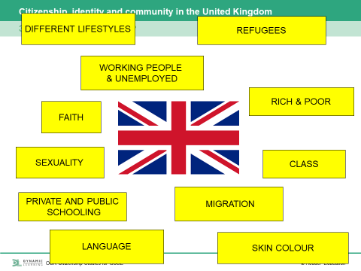
How much tolerance and respect for diversity is there really in the UK?

- Write down your own personal opinion on the opinion line given to you, be prepared to share with the rest of the class.
- Add the viewpoints of British politicians on this matter.
- Challenge: Add your personal viewpoint to their opinions, do you agree or not and why?

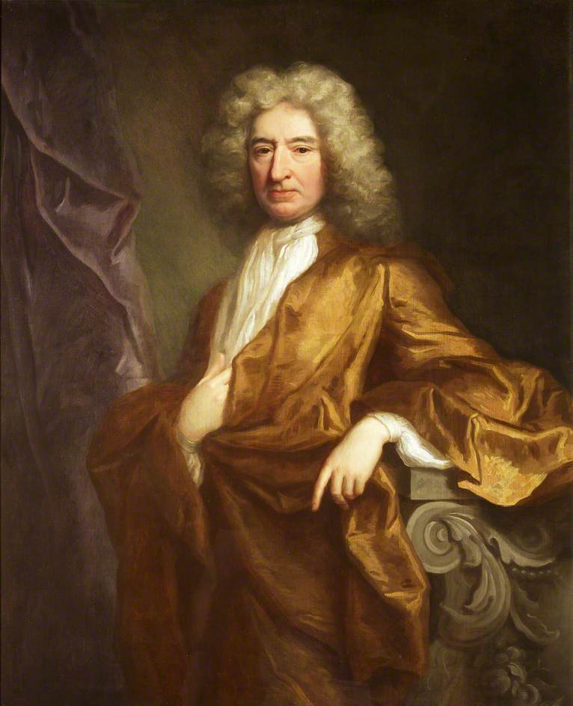

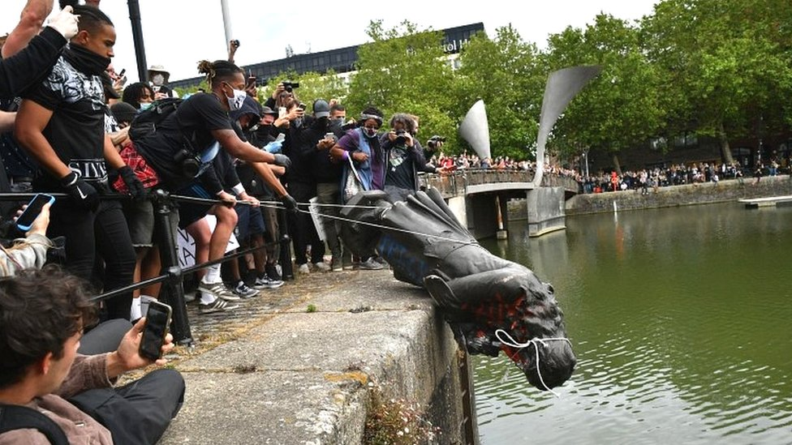

Colston was an important British hero and the statue is a vital part of Britain’s heritage. Colston should be celebrated and the statue should remain where it was.

Colston was an example of the worst aspects of British history. The statue was an embarrassment and it should be destroyed.

Read:
Excerpt from Bristol and Transataltic Slavery Orangins, Impact and Legacy 2021

The Black Lives Matter protests that spread across the world following the murder of George Floyd in May 2020 forced people to think hard about racism. The debates following the toppoling of Colston’s statue in Bristol demonstrated the connectio between modern racism and historical injustices of slavery.
Did race prejudice cause slavery? Or was it the other way around?
The Historian Peter Fryer asked these questions to introduce a long running historical debate. For the Trinidadian Historian Eric Williams, the desire to make money lead Europeans to adopt slavery. Racism, in his view was a way of justifying the brutal treatment of inslaved people. Other historians have challenged Willaims by pointing to racist ideas that existed before transalatic slavery began.
Today
Racism still scars our city, as it does people and places across the world. Cities like Bristol have not yet fully acknowledged the extent to which their economic and physical development rested on the racist ideas at the heart of the slave trade. Yet as the Black Lives Matter demonstrations of 2020 made clear, ordinary men and women will continue to protest against and resist racism and injustice.

What is race?
In the 19th century, people began to understand race in ascientific way.Even today we might think of terms like ‘Black’ and ‘white’ as scientific realities. Yet genetic science provides no evidence to support these catagories. All humans share 99.9% of their DNA, regardless of skin colour national origin. Most of the 0.1 differences exist within groups like ‘Black’ and ‘white’ not between them. Race is not made by our genes but by our history.

How should we remember Bristol’s slaving past?
The process of memorialisation, the way we remember the past, can be complicated. Societies use public spaces to memorialise people and events in history that are important to them, but there is rarely a full agreement on who or what is appropriate and peoples feelings about this change over time. The past does not change, but what and who we choose to memorialise from it does. Bristol like other cities, has struggled to agree about how we should remember its involvement in transatlantic slavery.
Commemorating Colston
When we discuss remembering transatlantic slavery in Bristol, it is important to remember that memorials to some of the people involved already exist.
Colston’s statue was erected in 1895, more than170 years after he died.

In the early 19th Century, Colston was not particularly well-known or popular in Bristol. However, there was at least four societies dedicated to doing charitable works in his memory. They began to raise funds for a Colston Statue by asking for public donations. They admired Colston because he was a successful businessman who had spent a lot of money improving the city. They believed that how he spent the money was more important than how he made it. (See 19th Century view below). They did not consider that by commemorating Colston they might also be condoning his slave trading past.

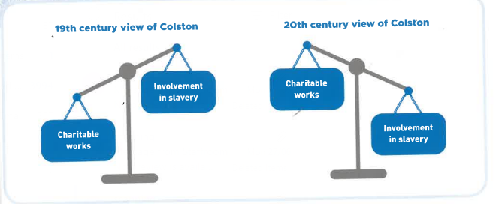

Proposal of how Bristol’s slaving past should be remember.
You need a poster explaining your ideas

Personal Freedom Debate Ideas

Philosopher: John Stuart Mill Principle of Harm –
For Mill – and the many politicians, philosophers and legal theorists who have agreed with him – social disapproval or dislike (“mere offence”) for a person’s actions isn’t enough to justify intervention by government unless they actually harm or pose a significant threat to someone.
For example – Consenting adults should be able to whatever they like,
The phrase “Your freedom to swing your fist ends where my nose begins” captures the general sentiment of the principle, which is why it’s usually linked to the idea of “negative rights”. These are demands someone not do something to you.
For example - we have a negative right to not be assaulted.

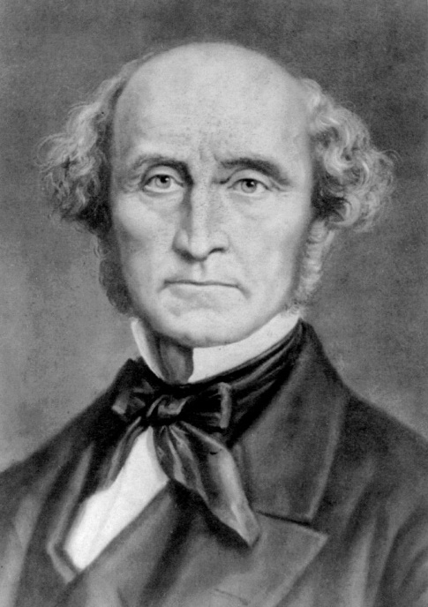

Current Political Controversies to Consider
- Compulsory vaccinations for Covid
- LGBTQ+ Equal Rights
- Reclaim the night (legislation to ensure women safety at night, including a male curfew.)
- Access to safe and legal abortions
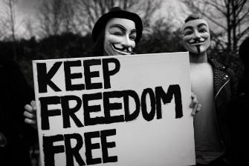
- Smoke tobacco

Tolerence and Respect for Diversity Debate Ideas
Philosopher: Michal Foucault–
Foucault rejects the standard picture according to which power is always about the strong oppressing the weak, the rich oppressing the poor, the monarchy oppressing its subjects. Instead he suggests that in the modern world, power is spread throughout society. You and I are just as much conduits of power as a CEO or a member of congress: we internalize the norms of our society, and we end up policing ourselves and other people, whether we realize it or not. We all act as unwitting enforcers of the power structure.
So it’s no longer a simple “us versus them” story. And one consequence is that we can start thinking of injustice as something systemic or structural: injustice is not just a set of acts that bad people do, but a system that even otherwise good people can end up perpetuating, often in spite of themselves.

Current Political Controversies to Consider
- Black Lives Matter Movement
- How we commemorate history
- Compulsory preference of pronouns being used on badges and emails
- Inclusion of Creationist ideas of evolution in the science curriculum

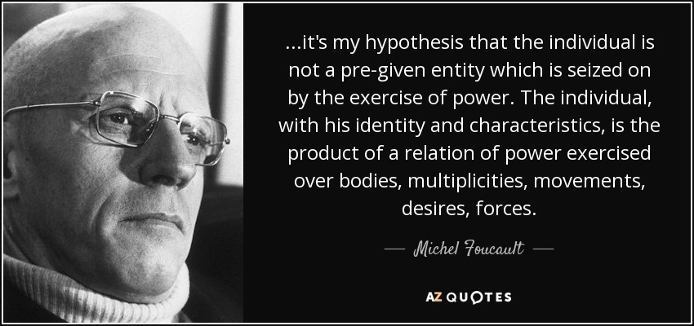
Acceptable and right to pull it down

Equality and Opportunity Debate Ideas
Philosopher: John Rawls
John Rawls asks us to complete a thought experiment.
If before you were born you knew how unjust the world is. For example: If you knew that one billion of the earths eight billion people live in slums. Approximately 842 million people suffer from hunger worldwide. That’s almost 12 percent of the world’s population. That 71 countries it is illegal to be Gay. That 1% of the world is a refugee. That if you are a women you were going to be 23% less worth off than if you are a man.
If you knew that you had equal chance growing up in any current world circumstance, would you gamble coming to earth as it is? Or would you make the world a little fairer with less privileged people but a lot less vulnerable people?
If you would make the world less risky before you would gamble on coming to Earth, we morally should be making the world fairer.
Current Political Controversies to Consider
- Gender pay gap in the UK is still 7%
- There is a 13% attainment gap between ‘white’ and BAME students
- Cycle of Poverty - poor families become trapped in poverty for generations. Because they have limited or no access to critical resources, such as education and financial services, subsequent generations are also impoverished
- 65% of all judges in the UK, went to a private school.

Representative Democracy and the Rule of Law – Debate ideas
Philosopher: Aristotle
The Rule of Law is a principle that all people and organizations within a country, state, or community are held accountable to the same set of laws. The Rule of Law has its origins in ancient Greece and, more specifically, in the philosophy of Aristotle. In his work titled Politics, Aristotle raised the question of whether it is better to be ruled by the best leader or the best laws. In exploring this question he found advantages and disadvantages to both governing methods. His conclusion, however, suggested that laws were appropriate for most societies since they were carefully thought out and could be applied to most situations. Therefore, people should be ruled by the best laws.

Current Political Controversies to Consider
- 60% of the UK population would vote to bring back the death penalty
- Referendum for Scottish independence
- Just 7% of British people are privately educated, compared to two-fifths (29%) of MPS.
- Party Gate, parties in 10 downing street during lock down
- Only 34% of MPs are women
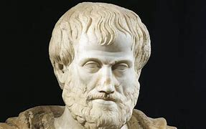
- Brexit

