Sex & Relationships Education
Rules

1
2
3
4
5
6
7
8

Sex and The Law Quiz

1. It is illegal for a man to have sexual intercourse with a young woman under 16
years old.
TRUE 􀂆 FALSE 􀂆

2. It is illegal for a woman to have sexual intercourse with a young man under:
a) 13 years old
b) 16 years old
c) 18 years old
d) No specific age

3. If two 15-year-old girls have a sexual relationship they are breaking the law.
TRUE 􀂆 FALSE 􀂆

4. The age of consent for 2 men to have a sexual relationship is:
a) 21 years old
b) 18 years old
c) 16 years old
d) Still illegal

5. To get contraceptive advice a person needs to be:
a) 16 years old
b) 18 years old
c) 21 years old
d) Any age

6. Two people can get married or enter a same sex civil partnership at 16 years
of age if their parents / guardians agree.
TRUE 􀂆 FALSE 􀂆

7. In England and Wales two people can marry or enter a same sex civil
partnership even if their parents / guardians disagree at 17 years of age.
TRUE 􀂆 FALSE 􀂆

8. A woman will always get an abortion on request.
TRUE 􀂆 FALSE 􀂆

9. Abortion cannot take place after the 20th week of pregnancy.
TRUE 􀂆 FALSE 􀂆

10. Prostitution is illegal.
TRUE 􀂆 FALSE 􀂆

11. At what age can a woman be prescribed the pill?
a) 18 years old
b) 16 years old
c) 14 years old
d) Any age

12. To buy condoms a person needs to be:
a) 18 years old
b) 16 years old
c) 12 years old
d) Any age

13. It is illegal for schools and youth projects to talk to young people about
homosexuality.
TRUE 􀂆 FALSE 􀂆

14. Male rape is legal.
TRUE 􀂆 FALSE 􀂆

15. It is illegal for a man to rape his wife.
TRUE 􀂆 FALSE 􀂆

16. If a young woman under the age of consent asks for contraceptive advice her
parents / guardians will be told.
TRUE 􀂆 FALSE 􀂆

17. Parents and guardians have a legal right to withdraw their children from Sex
and Relationships Education.
TRUE 􀂆 FALSE 􀂆

18. It is illegal for a man to have sexual intercourse with a person they know is
their sister, mother, daughter, grand-mother or grand-daughter.
TRUE 􀂆 FALSE 􀂆

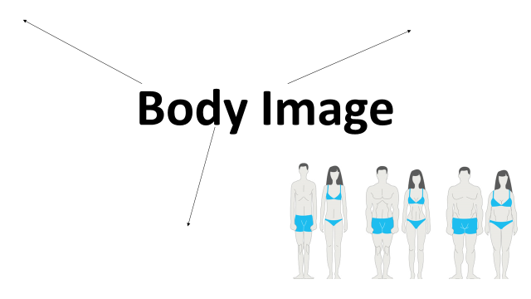
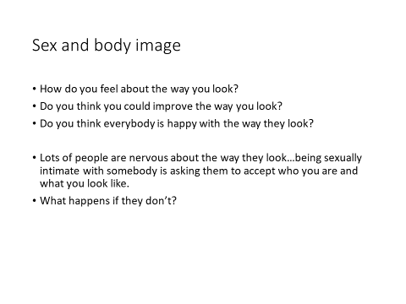

NOTES FROM THE CLIPS

True Or False?
- You can’t get pregnant if the woman doesn’t orgasm.
- You can’t get pregnant if you are standing up or the woman is on top.
- You don’t need to use contraception for oral sex.
- You can use Clingfilm or a balloon if you don’t have a condom.
- You won’t get pregnant if the man pulls out before he ejaculates.
- You won’t get pregnant the first time you have sex.
- The pill is effective immediately after you take it.
- The pill affects your fertility in the future.
- You can’t get pregnant if you have sex during your period.
- Two condoms are safer than one.

Notes On Sexually Shared Infections

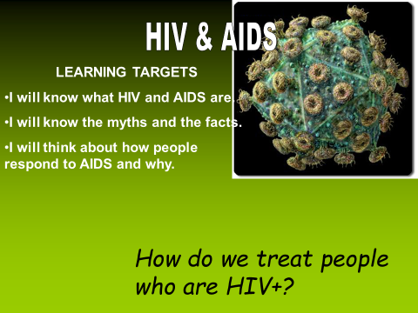

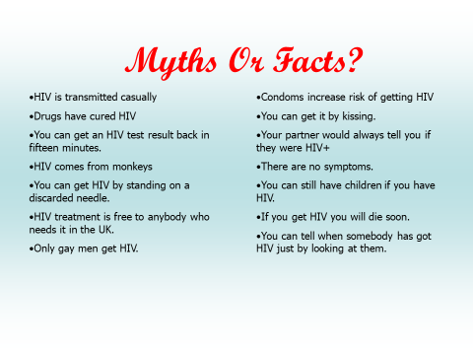

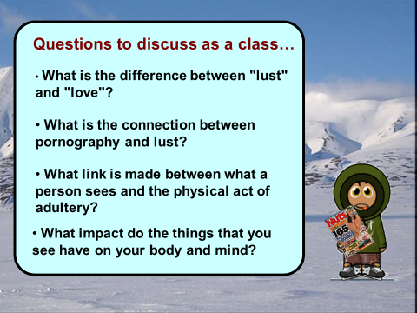
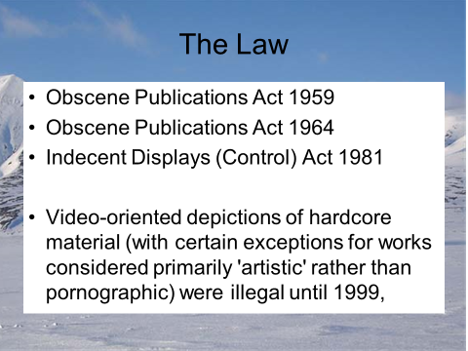
Alcohol & Sex

