Rules And Expectations For The RE Classroom

1
2
3
4
5
6
7
8
9
10

CURRENT AFFAIRS

 | NEWS STORY | WHAT’S IT GOT TO DO WITH RE?
1
2
3
4

SUPERTEACHER!

YOUR SUPERTEACHER
The Ten Gurus

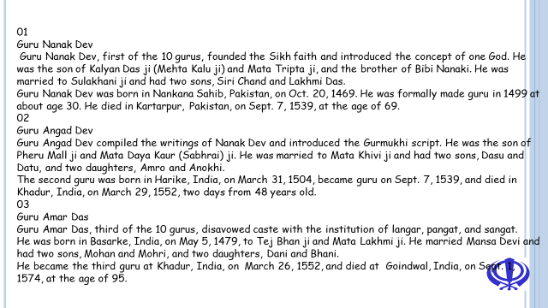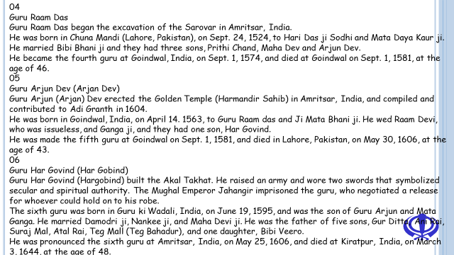
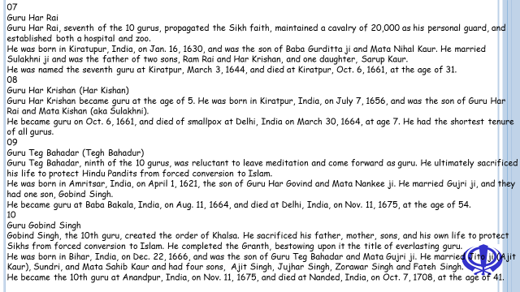
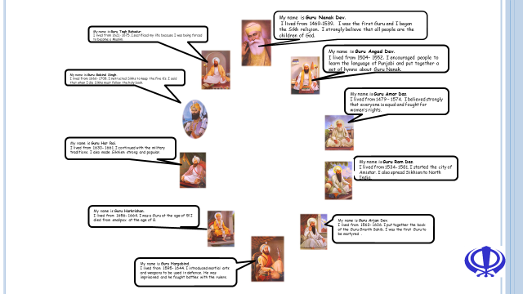
http://sikhism.about.com/od/tengurus/tp/Ten-Gurus-Timeline.htm
http://www.sikhs.org/10gurus.htm
http://www.sikhiwiki.org/index.php/Ten_Sikh_Gurus
http://www.sarabsanjhigurbani.com/ten-guru.asp
http://www.youtube.com/watch?v=N9-TdIl13Qs
The Ten Gurus Song

SUCCESSFUL WORK WILL:
- Be a catchy song!
- Give at least five facts about the Sikh religion (keep it basic!)
- Give the names of all of the Ten Gurus
- Give two further facts about each guru.
- Include contributions from all members of your group.
- Be performed by the whole group (nobody sits it out).

Try to look like you are enjoying it – presentation is vital.
Make sure that every member of your group has helped in
- the writing of your song
- the performance of your song
It is a good idea to start off by splitting up the research so that people can work in pairs gathering facts.
Eg, one pair finds the Sikhs religion facts and facts on the first three gurus. Another pair works on gurus 4 – 7 and another pair on gurus 8 – 10.
Keep your tune basic. Use existing nursery rhymes or children’s songs to help you.
TICK/EXAMPLE
We identified facts about the Sikh religion and gurus that might be important to Sikhs
We gave reasons why the gurus are important to Sikhs
We have shown how the facts about gurus might influence Sikhs in their lives.
We have used religious terms correctly in lyrics of the song and shown how the gurus are important to the Sikhs by using appropriate facts
We have shown how Sikh beliefs and ideas are connected to the needs and concerns of people living at different times and in different places.

Self-Assessment

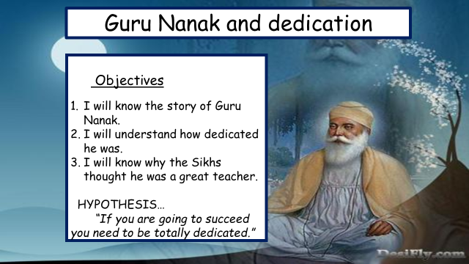
Notes from the video

1
2
3
1
2
3

The story of GURU AMAR DAS AND THE EMPEROR
Akbar was a famous king of India. He is known as "Akbar the Great' in history. He was a kind and good king and respected the Sikh Gurus for their teachings. In the year 1569, Akbar came to the Punjab and wanted to see the Guru. So he sent a message to Guru Amar Das that he was coming to visit him. The Sikhs were very happy at the news. Some Sikhs thought that special arrangements should be made to welcome the king. The Guru thought for a while and said, "Akbar is as much a human being as others are. The Guru's place is open to all. The king and his subjects, the Hindus and the Muslims, the rich and the poor are all equal here. So Akbar will be welcomed like all other visitors to the Guru's place and special arrangements need not be made."
The king arrived in Goindwal where the Guru lived. The Guru and a few Sikhs received them warmly. They were shown round the place. Akbar was interested to know how the Guru's Langar was run. Simple food was served to all in the Guru's Langar. It remained open day and night. Travellers, beggars, and strangers, as well as the followers of the Guru, were all served with food. Whatever was left was thrown to the cattle and birds so that nothing was wasted. The Guru had given an order that all persons coming to visit his place must have their food in the Langar. There they were to sit in rows as brothers and were to be served simple food in turn.
Akbar took his meal in the Guru's Langar. He sat among the common people in a row and the Sikhs served them food. They enjoyed the simple food and were very happy. Akbar liked the working of the Guru's Langar very much. Before leaving, Akbar said to the Guru, "I like Guru Nanak's religion very much and I respect you for your teachings. I want to make a grant of land for running the Langar. Would you mind it?"
"Dear Akbar," said the Guru, "I am very glad you like the religion of Guru Nanak. I am also grateful to you for your offer of a grant of land for the Langar, but I am sorry I cannot accept it because the Guru likes all to work hard to earn and to share their honest earnings with others, by giving something to the Langar to help others. As such, the Guru's langar is the people's Langar and it must be run on people's free gifts and not on a royal grant. That is why all share equally in the Guru's Langar and no one is looked upon as an outsider. Here, there is no difference between kings and beggars. All sit together; and eat simple food served with loving care."
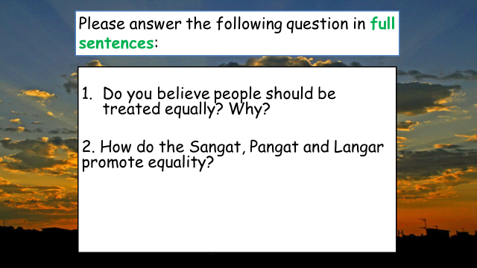
Guru Gobind Singh & The First Vaisakhi

The Sikh leader was called Guru Gobind Singh. Guru means teacher, and he taught people about God. Guru Gobind Singh decided things had to change, and so, on the spring festival of Vaisakhi, he called the Sikhs to join him. There was a huge crowd, over 20,000 people. Guru Gobind Singh stood outside his tent and called out: 'I need a Sikh who is willing to die for God and for the Guru.'
His words were passed through the crowd. Everyone was amazed. Who was devoted enough to give up their life? Twice more the Guru called out to the crowd and asked the question. Then one man came forward. Guru Gobind Singh took him into his tent. After a while the Guru came out by himself. But in his hand was a sword covered in blood! The crowd gasped. Then the Guru asked again. 'Who is willing to die for God and the Guru?' Surely no one else would come forward.
What about that sword with blood on the blade? But then another man stepped forward and went into the tent with the Guru. Once again the Guru came out of the tent alone, with blood on his sword. Then amazingly, another man stepped forward and went into the tent, and then another. Four brave and devoted men - and each time the Guru stepped out of the tent alone, with his sword in his hand.
Then a fifth man stepped forward and went into the tent with the Guru. How many men must die, the crowd wondered. But this time the Guru came out of the tent, with his sword, and behind him were the five men. They were still alive!
'This was a test,' the Guru explained, 'to see who was brave enough and willing to give up everything to show how much they were devoted to God.' The Guru called the five men the 'Panje Pyare', the beloved ones. They were to become the first members of a group called the Khalsa, which would defend the Sikh faith and care for the poor and helpless, whoever they were and whatever they believed.
Then the Guru made a mixture of sugar and water called 'amrit'. He asked the beloved ones to give him some of the amrit, to show that although he was the Guru, all people were equal in God's eyes. That day amrit was given to people in the crowd who said that they believed in one God, and that all people were equal. They were given new last names too, to show that they now belonged to one big family - women were given the name Kaur, which means princess, and men were given the name Singh, which means lion.

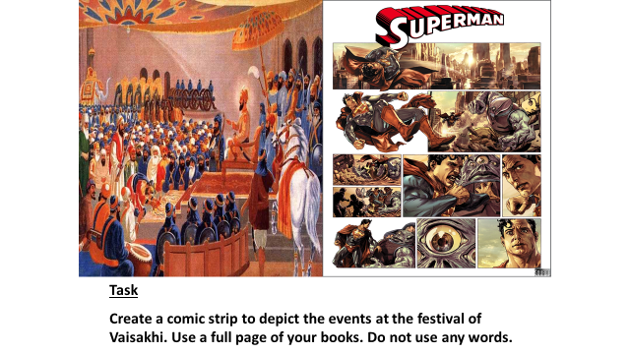

THE TEN GURUS SELF-ASSESSMENT
Your starting point will be to write two speeches. Each should last for one minute.
The first minute should be about one guru. In your speech you have to say why this guru is so good, and why the teachings of this guru are still important.
The second speech is more about trying to say why the teachings of the other gurus aren’t as important as the one you have got.

Guru Nanak – dedication (starting, spreading Sikhism, giving everything up etc)
Guru Gobind Singh – self-sacrifice (5 beloved ones, festival of Vaisakhi)
Guru Amar Das – equality (Langar, the emperors visit)
EXCELLENT WORK | You will have to show, in your speech, that you know who your guru was and what his teachings were. You will have to show that you understand the teachings by applying them to modern life today. Explain why they still work. Use examples from real life to show that the teaching(s) would still work.  Also show that you understand the teachings of the other gurus and why their teachings aren’t quite as good by making them sound old fashioned and out of touch. Have reasons and examples.
ADEQUATE WORK | Adequate work will show a knowledge of your guru, who he was etc and also that you know what his teaching was. You will probably explain that you think the teaching is good, but you might not be able to say why it is so good or give any real reasons. You won’t really apply the teachings to real life today.
LESS THAN ADEQUATE WORK | No real thought put into the work. Not sure of who the guru was or what the teaching was really about. The speeches will not last a minute.

Pathways
Foundation | Secure | Confident | Exceptional
- You will be able to give some details about your guru.  - You will outline the teachings of your guru.  - You will say what Sikhs might learn from the teachings.  - You can say why things the guru said or taught are important. | - You will show clear understanding of the teachings of one guru.  - You will know the stories of the different gurus.  - You will use key words that Sikhs use.  - You can relate the teachings to real life. | - You will show that you have thought carefully about the teachings of the gurus and how they would affect the lives of Sikhs.  - You will be able to compare and contrast the teachings of the gurus, showing similarities and differences.  - You will give clear reasons why your guru’s teaching are the most important.  - You can include references to current events and news items. | - You will show that you understand why different people think that other teachings are more important, but you will still be able to argue for your guru.  - You will raise questions that are difficult to answer.  - You will write about how the time and place that people live in can affect their responses to teachings.  - You will show clear links between Sikh teachings and those of other relgions.
Sentence Starters

Speech One- Explaining why your guru is the best:

- The guru I think the best is ....
- This is because...
- His main quality is...
- This quality is useful because...

Speech Two- Explaining why the other gurus are not as good as yours:

- Other gurus are not as good because...
- Their qualities are...
- These are not as important because...

