RE AT KINGSHILL
Rules And Expectations For The RE Classroom

1
2
3
4
5
6
7
8
9
10

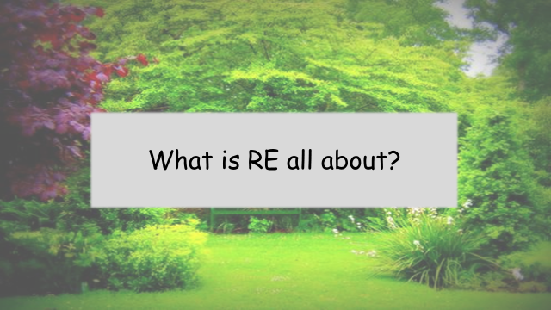
CURRENT AFFAIRS

 | NEWS STORY | WHAT’S IT GOT TO DO WITH RE?
1
2
3
4

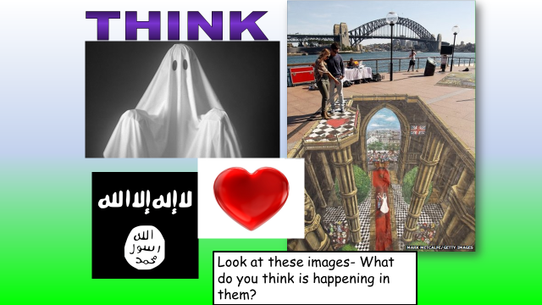
IT IS THE LAW  The law states that all pupils in school must have RE lessons. | TO KNOW ABOUT GOD  It is an important subject because it helps you to learn and understand more about God. | TO THINK ABOUT BIG QUESTIONS  It is important because it gives you the chance to really think about life’s huge questions like:  What is the meaning of life?  What happens when we die?  Where do we come from?
RELIGION IS ALWAYS IN THE NEWS  It is important to take RE because every day there is something on the news that has something to do with religion. | IT IS PART OF OUR CULTURE  Our culture is based on Christian teachings and we now live in a community that has many faiths. RE helps us to understand what it is to be British. | TO EXPLORE OUR OWN VALUES AND BELIEFS  RE is important because it gives the chance to think about our own beliefs, feelings and ideas.
IT HELPS TO DEVELOP IMPORTANT SKILLS  RE is an important lesson because it involves lots of skills that help you in life – reading, writing, debating, analyzing etc. | TO UNDERSTAND WHAT OTHER PEOPLE BELIEVE  In our lives we will come into contact with people of faith. RE helps us to understand the beliefs of different people. This could help us in our future jobs. | RE DEALS WITH TOPICS THAT OTHER SUBJECTS DON’T TOUCH  Some of the things we talk about in RE are very important but they don’t come up in other lessons. Eg death, relationships, right and wrong.
TO MAKE US ALL RELIGIOUS  RE is important because it helps to make everybody religious. | RE IS FUN  RE is an important subject because it is interesting and fun. | TO HELP US GET ON WITH PEOPLE OF DIFFERENT FAITHS  RE is important because there is a lot of misunderstanding in the world about religions and beliefs. RE helps us to understand each other.

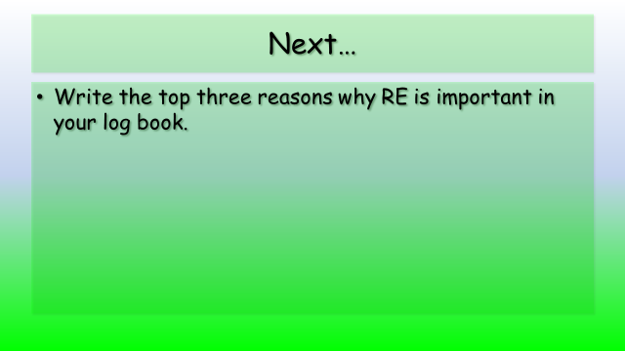
1
2
3

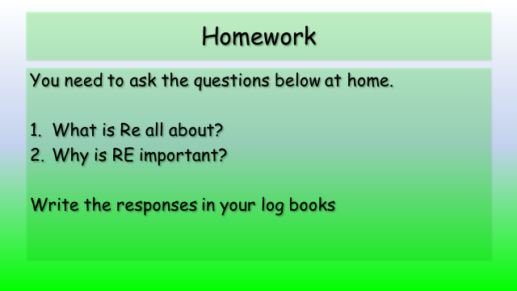

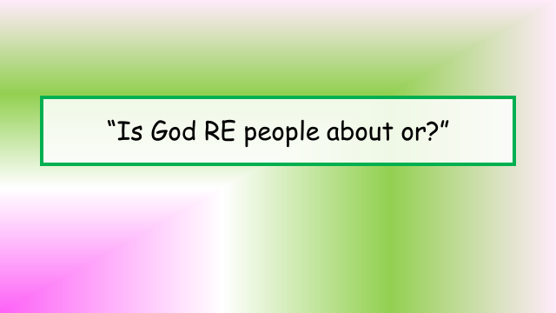
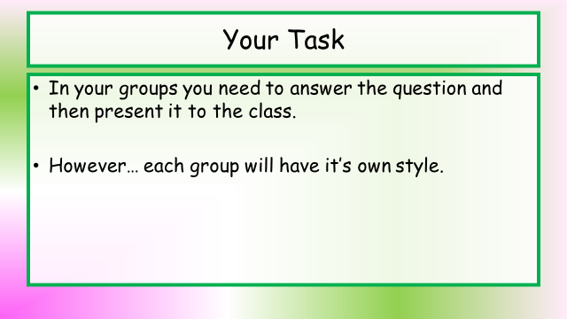
IS RE ABOUT GOD OR ABOUT PEOPLE?
ASSESSMENT SHEET
 | 0 | 1-2 | 3-4 | 5
Was the presentation effective? | They did not do it in the style they were supposed to. They did not follow instructions. | They made some attempt to present their work in the right style. Most instructions were followed. | On the whole, their work was in the correct style. All the instructions were followed but without much enthusiasm. | The presentation was excellent and all the instructions were followed.
Did the group answer the question? | They did not even raise the questions. | They attempted to answer, but it wasn’t really clear. | They had an answer to the question but no reasons were given. | The answer was clear and full reasons were given.

TOTAL: 10
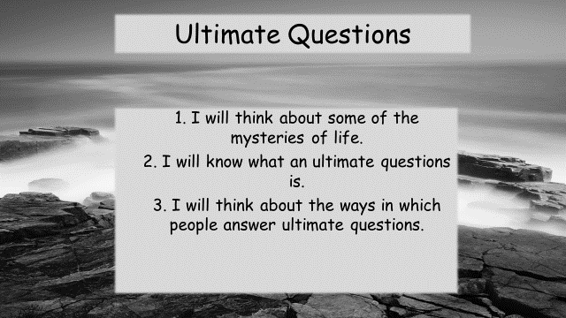
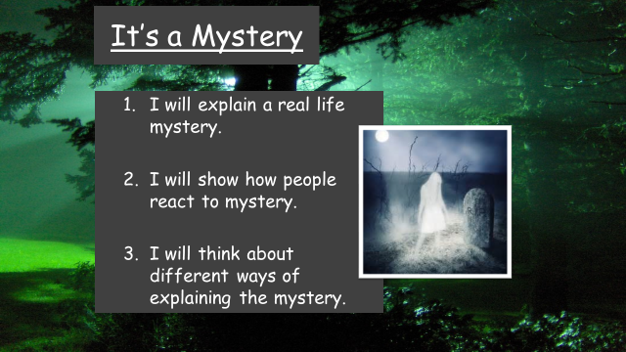
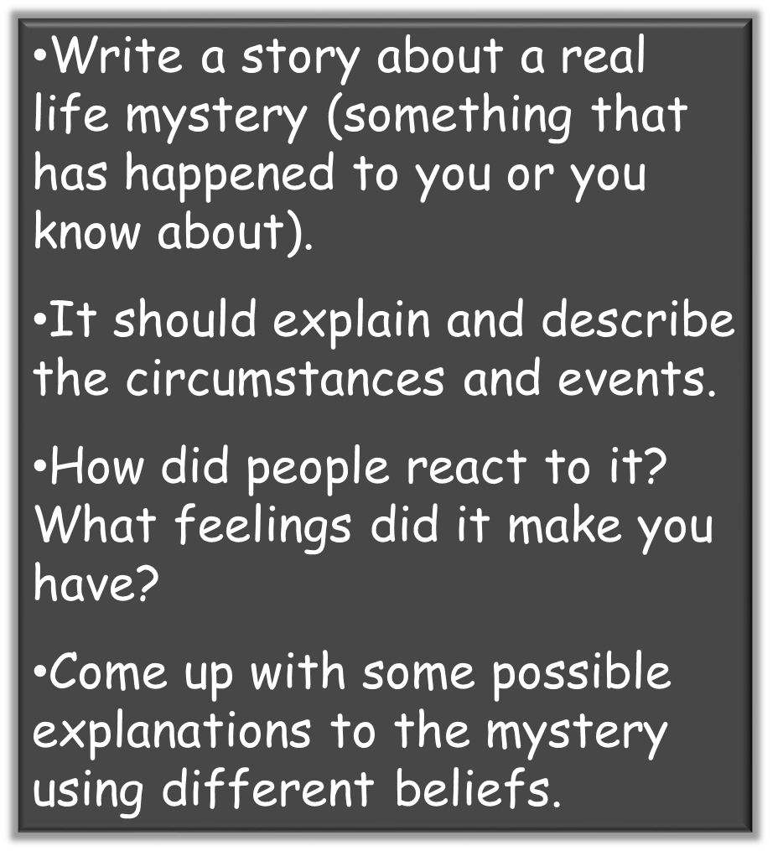

Research your mystery carefully!

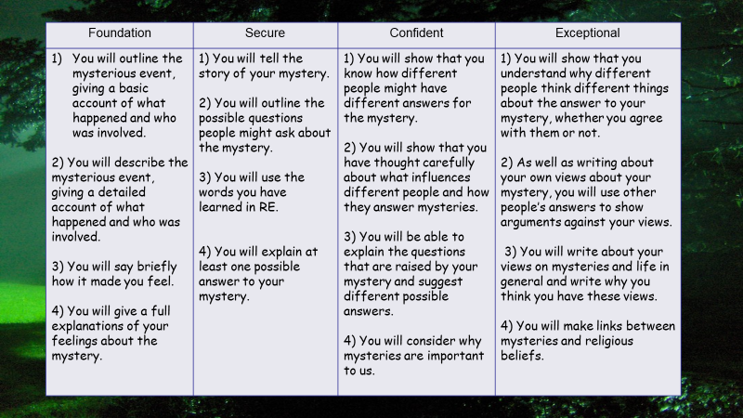
Writing frame and sentence starter…if you need it!
Introduction
The mystery that I will be explaining is when…
Once, a mysterious event took place in…
Once, a mysterious event took place at…
It made me feel……………………….

Paragraph 1
Some people think that……………….happened
A man called………….thinks that……………..happened
A witness from the scene said that…………….

Paragraph 2
I think that………………………………….could have happened, because…………………….
My thoughts/feelings have been influenced by…………………………

Conclusion
Overall, after considering my own thoughts and those of others, the most likely explanation is that…………………………………………………..
It is/is not still a mystery.

USE THE SENTENCES ON THE ASSESSMENT TABLE FOR FURTHER IDEAS.
Before you start your work, write down what level you are aiming for. Then write down three reminders that will help you to get that pathway. Eg
I want to aim for secure.
* I have to fully explain the mystery and how it made me feel.
* I have to give reasons why different people would give different answers ETC…

Your Mystery Picture

What is an ‘Ultimate Question’?

Three really good ultimate questions:

1
2
3

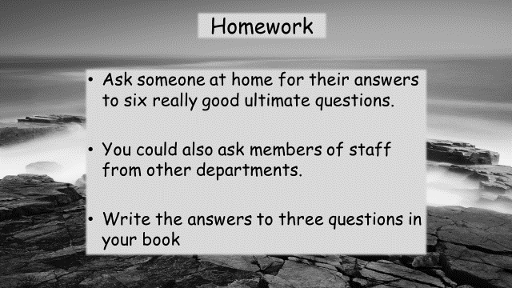

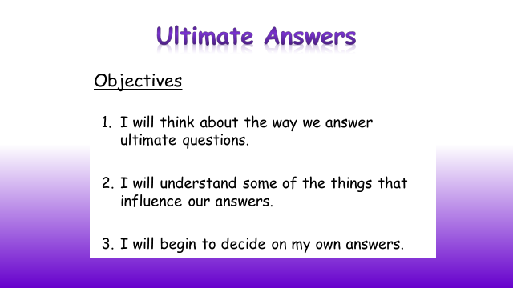
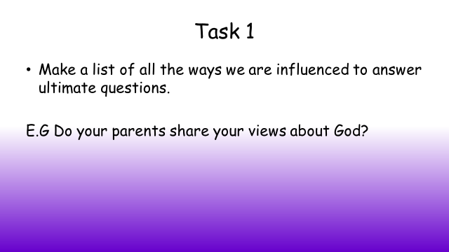

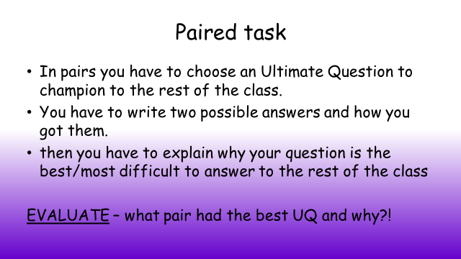

My Emotions

Do we have a “soul”?

