|  |
| --- |
|  |
|  |
|  |
|  |
|  |
|  |
|  |
|  |
|  |
|  |
|  |
|  |
|  |
|  |
|  |
|  |
|  |
|  |
|  |
|  |
|  |
|  |
|  |
|  |
|  |
|  |
|  |
|  |
|  |
|  |
|  |
|  |
|  |
|  |

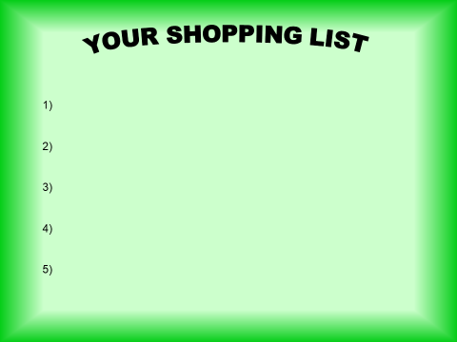

**Your luxury items in order.**

|  |  |  |
| --- | --- | --- |
|  | Item | Reason |
| 1 |  |  |
| 2 |  |  |
| 3 |  |  |
| 4 |  |  |
| 5 |  |  |
| 6 |  |  |
| 7 |  |  |
| 8 |  |  |
| 9 |  |  |
| 10 |  |  |
| 11 |  |  |
| 12 |  |  |
| 13 |  |  |

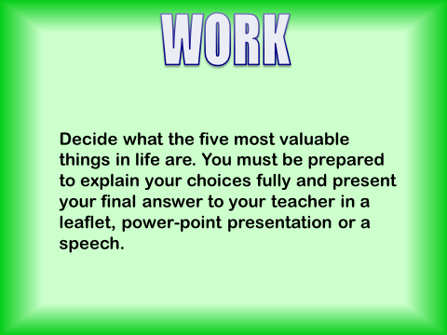

Some Tricky Questions

|  |
| --- |
| What is really of value to you? |
|  |
| Do you think you have too much money or too little money? Why? |
|  |
| What do you think is the best way to spend your money? |
|  |

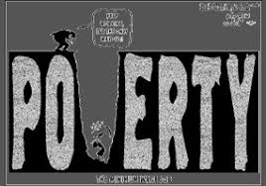 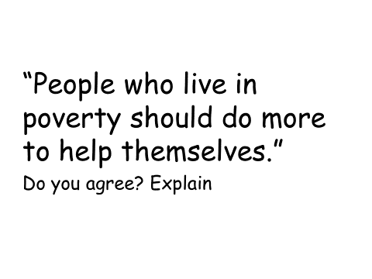

|  |
| --- |
|  |

|  |  |
| --- | --- |
| Images Of Poverty | |
| 1 |  |
| 2 |  |
| 3 |  |
| 4 |  |
| 5 |  |
| 6 |  |
| 7 |  |
| 8 |  |
| 9 |  |
| 10 |  |
| 11 |  |
| 12 |  |
| 13 |  |
| 14 |  |



  
  
  
  
  
  
  
  
  
  
  
  
  
  
  
  
  
  
  
  
  

