Happiness

Happiness is…

WORD ASSOCIATION

1
2
3
4
5
6
7
8
9
10
11

A Time When I Was Happy
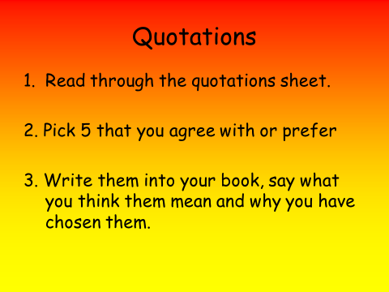
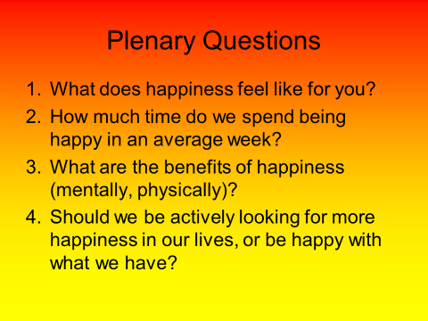
The Philosophy Of Happiness

Socrates

Plato

Aristotle

Diogenes

Epicurus

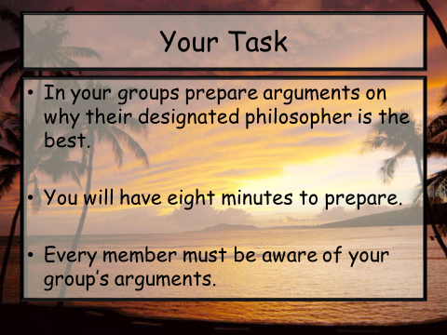
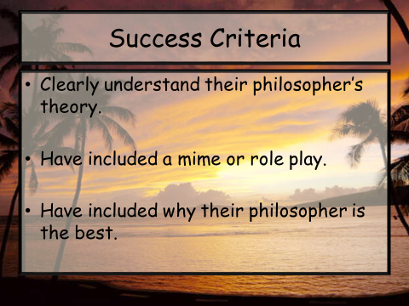
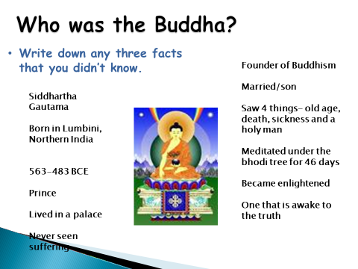

THE FOUR NOBLE TRUTHS
1
2
3
4

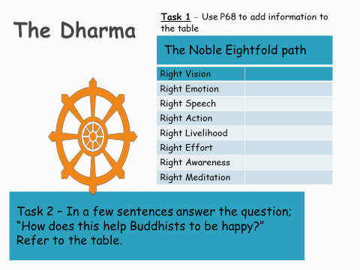

The Beatitudes

