|  |
| --- |
|  |
|  |
|  |
|  |
|  |
|  |
|  |
|  |
|  |
|  |
|  |
|  |
|  |
|  |
|  |
|  |
|  |
|  |
|  |
|  |
|  |
|  |
|  |
|  |
|  |
|  |
|  |
|  |
|  |
|  |
|  |
|  |
|  |
|  |

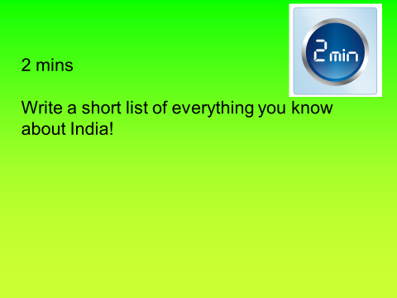

|  |
| --- |
|  |

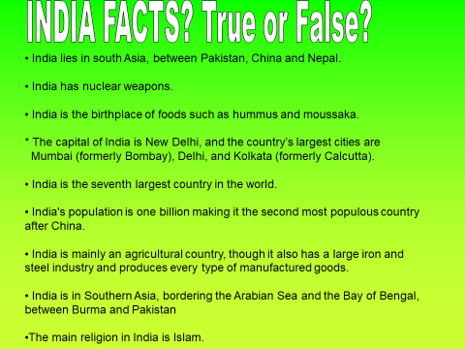

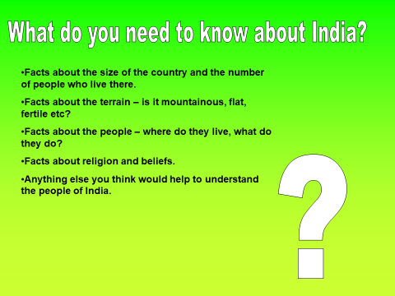

|  |
| --- |
|  |
|  |
|  |
|  |
|  |
|  |
|  |
|  |
|  |
|  |
|  |
|  |
|  |
|  |
|  |
|  |
|  |
|  |
|  |
|  |
|  |
|  |
|  |
|  |

|  |
| --- |
|  |
|  |
|  |
|  |
|  |
|  |
|  |
|  |
|  |
|  |
|  |
|  |

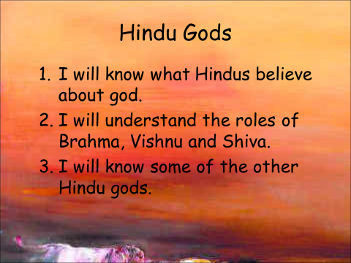

|  |
| --- |
|  |
|  |
|  |
|  |
|  |
|  |
|  |
|  |

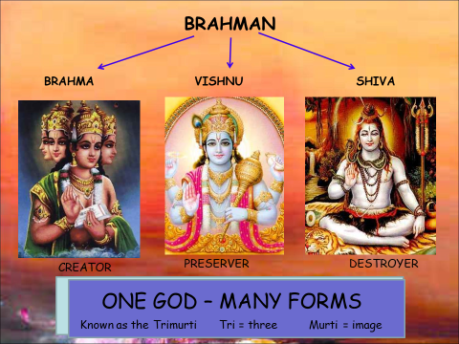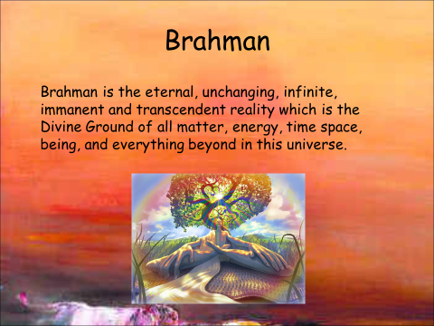

|  |
| --- |
|  |
|  |
|  |
|  |
|  |
|  |
|  |
|  |

Avatars of Vishnu

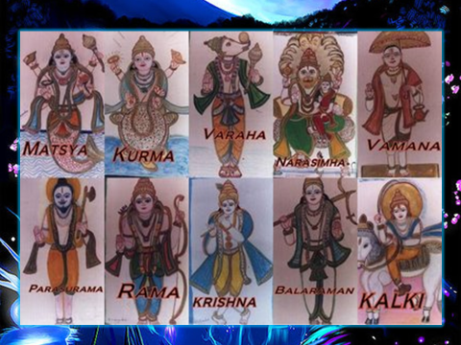

|  |
| --- |
| Who is your favourite super hero? Why? |
|  |

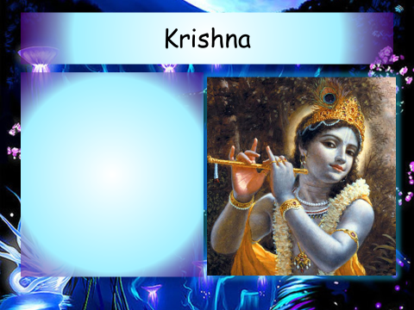

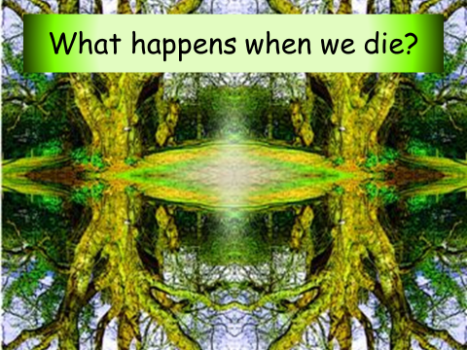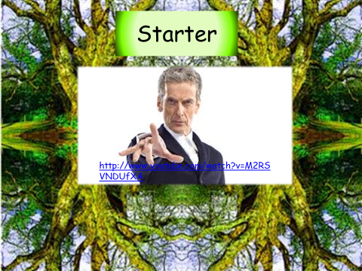

|  |
| --- |
|  |
|  |
|  |
|  |
|  |
|  |
|  |
|  |

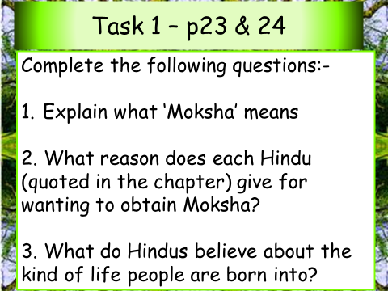

|  |  |
| --- | --- |
|  | |
|  | |
|  | |
|  | |
|  | |
|  | |
|  | |
|  | |
|  |
|  |
|  |
|  |
|  |
|  |
|  |
|  |
|  |
|  |
|  |
|  |
|  |
|  |
|  |
|  |
|  |
|  |
|  |
|  |
|  |
|  |
|  |
|  |
|  |
|  |
|  |
|  |
|  |
|  |
|  |
|  |
|  |
|  |

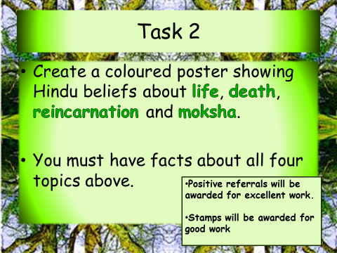

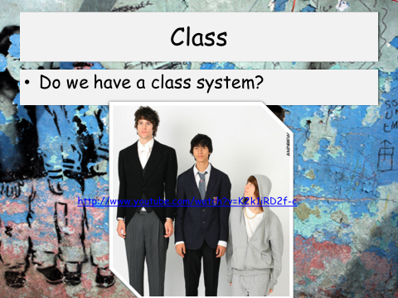

|  |
| --- |
|  |
|  |
|  |
|  |
|  |
|  |
|  |
|  |

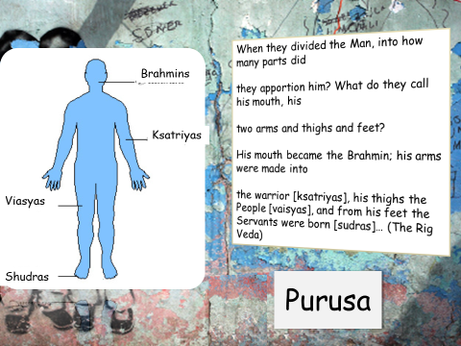

|  |  |
| --- | --- |
| CASTE | DESCRIPTION |
|  |  |
|  |  |
|  |  |
|  |  |
|  |  |



  
  
  
  
  
  
  
  
  
  
  
  
  
  
  
  
  
  
  
  
  
  
  
  
  
  
  
  
  
  
  
  
  
  
  
  
  
  
  
  
  
  
  
  
  
  
  
  
  
  
  
  
  
  
  
  
  
  
  
  
  
  
  
  
  
  
  
  
  
  
  
  
  
  
  
  
  
  
  
  
  
  
  
  
  
  
  
  
  
  
  
  
  
  
  
  
  
  
  
  
  
  
  
  