|  |
| --- |
|  |
|  |
|  |
|  |
|  |
|  |
|  |
|  |
|  |
|  |
|  |
|  |
|  |
|  |
|  |
|  |
|  |
|  |
|  |
|  |
|  |
|  |
|  |
|  |
|  |
|  |
|  |
|  |
|  |
|  |
|  |
|  |
|  |
|  |

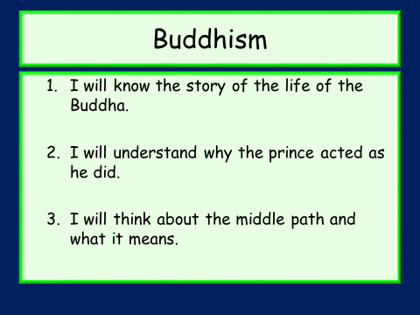

* Write down any words you think of when you think of ‘Buddhism’.

**The Life Of The Buddha**

|  |
| --- |
|  |
|  |
|  |
|  |
|  |
|  |
|  |
|  |
|  |
|  |
|  |
|  |
|  |
|  |
|  |
|  |
|  |
|  |
|  |
|  |
|  |
|  |
|  |
|  |
|  |
|  |
|  |
|  |
|  |
|  |
|  |
|  |
|  |
|  |
|  |
|  |
|  |
|  |
|  |
|  |
|  |
|  |
|  |
|  |
|  |
|  |
|  |
|  |

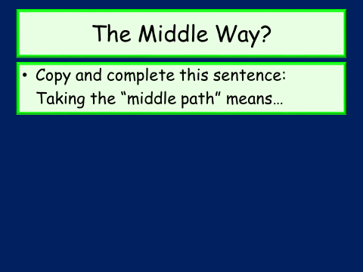

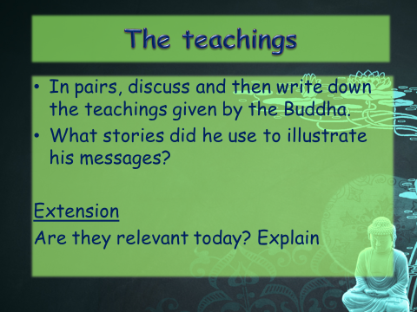

The Vaguely Impossible Information Grid

|  |  |  |  |  |  |  |  |  |  |
| --- | --- | --- | --- | --- | --- | --- | --- | --- | --- |
|  |  |  |  |  |  |  |  |  |  |
|  |  |  |  |  |  |  |  |  |  |
|  |  |  |  |  |  |  |  |  |  |
|  |  |  |  |  |  |  |  |  |  |
|  |  |  |  |  |  |  |  |  |  |
|  |  |  |  |  |  |  |  |  |  |
|  |  |  |  |  |  |  |  |  |  |
|  |  |  |  |  |  |  |  |  |  |
|  |  |  |  |  |  |  |  |  |  |
|  |  |  |  |  |  |  |  |  |  |

|  |
| --- |
|  |
|  |
|  |
|  |
|  |
|  |
|  |
|  |
|  |
|  |
|  |
|  |
|  |
|  |
|  |
|  |
|  |
|  |
|  |
|  |
|  |
|  |
|  |
|  |

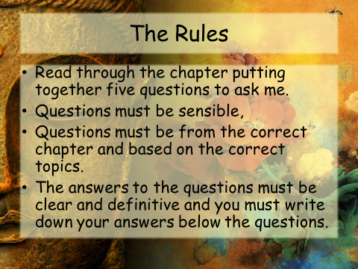The middle path and the Four Noble Truths

|  |
| --- |
|  |
|  |
|  |
|  |
|  |
|  |
|  |
|  |
|  |
|  |
|  |
|  |
|  |
|  |
|  |
|  |
|  |
|  |
|  |
|  |
|  |
|  |
|  |
|  |
|  |
|  |
|  |
|  |
|  |
|  |
|  |
|  |
|  |
|  |
|  |
|  |
|  |
|  |
|  |
|  |
|  |
|  |
|  |
|  |
|  |
|  |
|  |
|  |
|  |
|  |
|  |
|  |
|  |
|  |
|  |
|  |
|  |
|  |
|  |
|  |
|  |
|  |
|  |
|  |
|  |
|  |
|  |
|  |
|  |
|  |
|  |
|  |
|  |
|  |
|  |
|  |
|  |
|  |
|  |
|  |
|  |
|  |
|  |
|  |
|  |
|  |
|  |
|  |
|  |
|  |
|  |
|  |
|  |
|  |
|  |
|  |
|  |
|  |
|  |
|  |
|  |
|  |
|  |
|  |
|  |
|  |
|  |



  
  
  
  
  
  
  
  
  
  
  
  
  
  
  
  
  
  
  
  
  
  
  
  
  
  
  
  
  
  
  
  
  
  
  
  
  
  
  
  
  
  
  
  
  
  
  
  
  
  
  
  
  
  
  
  
  
  
  
  
  
  
  
  
  
  
  
  
  
  
  
  
  
  
  
  
  
  
  
  
  
  
  
  
  
  
  
  
  
  
  
  
  
  
  
  
  
  