LESSON ONE – STRESS
Rules And Expectations For The PSHEE Classroom

1
2
3
4
5
6
7
8
9
10
UNDER
PRESSURE?
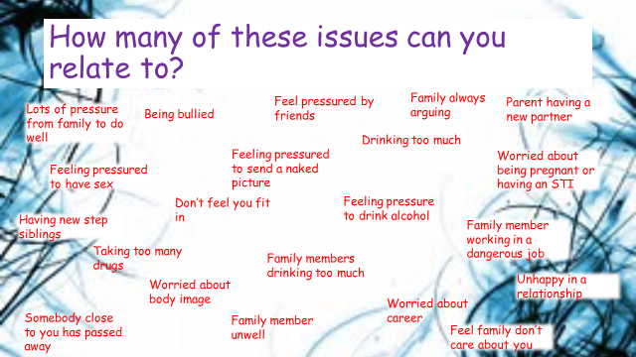
Circle the ones that do.

How would YOU define “stress”?
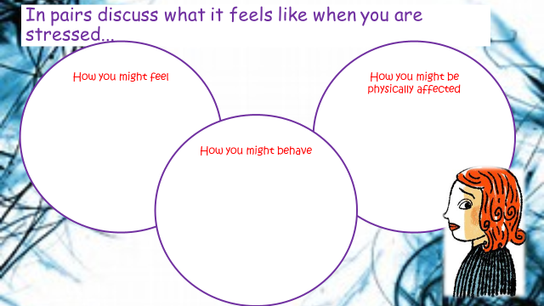

Write a brief account of a time when you were stressed. What happened? How did you feel? How did it affect you? How did you deal with it?

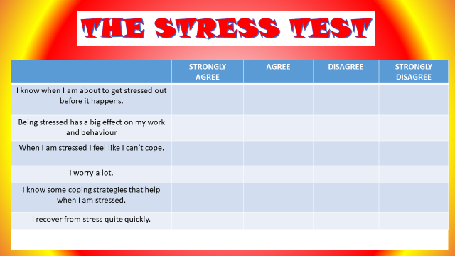

What do the results say about you?

COPING WITH STRESS

Meet up with friends | Walk the dog
Do exercise e.g. go running | Sort out the problem- talk to the person
Hit something | Go to a club regularly (eg: football/ swimming/cadets)
Have a little cry | Ignore it- it goes away eventually
Talk to friends and family | Watch a film
Read a book | Listen to music
Write my stresses down | Avoid the problems
Go over and over things in my head | Think about the bigger picture- things could be worse
Get a good night sleep | Get drunk
Do something creative | Make sure I’m eating healthily
Have a change of scenery | Forgive yourself- no one is perfect

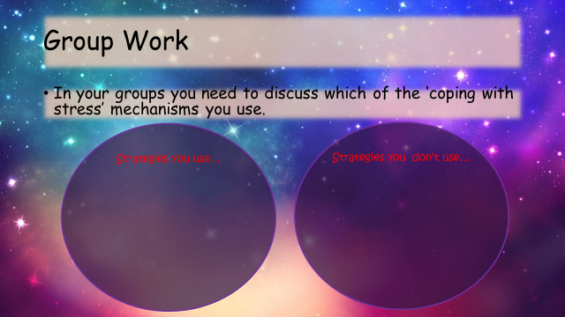

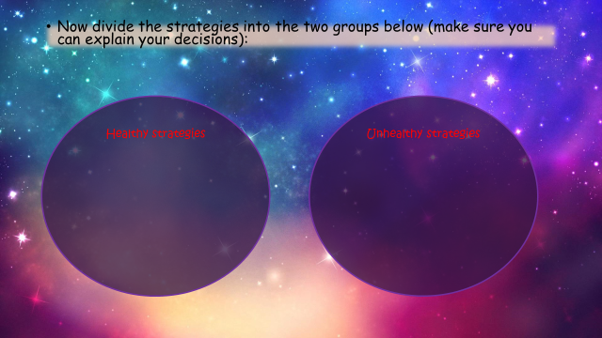

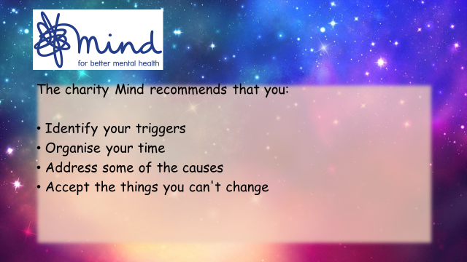

Mind Map

PROTECTED CHARACTERISTICS
 | ISSUE | T or F | SCORE | REASON
1 | AGE
2 | DISABILITY
3 | RELATIONSHIP  STATUS
4 | REFERENCES
5 | PREGNANCY
6 | RACE
7 | EXPERIENCE
8 | BELIEF
9 | APPEARANCE
10 | SEX

DECISION MAKING

GOOD DECISION MAKING METHOD | BAD DECISION MAKING METHOD

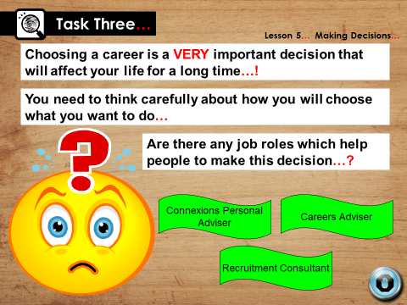
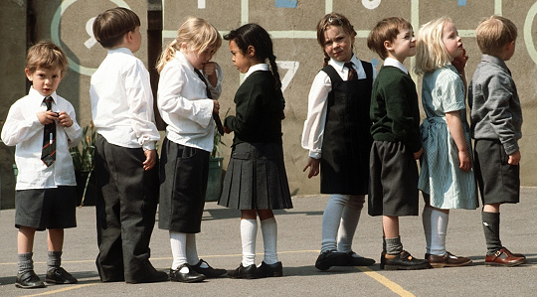

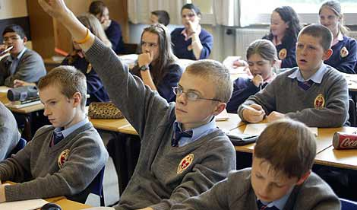

BELIEF/VALUE | STATEMENT

Ideas to help with your presentation…

My Skills | My Values
Jobs That Interest Me | My Hopes For The Future

TOP PUBLIC SECTOR EMPLOYERS IN THE UK
1
2
3
4
5
6
7
8
9
10
11

TOP PAYING COMPANIES IN THE UK
1
2
3
4
5
6
7
8
9
10

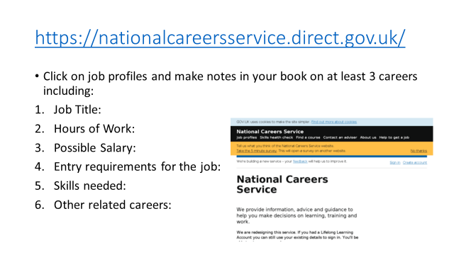

JOB + DETAILS | PLUS | MINUS | INTERESTING

