LESSON ONE – REMEMBERING THE RULES AND LAST YEAR’S CHALLENGES
Rules And Expectations For The PSHEE Classroom

1
2
3
4
5
6
7
8
9
10

LAST YEAR’S CHALLENGES…

Discuss in small groups. See how many you can come up with and write them into the table.
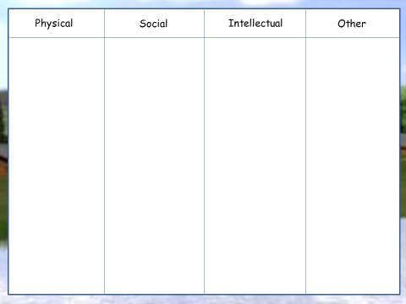
Dear New Year 7 Pupil,
(My letter of advice for new year 7s)
LESSON TWO – THE CHALLENGES AHEAD
Oh no! It’s Year 8!
Year Eight, I’m pretty sure, will not be great,
Just full of many more things that I hate.
And the more I think back to good old Year Seven
I have to admit even that was hardly heaven.
But things move on, and life gets tougher
The teachers get meaner and the work gets rougher
Is this poem right?
And I really don’t know how I’m going to cope.

I tried so hard last year – really I did!
From the moment I came here – a frightened kid,
In a new school with new systems and rules
We all made mistakes, and we all felt like fools.
But at least we were new, and had an excuse
How would you reply to the writer?
This year we’re not and we don’t – that’s the truth.
It can only get harder, and I feel there’s no hope.

THE TOP TEN OF TERROR

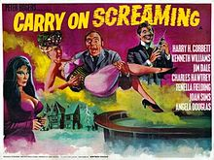

YEAR 8 NIGHTMARE SCENARIOS
 | What could happen? | How can it be avoided? | What do you do if it DOES happen?
1
2
3

ME 1 | ME 2

LESSON THREE AND FOUR – FIRST AID
ASTHMA

MINOR BLEEDING

COMMUNICATION &
CASUALTY CARE

COPING IN AN EMERGENCY

FAINTING

FIRST AID KIT

PRIMARY SURVEY

RECOVERY POSITION

ONCE YOU HAVE MADE NOTES, PAIR UP WITH A PARTNER.
TEST EACH OTHER ON WHAT YOU SHOULD DO IN EACH CASE. YOU NEED TO DO THIS IN ORDER TO PREPARE FOR THE SCENARIOUS.

WHEN DOING THE SCENARIOUS, LET’S HAVE SOME OSCAR-WORTHY ACTING!

LESSON FIVE – EMOTIONAL FIRST AID

 | Most Of The Time | Some Of The Time | Almost Never
- My feelings are easily hurt
- I get very upset if someone criticizes me, even if it is “constructive criticism.”

- I feel angry at myself if I make a mistake, even if it is an “honest mistake.”

- Instead of making decisions by myself, I usually ask other people what they think I should do.

- I usually go along with the group, even if I don’t really agree.

- I feel uncomfortable when someone gives me a compliment.

- I feel as if I don’t “measure up.” I never feel good enough.

- I frequently say negative things to myself, like telling myself I am stupid or fat or just no good
- I don’t like what I see when I look in the mirror. I feel I am very unattractive.

- I find myself apologizing for things a lot, even things that aren’t really my fault.

How did you score?

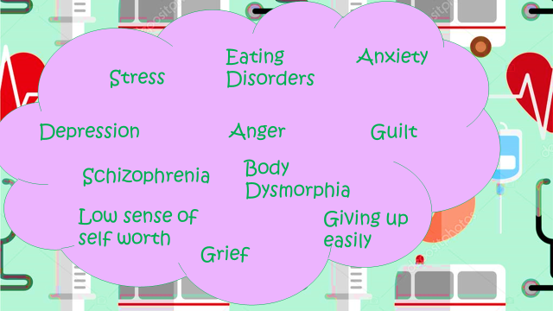
Things I’m good at | Things I’m not good at
LESSON SIX – EMOTIONAL FIRST AID POSTER FEEDBACK!

LESSON SEVEN – BONUS CAREERS LESSON!
Which of the public sector employers is of most interest to you?
Why?
What are positives and negatives of working in the public sector?

