LESSON ONE – PSHEE AT KINGSHILL
Rules And Expectations For The PSHEE Classroom

1
2
3
4
5
6
7
8
9
10

Q | ANSWER | SCORE
1
2
3
4
5
6
7
8
9
10
 | TOTAL
Welcome to Kingshill – here’s a quiz!
P
HAVE A GUESS!

________ __________ __________ __________ ___________ __________ __________ ,

S

___________ ____________ ____________ ___________ __________ ,
H

__________ ____________ ___________ ____________ ____________ &
E

__________ ___________ __________ __________ __________ __________ __________
EDUCATION

What are your memories of
PSHEE from your last school?
What did we learn today?

LESSON TWO – FOUR WELCOME TO KINGSHILL!
I SPY!
Where were the pictures taken?

1 | 2 | 3 | 4 | 5 | 6 | 7

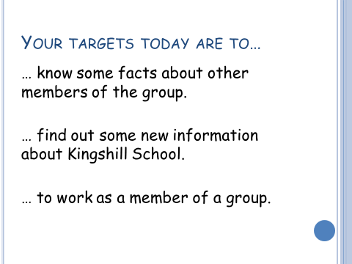

NAME
LIKES
DISLIKES
HOBBIES
ANY OTHER STUFF

CREATE YOUR OWN SCHOOL PROSPECTUS

Your school prospectus should be a four page document. It should include writing and pictures and should tell people who know nothing about Kingshill all about the school.
In particular, your group should focus on one of the following areas:

- The different types of academic work that students have to do in all their subjects.
- Try to find examples of the sorts of work you do in all your different subjects.
- Think about how each type of work helps you to become better and show this in your prospectus.
- Remember, you have to make everything about the school sound positive and helpful.
- Include the comments of at least one teacher, one member of the senior leadership team, one students and one parent.
- Try to think of the questions about the school that people will want to ask and provide the answers.

- The variety of extra-curricular activities that the school offers students.
- Try to find examples of the sorts of activities students can get involved in.
- Think about how these activities help you as a person and show this in your prospectus.
- Remember, you have to make everything about the school sound positive and helpful.
- Include the comments of at least one teacher, one member of the senior leadership team, one students and one parent.
- Try to think of the questions about the school that people will want to ask and provide the answers.

- The way the school ensures that ALL students, no matter who they are or what their needs are, are provided with equal access to education and extra-curricular activities. This is called INCLUSION.
- Try to find examples of the ways the school caters for people with special needs and requirements.
- Think about why it is important that everybody is included in all school activities.
- Remember, you have to make everything about the school sound positive and helpful.
- Include the comments of at least one teacher, one member of the senior leadership team, one students and one parent.
- Try to think of the questions about the school that people will want to ask and provide the answers.

- The rules and routines that students are expected to follow during their time at the school.
- Try to find examples of the school rules, expectations and day-to-day things like the school day and timings.
- Think about why it is important that a school has these rules and routines. How do they help students as individuals?
- Remember, you have to make everything about the school sound positive and helpful.
- Include the comments of at least one teacher, one member of the senior leadership team, one students and one parent.
- Try to think of the questions about the school that people will want to ask and provide the answers.

CREATE YOUR OWN SCHOOL PROSPECTUS
- THE SUCCESS CRITERIA –
Your finished Prospectus will be scored on the following three areas.
- Presentation
- Information And Accuracy
- Group Work
Scores will be awarded as follows:
PRESENTATION
 |  | SCORE
EXCELLENT WORK | The instructions have been followed. The work is extremely well put together and looks professional. It is colourful and glossy. | 4- 5 OUT OF 5
ADEQUATE WORK | The instructions have been followed. The finished prospectus is a bit messy or untidy in places. Large areas of blank space as opposed to colour. Some spelling errors. | 2-3  OUT OF 5
LESS THAN ADEQUATE WORK | Untidy work. It is unfinished or thin. The instructions have not been followed completely (eg only three pages, or no pictures). Too many mistakes. It looks rushed. | 0-1 OUT OF 5
 |  | SCORE
EXCELLENT WORK | The instructions have been followed. The work is accurate and correct. It is positive and provides reasons why what we do at Kingshill is helpful. It tells you more than you need to know. | 4- 5 OUT OF 5
ADEQUATE WORK | The instructions have been followed. It tells you everything you need to know. Reasons why the things we do at Kingshill are helpful are not always given. | 2-3  OUT OF 5
LESS THAN ADEQUATE WORK | It is unfinished or thin. The instructions have not been followed completely. It doesn’t really tell you a great deal about the things that happen at the school and why we do them. | 0-1 OUT OF 5
INFORMATION AND ACCURACY
GROUP WORK
 |  | SCORE
EXCELLENT WORK | The group has worked extremely well together. Everybody has made a fair contribution and a record has been made of who did what. | 4- 5 OUT OF 5
ADEQUATE WORK | The group has completed the work adequately and every member did something, although not everybody contributed a fair amount. | 2-3  OUT OF 5
LESS THAN ADEQUATE WORK | The group has been unable to work together effectively. Some members have been excluded, or have not produced work. Some members do not really know what they should have done. | 0-1 OUT OF 5

THE TOTAL SCORE IS OUT OF 15
LESSON FIVE – FINDING OUT ABOUT YOU
INTRODUCING THE BAND!

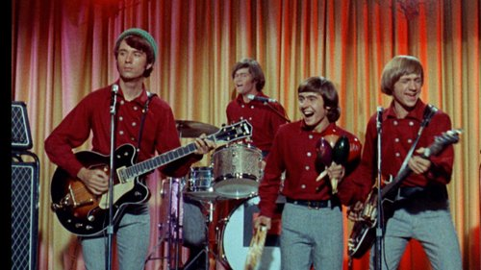
Image, characteristics, personalities, skills and attributes… | Image, characteristics, personalities, skills and attributes…

Now come up with your own “introducing the band” song for your group.

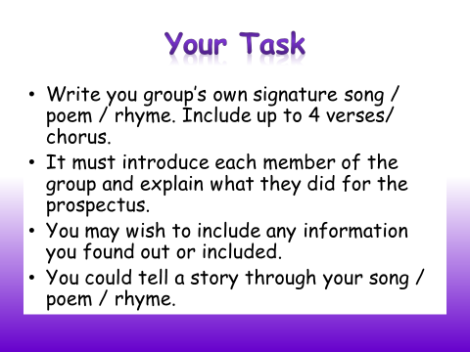

- Find out lots of information about each other first.
- Make sure the audience is clear about the sort of people you are.
- Have fun.
- Can you get your hands on any instruments? Everybody loves a tambourine….
LESSON SIX – THE PSHEEOVISION SONG CONTEST!
You have the first half of the lesson to finish writing your songs and to rehearse. During the second half of the lesson watch all the performances and learn about your classmates.

LESSON SEVEN – PUBERTY

It’s not just a change of school that you need to cope with, there are other changes going on too. You are changing physically, emotionally and mentally as you grow towards adulthood.

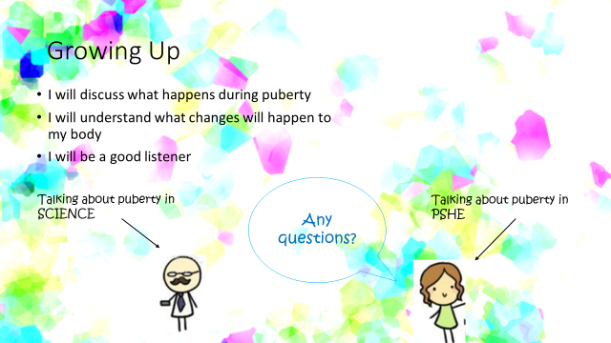

So what are the changes?
What are your concerns and questions?
Who can you talk to?

Boys And Girls

Q | ANSWER | SCORE
1
2
3
4
5
6
7
8
9
10
 | TOTAL
See if you can improve on your score – its the Kingshill quiz again!

