Sex & Relationships Education
Rules

1
2
3
4
5
6
7
8

Sex and The Law Quiz

1. It is illegal for a man to have sexual intercourse with a young woman under 16
years old.
TRUE 􀂆 FALSE 􀂆

2. It is illegal for a woman to have sexual intercourse with a young man under:
a) 13 years old
b) 16 years old
c) 18 years old
d) No specific age

3. If two 15-year-old girls have a sexual relationship they are breaking the law.
TRUE 􀂆 FALSE 􀂆

4. The age of consent for 2 men to have a sexual relationship is:
a) 21 years old
b) 18 years old
c) 16 years old
d) Still illegal

5. To get contraceptive advice a person needs to be:
a) 16 years old
b) 18 years old
c) 21 years old
d) Any age

6. Two people can get married or enter a same sex civil partnership at 16 years
of age if their parents / guardians agree.
TRUE 􀂆 FALSE 􀂆

7. In England and Wales two people can marry or enter a same sex civil
partnership even if their parents / guardians disagree at 17 years of age.
TRUE 􀂆 FALSE 􀂆

8. A woman will always get an abortion on request.
TRUE 􀂆 FALSE 􀂆

9. Abortion cannot take place after the 20th week of pregnancy.
TRUE 􀂆 FALSE 􀂆

10. Prostitution is illegal.
TRUE 􀂆 FALSE 􀂆

11. At what age can a woman be prescribed the pill?
a) 18 years old
b) 16 years old
c) 14 years old
d) Any age

12. To buy condoms a person needs to be:
a) 18 years old
b) 16 years old
c) 12 years old
d) Any age

13. It is illegal for schools and youth projects to talk to young people about
homosexuality.
TRUE 􀂆 FALSE 􀂆

14. Male rape is legal.
TRUE 􀂆 FALSE 􀂆

15. It is illegal for a man to rape his wife.
TRUE 􀂆 FALSE 􀂆

16. If a young woman under the age of consent asks for contraceptive advice her
parents / guardians will be told.
TRUE 􀂆 FALSE 􀂆

17. Parents and guardians have a legal right to withdraw their children from Sex
and Relationships Education.
TRUE 􀂆 FALSE 􀂆

18. It is illegal for a man to have sexual intercourse with a person they know is
their sister, mother, daughter, grand-mother or grand-daughter.
TRUE 􀂆 FALSE 􀂆

WRITE YOUR QUESTIONS ON
THE SLIPS OF PAPER. AT THE
END OF THE UNIT WE WILL GO
THROUGH THEM AND ANSWER
ANY WE ARE STILL UNSURE ABOUT.

What is a sexual relationship?

What is sex?

What are the different types of sexual activity?

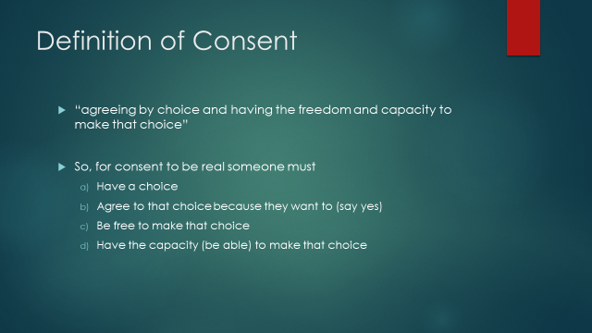

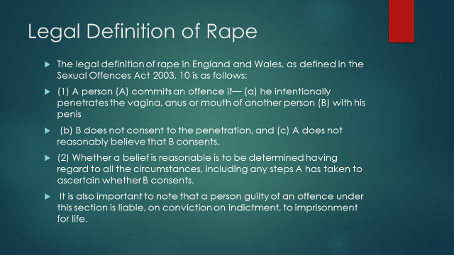

What have you learned from the video diaries?

Notes, ideas, scribbles, thoughts and doodles

Notes, ideas, scribbles, thoughts and doodles

CONTRACEPTION

NAME | TYPE/HOW IT WORKS | 3 STAR RATING  1 = GOOD AT PREVENTING PREGNANCY  2 = EXTREMELY GOOD AT PREVENTING PREGNANCY  3 = EXTREMELY GOOD AT PREVENTING SEXUALLY SHARED INFECTIONS
 |  | 1 | 2 | 3
a)

b)

c)

d)

e)

f)

g)

h)

i)

j)

k)

l)

