YEAR EIGHT LESSON ONE

FAMILY QUIZ

- You have to attend a family dinner on a Saturday night. Would you?

  - Refuse. Saturday nights are meant for parties
  - Agree. It is okay to have a quiet Saturday night once in a while for family
- Do you know what each of your family member is doing in terms of school, work and personal life at the moment?

  - Vaguely
  - Yes. You are generally up-to-date on the lives of all your family members
- How often do you meet or speak to your family?

  - Rarely. You hardly get time from your busy schedule
  - Very often. You like to keep in touch with your family members
- Members of your family are having a fight. You

  - Let them continue fighting. It's their life and they will deal with their own problems
  - Try to intervene and play peacemaker
- Do you get along well with all your siblings?

  - Only with the ones who like your favourite band
  - Absolutely. Your siblings are your support system
- You've suddenly noticed that your father has started working overtime even during weekends. What do you do?

  - Nothing. Your father can decide for himself how much he wants to work
  - Talk to him out of concern to check if he is facing any financial troubles or any other issues
- Your best and most favourite childhood memories involve

  - Carefree times with your friends
  - Loving moments spent with family members
- You recently had a major breakup with your partner. Whom do you speak to for emotional comfort?

  - Your friends, of course
  - One of your close family members who knows everything about you
- Do your friends know all about your family?

  - No. You strictly keep your family matters away from your friends
  - Yes. You tend to mention your family in casual conversations to your friends very often
Notes, ideas, scribbles, thoughts and doodles
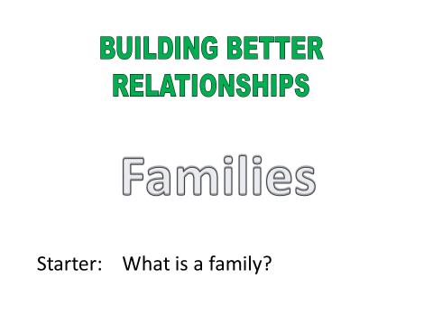
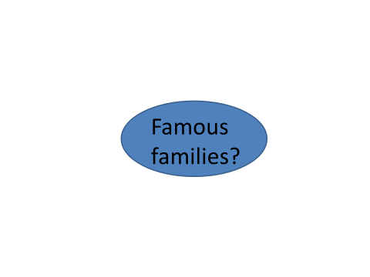

TYPES OF FAMILIES

Nuclear
Single Parent
Reconstituted
Extended

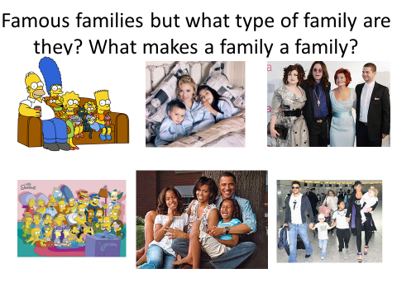
Notes, ideas, scribbles, thoughts and doodles
BATTLE OF THE FAMILIES

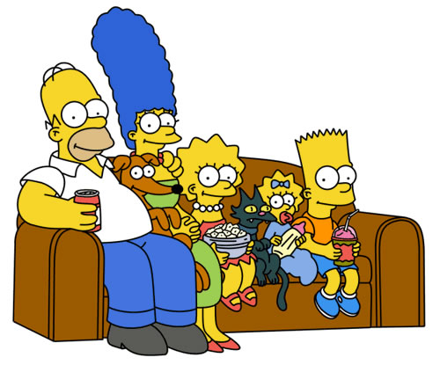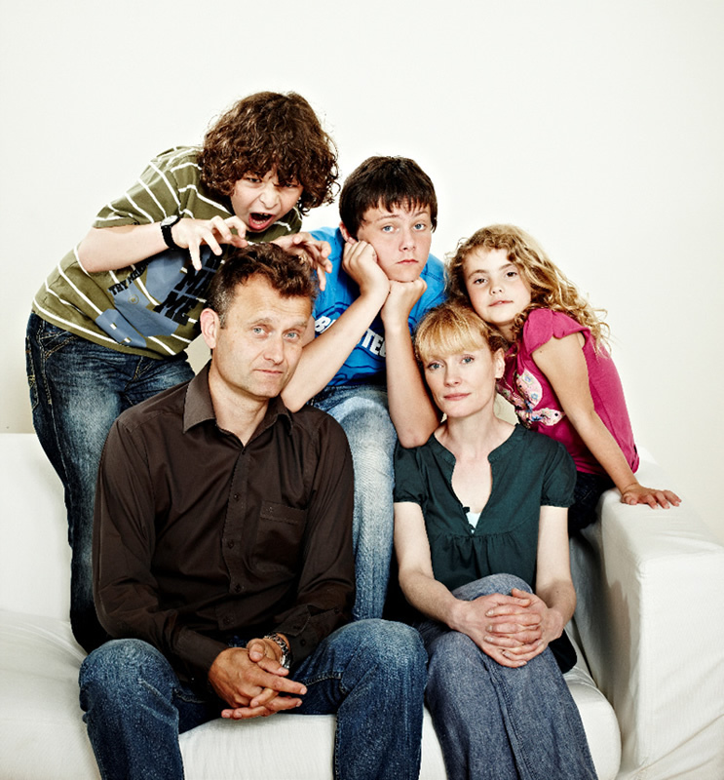
V

Notes, ideas, scribbles, thoughts and doodles
Notes, ideas, scribbles, thoughts and doodles

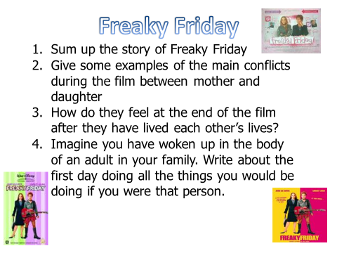

Notes, ideas, scribbles, thoughts and doodles
Notes, ideas, scribbles, thoughts and doodles

