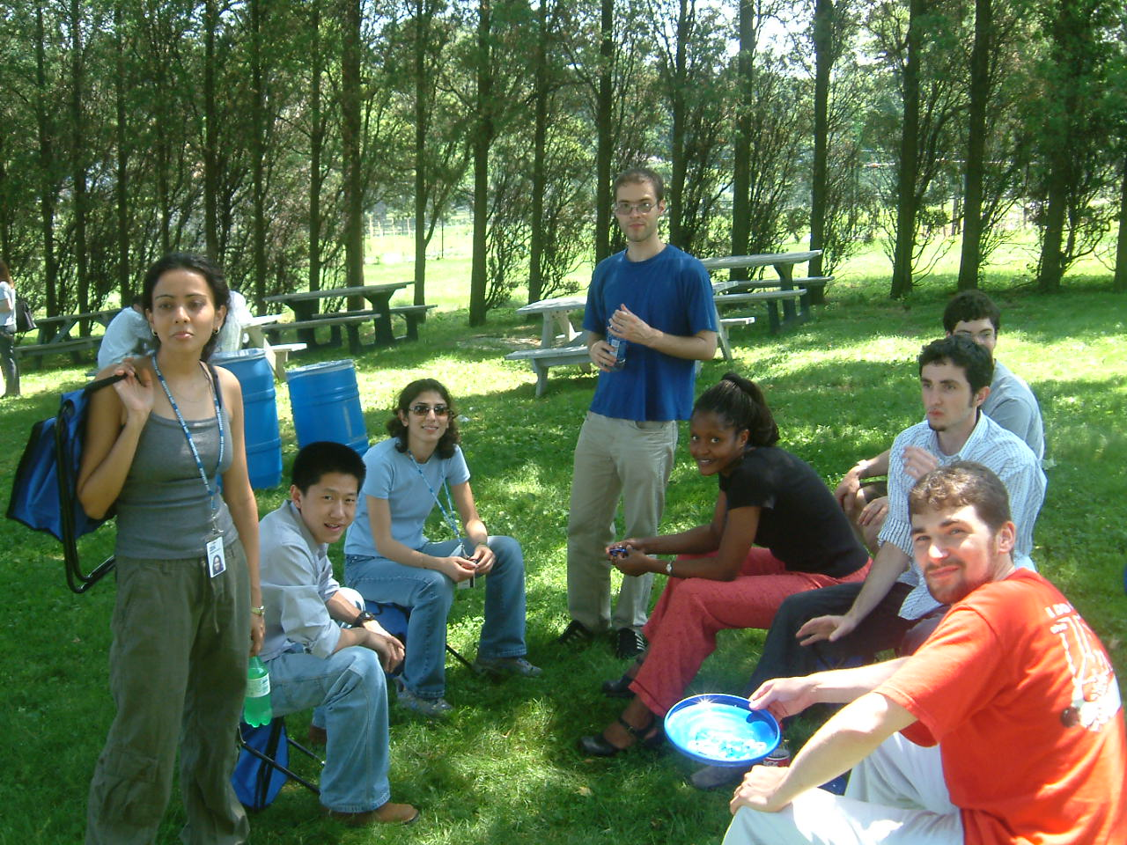

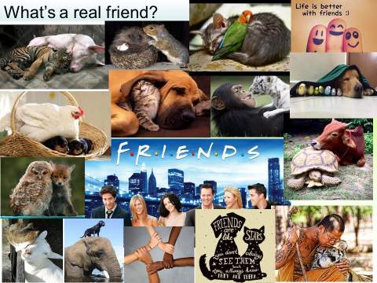

Notes, ideas, scribbles, thoughts and doodles

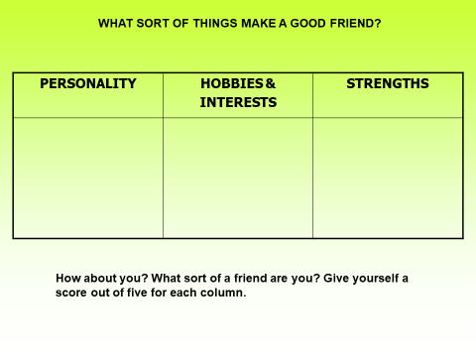CASE STUDIES
) My best friends are Lucy and Sinead. We are in the same year at school together and we all like doing the same sort of things. The problem is that Lucy and Sinead don’t get on. They can’t do anything together and neither of them likes the other being with me. If I spend time with Lucy, Sinead doesn’t like it and if I spend time with Sinead, Lucy doesn’t like it. My birthday is coming up and I really want to invite both of them round, but I don’t want them to spoil my party. I don’t know what to do.
YOUR ADVICE

My best friend is called Kelvin. I’ve known him since we were about six and we’ve always been close because our parents are good friends. They always see each other, even on holiday, so I always get to see a lot of Kelvin. The thing is, though, sometimes it feels like he is still six and I am twelve. He can be very immature and he still likes playing the sort of games we played years ago. He’s not into sport or music or computer games. I’m not really into computer games but at least we could do something like that together without it feeling stupid. But he won’t. I’m going off him a lot and my other friends are all very different. But I know it would upset my parents and his parents if I said anything. I don’t know what to do.
YOUR ADVICE

I’m Stacey and I have a bit of problem because my best friend Kerri and I both really fancy the same guy. His name is Kal and he is pretty amazing. And I think he likes me more than he likes Kerri. But I don’t know what to do because she really really likes him and I don’t want to hurt her feelings. But I don’t want to her to be with him and not me.
YOUR ADVICE

I’ve been good mates with Joe and Charlie for nearly a year. We have a real laugh together. But there’s this new lad who is friends with them and I don’t like him. He tells racist jokes and says things that are completely out of order. My dad is West Indian and when I told him he just laughed. I don’t know what to do because Joe and Charlie like him and want to stay friends with him.
YOUR ADVICE

I don’t know why, but I can’t make friends. I spend a lot of time on my own, at school and at home. I think there must be something wrong with me. I want to have friends, but nobody really wants to know. I join clubs and groups – even ones I don’t like doing – so that I can get to know people, but they usually just have their own friends already. I wish I could make some friends but I don’t know how to do it.
YOUR ADVICE

Notes, ideas, scribbles, thoughts and doodles

THE "HOW GOOD A FRIEND
ARE YOU?"
QUIZ

YEAR 7 FRIENDSHIP TEST (LESSON 1)

- How do you initiate friendship with a totally new person?

  - Begin with a smile.
  - Introduce yourself.
  - Find a mutual acquaintance to do the introduction.
- How easily do you connect with new people?

  - Very easily.
  - On most occasions, easily.
  - Barely, if ever.
- What do you do on weekends and holidays?

  - Meet new friends you made recently.
  - You call a few good friends at home.
  - You spend it with family, if not alone.
- What do you do at a good party?

  - Meet new people, make new friends, have a great time.
  - Mostly stick with your old group of friends, but meet new people if you can.
  - Keep to yourself most of the time, watching the action.
- What do your friends say about you?

  - Totally outgoing, extrovert.
  - Pleasant to be with.
  - Don't know.
- How many people in your neighbourhood know you?

  - All of them.
  - Most of them.
  - Just a few.
- Once you make a new friend, do you take initiatives to develop the friendship?

  - Yes, I always call him/her the next day.
  - I wait for a few days, and then call if he/she doesn't call up.
  - If the person wants to be friends with me, he/she will call me up.
TOTAL = 21

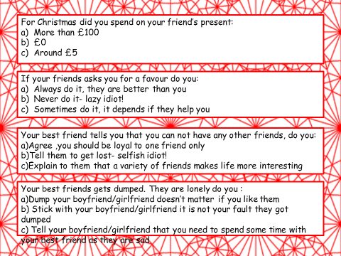

Notes, ideas, scribbles, thoughts and doodles

ME AND MY FRIEND
(Use these statements to help you write a story about friendship).

- We look out for each other.
- We are honest with each other.
- We have some shared likes and dislikes.
- I am there for him/her.
- S/he is there for me.
- S/he knows when I need my own space.
- We make each other laugh.
- We make each other feel better about ourselves.
- S/he always seems to know what I am thinking.
- I give him/her good advice.
- We trust each other.
- We don’t always agree but we know that doesn’t matter.

Notes, ideas, scribbles, thoughts and doodles

Notes, ideas, scribbles, thoughts and doodles

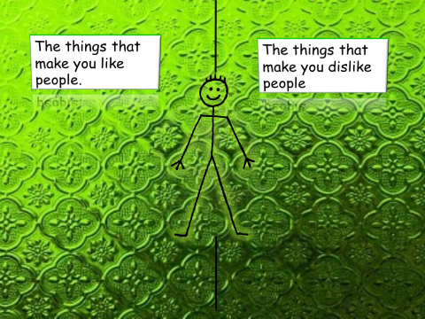
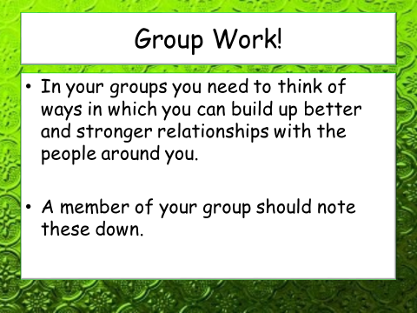

Network of friends

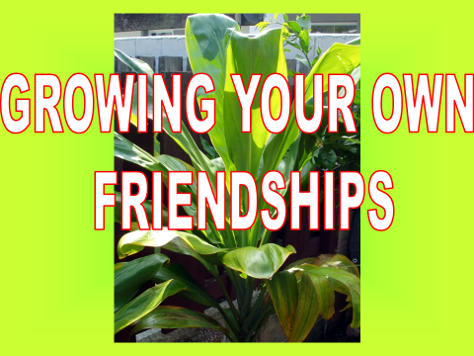
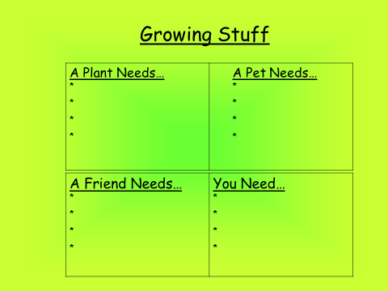

INGREDIENTS  (What sort of things will help your friendship to grow and develop?) | ACTIONS  (What do you need to do in order to keep your friendship growing?)
TIME  (How long does it take? Why? What are the reasons?) | HELP!  (If it starts going wrong, where can you get help? What sort of things do you need to do?)

Mountain High School
Rob
Rob is in Stephanie’s tutor group at school. He likes school most of the time and he has a small, close group of friends. Rob works pretty hard in lessons but is quite quiet so he doesn’t like to answer too many questions in front of the class.

Rob doesn’t like being mean to others and thinks that you should be fair. Recently he has noticed this girl called Stephanie being bullied in his tutor group. He has heard some rumours about people sending messages about her and has seen Max and his friends being horrible to her.

One day in tutor Rob saw Max take Stephanie’s bag and hide it for ages. Max was laughing at Stephanie and kept pointing at her when she started to cry. Rob felt pretty sad for Stephanie so when he got home he spoke to his mum about it. She said that letting something happen was as bad as causing it to happen in the first place so Rob decided to take action.
Masie
Masie is 12 years old. She is in Year 8 at Mountain High School. When Masie started school she was a pretty shy person as she only knew a few other people from her primary school.

Masie now enjoys school because she likes meeting up with her friends and she also lies most of her lessons. She hangs around with quite a big group and afterschool they always message.

Recently a few messages have been sent about a girl called Stephanie. Masie thought some them were funny so she passed them on. After she sent them to other people she did feel a bit bad though because the stuff that was written about Stephanie was pretty mean.

Masie has seen Stephanie been called horrible names at school by Max. She thinks Max is okay but he can go too far sometimes although she would never stop him.

Max

Max is 12 and in Year 8 at Mountain High School. He lives with his Dad, Mark, and his older brother Danny.

Max’s mum left the family for another boyfriend when Max was 2 Years old. Since then Max has been brought up by his Dad. His Dad has tried his best but is struggling with depression. Max’s home often feels sad and his older brother is always ‘play fighting’ with him. In fact, Max’s brother is pretty horrible to him.

Max used to like school but he doesn’t so much anymore so to help him get through the day he likes to have a bit of fun. He sometimes messes around in lessons or jokes around with his friends. There is a girl called Stephanie at the school that is a bit of a loner. He finds it funny to take her bag and hide it. He thinks it is hilarious when everyone else joins in laughing at Stephanie- especially when she cries!

A couple of times he did push Stephanie and threaten to punch her.
Stephanie

Stephanie is 13 years old. She has been going to Mountain High School for 2 years and is in Year 8.

Stephanie went to 4 different primary schools because her Mum kept running out of money so they had to move house.

As Stephanie’s mum doesn’t have a lot of money Stephanie doesn’t have a phone and the other kids think this is strange.

Most of the students at Stephanie’s school aren’t horrible to her but they don’t really notice her. She gets ignored. Not many ask her how she is or what she likes doing.

There is a few students at the school who are horrible to her; one of those is Max. Max often calls her names and laughs at her clothes. He has started nasty rumours about her on a few occasions. He always takes her bag and hides it and then laughs when she can’t find it.

