Year 11 Spanish TERM 1: Lessons Outline

- Pupils have 2 lessons of Spanish a week (one single and one double).
- Pupils have been given their own copy of the GCSE Viva textbook they also have access to online resources to accompany the textbook https://pearsonactivelearn.com/
- If absent, pupils should read through the vocabulary for that section of the book (found on p136-137 or p158-158 and also in the pupil work area) and then work through all of the exercises (with the exception of the listening tasks). Pupils should copy the relevant vocabulary in to their folders and learn it. If pupils do NOT have their textbooks at home they should watch recorded lessons on the Oak National Academy website and make notes:
https://classroom.thenational.academy/units/special-events-4ac7
Pupils should do any of the lessons from the KS4 Spanish ‘Special events’ section.
- Pupils can also work on their GCSE speaking questions which are on the next page.
or use the Linguascope or Quizlet websites for extension work.
- Homework will be set on Satchel One

Week Beginning | Work set  (Viva GCSE- Chapters 6+7) | Link to pages in textbook  or alternative activity
5th September | Punto de partida  Talking about typical foods and meals of the day  Body parts and doctor's advice | P116-119  Or Oak National Academy lessons –  KS4 Spanish, ‘Special Events’ topic.  Follow the link in blue above to the website
12th September | Sabores del mundo  Talking about routine.  Spotting words which indicate an increase/ decrease | Pages 120-121  Or Oak National Academy lessons –  KS4 Spanish, ‘Special Events’ topic.  Follow the link in blue above to the website
19th September | De fiesta+ el festival de música  Focussing on reading for festivals in different countries and traditions | Pages 122-123  Pages 128-129  Or Oak National Academy lessons –  KS4 Spanish, ‘Special Events’ topic.  Follow the link in blue above to the website
26th September | Punto de partida+  ¿Qué haces para ganar dinero?  Talking about different jobs / discussing job preferences | Pages 138-141  Or Oak National Academy lessons –  KS4 Spanish, ‘Special Events’ topic.  Follow the link in blue above to the website
3rd October | Mis prácticas laborales+  ¿Por qué aprender idiomas?  Talking about work experience  Talking about the importance of languages | Pages 142-145  Or Oak National Academy lessons –  KS4 Spanish, ‘Special Events’ topic.  Follow the link in blue above to the website
10th October | Roleplay  and photocard focus week | Choose some of the tasks from the ‘Kate’s languages role-play and photocard booklets’ which are in the pupil work area.
17th October | Conversation focus week  Focus on learning the answers to your general conversation questions in preparation for the speaking exam next term.

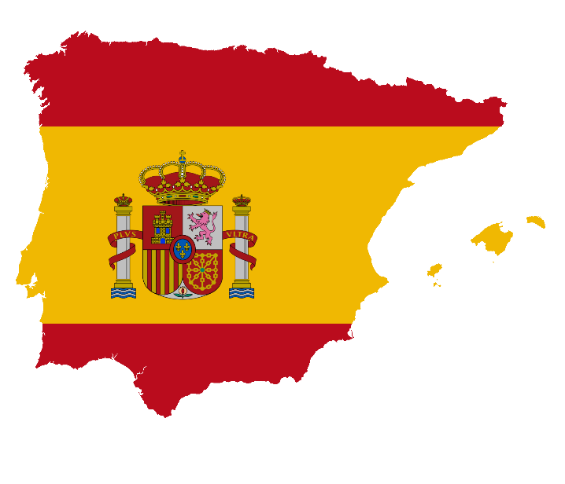

GCSE Spanish Speaking Booklet

Theme 1 Module 3 – Me, my family and friends; Technology in everyday life
- ¿Cómo es tu mejor amigo/a descríbelo/a:
……………………………………………………………………………………………………………………………………………………………………………………………………………………………………………………………………………………………………………………………………………………………………………………………………………………………………………………………………………………………………………………
- ¿Qué planes tienes para el futuro en tu vida personal?
……………………………………………………………………………………………………………………………………………………………………………………………………………………………………………………………………………………………………………………………………………………………………………………………………………………………………………………………………………………………………………………
- ¿Cómo usaste las redes sociales el fin de semana pasado?
……………………………………………………………………………………………………………………………………………………………………………………………………………………………………………………………………………………………………………………………………………………………………………………………………………………………………………………………………………………………………………………
- ¿Te llevas bien con tu familia? ¿Por qué (no)?
……………………………………………………………………………………………………………………………………………………………………………………………………………………………………………………………………………………………………………………………………………………………………………………………………………………………………………………………………………………………………………………
……………………………………………………………………………………………………………………………………………………………………………………………………………………………………………………………………………………………………………………………………………………………………………………………………………………………………………………………………………………………………………………

Module 4 – Free-time activities (music, cinema and TV, sport)
- ¿Qué sueles hacer en tus ratos libres?
……………………………………………………………………………………………………………………………………………………………………………………………………………………………………………………………………………………………………………………………………………………………………………………………………………………………………………………………………………………………………………………
- ¿Qué película viste la semana pasada? Descríbela
……………………………………………………………………………………………………………………………………………………………………………………………………………………………………………………………………………………………………………………………………………………………………………………………………………………………………………………………………………………………………………………
- Háblame de un concierto al que vas a ir en el futuro.
……………………………………………………………………………………………………………………………………………………………………………………………………………………………………………………………………………………………………………………………………………………………………………………………………………………………………………………………………………………………………………
- ¿Qué deportes te gustaría practicar en el fututo? ¿Por qué?
……………………………………………………………………………………………………………………………………………………………………………………………………………………………………………………………………………………………………………………………………………………………………………………………………………………………………………………………………………………………………………………
- ¿Qué deportes solías practicar cuando eras niño/a?
……………………………………………………………………………………………………………………………………………………………………………………………………………………………………………………………………………………………………………………………………………………………………………………………………………………………………………………………………………………………………………………

Module 6 –Festivals and celebrations- Food and eating out
- ¿Qué te gusta comer? ¿Qué no te gusta comer ¿Por qué?
……………………………………………………………………………………………………………………………………………………………………………………………………………………………………………………………………………………………………………………………………………………………………………………………………………………………………………………………………………………………………………………

- Háblame de una mala visita a un restaurante en el pasado
……………………………………………………………………………………………………………………………………………………………………………………………………………………………………………………………………………………………………………………………………………………………………………………………………………………………………………………………………………………………………………………
- ¿Por qué son importantes las celebraciones tradicionales?
……………………………………………………………………………………………………………………………………………………………………………………………………………………………………………………………………………………………………………………………………………………………………………………………………………………………………………………………………………………………………………………
- Háblame de una fiesta o celebración a la que te gustaría ir en el futuro y por qué
……………………………………………………………………………………………………………………………………………………………………………………………………………………………………………………………………………………………………………………………………………………………………………………………………………………………………………………………………………………………………………………

Theme 2
Module 1 – Holidays
- ¿Qué haces en tus vacaciones normalmente?
……………………………………………………………………………………………………………………………………………………………………………………………………………………………………………………………………………………………………………………………………………………………………………………………………………………………………………………………………………………………………………………
- ¿Adónde fuiste de vacaciones el año pasado?
……………………………………………………………………………………………………………………………………………………………………………………………………………………………………………………………………………………………………………………………………………………………………………………………………………………………………………………………………………………………………………………

- ¿Adónde te gustaría ir de vacaciones el año próximo?
……………………………………………………………………………………………………………………………………………………………………………………………………………………………………………………………………………………………………………………………………………………………………………………………………………………………………………………………………………………………………………………
- ¿Cuáles serían tus vacaciones ideales? Descríbelas
……………………………………………………………………………………………………………………………………………………………………………………………………………………………………………………………………………………………………………………………………………………………………………………………………………………………………………………………………………………………………………………

Module 5 – Home, town, neighbourhood and region
- Describe la ciudad o el pueblo dónde vives
……………………………………………………………………………………………………………………………………………………………………………………………………………………………………………………………………………………………………………………………………………………………………………………………………………………………………………………………………………………………………………………
- ¿Qué cosas cambiarías de tu ciudad? ¿Por qué?
……………………………………………………………………………………………………………………………………………………………………………………………………………………………………………………………………………………………………………………………………………………………………………………………………………………………………………………………………………………………………………………

- ¿Cuál es la ciudad más bonita que has visitado en el Reino Unido? ¿Por qué?
……………………………………………………………………………………………………………………………………………………………………………………………………………………………………………………………………………………………………………………………………………………………………………………………………………………………………………………………………………………………………………………
- ¿A dónde te gustaría vivir en el futuro? ¿Por qué?
……………………………………………………………………………………………………………………………………………………………………………………………………………………………………………………………………………………………………………………………………………………………………………………………………………………………………………………………………………………………………………………

Module 8 – Home and global issues- El medio ambiente
- ¿Cómo te vas a mantener saludable en el futuro?
……………………………………………………………………………………………………………………………………………………………………………………………………………………………………………………………………………………………………………………………………………………………………………………………………………………………………………………………………………………………………………………
- ¿Qué haces en casa para proteger el medio ambiente?
……………………………………………………………………………………………………………………………………………………………………………………………………………………………………………………………………………………………………………………………………………………………………………………………………………………………………………………………………………………………………………………
- En tu opinión: ¿Cuáles son los problemas globales más serios hoy en día?
……………………………………………………………………………………………………………………………………………………………………………………………………………………………………………………………………………………………………………………………………………………………………………………………………………………………………………………………………………………………………………………
- ¿Qué hiciste para proteger al medio ambiente el mes pasado?
……………………………………………………………………………………………………………………………………………………………………………………………………………………………………………………………………………………………………………………………………………………………………………………………………………………………………………………………………………………………………………………

Theme 3 Module 2 – My studies; Life at school/college
- Describe tu instituto y sus instalaciones
……………………………………………………………………………………………………………………………………………………………………………………………………………………………………………………………………………………………………………………………………………………………………………………………………………………………………………………………………………………………………………………
- ¿Qué asignaturas te gustan y no te gustan? ¿Por qué?
……………………………………………………………………………………………………………………………………………………………………………………………………………………………………………………………………………………………………………………………………………………………………………………………………………………………………………………………………………………………………………………
- ¿Cómo era tu escuela primaria?
……………………………………………………………………………………………………………………………………………………………………………………………………………………………………………………………………………………………………………………………………………………………………………………………………………………………………………………………………………………………………………………
- Describe un viaje escolar que vas a hacer con tu escuela en el futuro
……………………………………………………………………………………………………………………………………………………………………………………………………………………………………………………………………………………………………………………………………………………………………………………………………………………………………………………………………………………………………………………

Module 7 – Education post-16; jobs, career choices and ambitions
- ¿Dónde hiciste tus prácticas laborales?
……………………………………………………………………………………………………………………………………………………………………………………………………………………………………………………………………………………………………………………………………………………………………………………………………………………………………………………………………………………………………………………
- ¿Qué planes tienes para seguir estudiando en el futuro?
……………………………………………………………………………………………………………………………………………………………………………………………………………………………………………………………………………………………………………………………………………………………………………………………………………………………………………………………………………………………………………………
- ¿En qué te gustaría trabajar en el futuro? ¿Por qué?
……………………………………………………………………………………………………………………………………………………………………………………………………………………………………………………………………………………………………………………………………………………………………………………………………………………………………………………………………………………………………………………

- ¿Qué otras ambiciones tienes para el futuro?
……………………………………………………………………………………………………………………………………………………………………………………………………………………………………………………………………………………………………………………………………………………………………………………………………………………………………………………………………………………………………………………

