Year 11 Spanish TERM 5: Lessons Outline

- Pupils have 2 lessons of Spanish a week (one single and one double).
- Pupils have been given their own copy of the GCSE Viva textbook they also have access to online resources to accompany the textbook https://pearsonactivelearn.com/
- For extension they could also look at lessons on BBC Bitesize or Oak Academy where there are a range of topic areas to extend their learning. Pupils can also use the Linguascope or Quizlet websites.
AQA GCSE Spanish | Quizlet
- Homework will be set on Show my Homework.

PUPILS SHOULD ALSO BE LEARNING THE ANSWERS TO THEIR SPEAKING QUESTIONS OFF BY HEART READY FOR THEIR SPEAKING EXAM DURING 1st/2nd WEEK OF TERM. THE QUESTIONS ARE BELOW THIS WEEKLY PLAN AND SPEAKING BOOKLETS ARE IN THE PUPIL WORK AREA FOR ROLEPLAY AND PHOTOCARD PRACTICE.

Week | Work Set  (Viva GCSE- Starting to revise previous modules) | Link to pages in On- line textbook where possible  Or alternative activity
Week 1 | Speaking focus week and speaking exams  Roleplay, photocard and general conversation work. | Speaking question booklets (questions are on the next page too).  Photo card and roleplay booklets are in the pupil work section.
Week 2 | Speaking focus week and speaking exams  Roleplay, photocard and general conversation work.  Vocabulary revision for those who have completed their speaking exam | Speaking question booklets (questions are on the next page too).  Photo card and roleplay booklets are in the pupil work section.  Pupils have been given a vocabulary revision book or can contact Mrs Leiva if they have misplaced it. They can also revise from their textbook or follow the Quizlet link above.
Week 3 | Vocabulary revision chapters 1-4 of textbook | Use textbook, revision flashcards,and the quizlet link above
Week 4 | Vocabulary revision chapters 5-8 of textbook | Use textbook, revision flashcards,and the quizlet link above.
Week 5 | Writing focus week | Contact your teacher for resources.

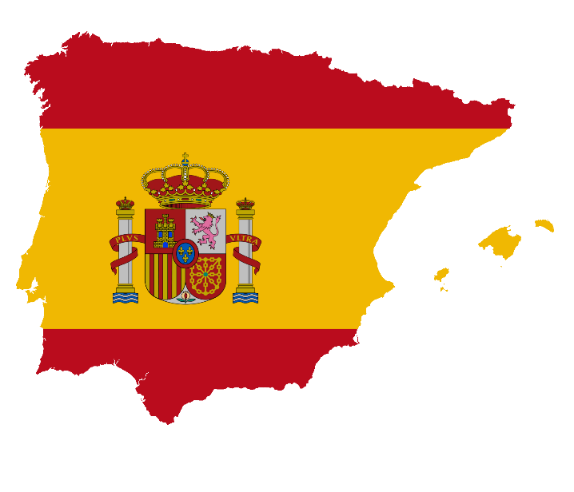

GCSE Spanish Speaking Booklet

Theme 1
Module 3 – Me, my family and friends; Technology in everyday life
¿Describe a un buen amigo tuyo/una buena amiga tuya.
……………………………………………………………………………………………………………………………………………………………………………………………………………………………………………………………………………………………………………………………………………………………………………………………………………………………………………………………………………………………………………………
¿Qué aplicaciones usas para estar en contacto con tus amigos y con tu familia?
……………………………………………………………………………………………………………………………………………………………………………………………………………………………………………………………………………………………………………………………………………………………………………………………………………………………………………………………………………………………………………………
¿Qué piensas de las redes sociales?
……………………………………………………………………………………………………………………………………………………………………………………………………………………………………………………………………………………………………………………………………………………………………………………………………………………………………………………………………………………………………………………
¿Te llevas bien con tu familia? ¿Por qué (no)?
……………………………………………………………………………………………………………………………………………………………………………………………………………………………………………………………………………………………………………………………………………………………………………………………………………………………………………………………………………………………………………………

¿Qué planes tienes con tus amigos o con tu familia este fin de semana?
……………………………………………………………………………………………………………………………………………………………………………………………………………………………………………………………………………………………………………………………………………………………………………………………………………………………………………………………………………………………………………………

Module 4 – Free-time activities (music, cinema and TV, sport)
¿Qué sueles hacer en tus ratos libres?
……………………………………………………………………………………………………………………………………………………………………………………………………………………………………………………………………………………………………………………………………………………………………………………………………………………………………………………………………………………………………………………
¿Prefieres ver películas en casa o en el cine? ¿Por qué?
……………………………………………………………………………………………………………………………………………………………………………………………………………………………………………………………………………………………………………………………………………………………………………………………………………………………………………………………………………………………………………………
¿Te gusta la música? ¿Por qué (no)?
……………………………………………………………………………………………………………………………………………………………………………………………………………………………………………………………………………………………………………………………………………………………………………………………………………………………………………………………………………………………………………………
Háblame de la última vez que participaste en un deporte.
……………………………………………………………………………………………………………………………………………………………………………………………………………………………………………………………………………………………………………………………………………………………………………………………………………………………………………………………………………………………………………………
¿Quién es tu modelo a seguir?
……………………………………………………………………………………………………………………………………………………………………………………………………………………………………………………………………………………………………………………………………………………………………………………………………………………………………………………………………………………………………………………

Module 6 – Customs and festivals in Spanish-speaking countries; Free-time activities (food and eating out)
¿Qué te gusta comer? ¿Por qué?
……………………………………………………………………………………………………………………………………………………………………………………………………………………………………………………………………………………………………………………………………………………………………………………………………………………………………………………………………………………………………………………

¿Prefieres cenar en casa o en un restaurante? ¿Por qué?
……………………………………………………………………………………………………………………………………………………………………………………………………………………………………………………………………………………………………………………………………………………………………………………………………………………………………………………………………………………………………………………
¿Has asistido a un festival de música? ¿Puedes describirlo?
……………………………………………………………………………………………………………………………………………………………………………………………………………………………………………………………………………………………………………………………………………………………………………………………………………………………………………………………………………………………………………………
¿Crees que las fiestas tradicionales son importantes? ¿Por qué (no)?
……………………………………………………………………………………………………………………………………………………………………………………………………………………………………………………………………………………………………………………………………………………………………………………………………………………………………………………………………………………………………………………
Háblame de una fiesta a la que te gustaría asistir.
……………………………………………………………………………………………………………………………………………………………………………………………………………………………………………………………………………………………………………………………………………………………………………………………………………………………………………………………………………………………………………………

Theme 2
Module 1 – Travel and tourism
¿Por qué son importantes las vacaciones?
……………………………………………………………………………………………………………………………………………………………………………………………………………………………………………………………………………………………………………………………………………………………………………………………………………………………………………………………………………………………………………………
¿Adónde fuiste de vacaciones el año pasado?
……………………………………………………………………………………………………………………………………………………………………………………………………………………………………………………………………………………………………………………………………………………………………………………………………………………………………………………………………………………………………………………
¿Dónde te alojaste?
……………………………………………………………………………………………………………………………………………………………………………………………………………………………………………………………………………………………………………………………………………………………………………………………………………………………………………………………………………………………………………………
¿Qué fue lo mejor de tus vacaciones?
……………………………………………………………………………………………………………………………………………………………………………………………………………………………………………………………………………………………………………………………………………………………………………………………………………………………………………………………………………………………………………………
¿Qué planes tienes para el próximo verano?
……………………………………………………………………………………………………………………………………………………………………………………………………………………………………………………………………………………………………………………………………………………………………………………………………………………………………………………………………………………………………………………

Module 5 – Home, town, neighbourhood and region
¿Cómo es la ciudad o el pueblo donde vives?
……………………………………………………………………………………………………………………………………………………………………………………………………………………………………………………………………………………………………………………………………………………………………………………………………………………………………………………………………………………………………………………
¿Cuál es tu ciudad favorita? ¿Por qué?
……………………………………………………………………………………………………………………………………………………………………………………………………………………………………………………………………………………………………………………………………………………………………………………………………………………………………………………………………………………………………………………
¿Qué es mejor, vivir en la ciudad o en el campo?
……………………………………………………………………………………………………………………………………………………………………………………………………………………………………………………………………………………………………………………………………………………………………………………………………………………………………………………………………………………………………………………
¿Qué hay para turistas en tu zona? ¿Qué se puede hacer?
……………………………………………………………………………………………………………………………………………………………………………………………………………………………………………………………………………………………………………………………………………………………………………………………………………………………………………………………………………………………………………………
¿Cómo cambiarías tu zona?
……………………………………………………………………………………………………………………………………………………………………………………………………………………………………………………………………………………………………………………………………………………………………………………………………………………………………………………………………………………………………………………

Module 8 – Home; social issues; global issues
¿Cómo te puedes mantener en forma?
……………………………………………………………………………………………………………………………………………………………………………………………………………………………………………………………………………………………………………………………………………………………………………………………………………………………………………………………………………………………………………………
¿Qué opinas de fumar?
……………………………………………………………………………………………………………………………………………………………………………………………………………………………………………………………………………………………………………………………………………………………………………………………………………………………………………………………………………………………………………………
¿Qué haces en casa para proteger el medio ambiente?
……………………………………………………………………………………………………………………………………………………………………………………………………………………………………………………………………………………………………………………………………………………………………………………………………………………………………………………………………………………………………………………
¿Cuál es son los problemas globales más serios hoy en dia?
……………………………………………………………………………………………………………………………………………………………………………………………………………………………………………………………………………………………………………………………………………………………………………………………………………………………………………………………………………………………………………………
¿Para qué sirven los eventos deportivos internacionales?
……………………………………………………………………………………………………………………………………………………………………………………………………………………………………………………………………………………………………………………………………………………………………………………………………………………………………………………………………………………………………………………

Theme 3
Module 2 – My studies; Life at school/college
¿Cómo es tu instituto? ¿Qué instalaciones tiene/no tiene?
……………………………………………………………………………………………………………………………………………………………………………………………………………………………………………………………………………………………………………………………………………………………………………………………………………………………………………………………………………………………………………………
¿Qué asignaturas te gustan y no te gustan? ¿Por qué?
……………………………………………………………………………………………………………………………………………………………………………………………………………………………………………………………………………………………………………………………………………………………………………………………………………………………………………………………………………………………………………………
¿Qué opinas del uniforme escolar?
……………………………………………………………………………………………………………………………………………………………………………………………………………………………………………………………………………………………………………………………………………………………………………………………………………………………………………………………………………………………………………………
¿Qué piensas de las normas de tu insti?
……………………………………………………………………………………………………………………………………………………………………………………………………………………………………………………………………………………………………………………………………………………………………………………………………………………………………………………………………………………………………………………
¿Qué actividades extraescolares haces?
……………………………………………………………………………………………………………………………………………………………………………………………………………………………………………………………………………………………………………………………………………………………………………………………………………………………………………………………………………………………………………………
¿Qué es lo bueno/lo malo de tu insti?
……………………………………………………………………………………………………………………………………………………………………………………………………………………………………………………………………………………………………………………………………………………………………………………………………………………………………………………………………………………………………………………
Compara tu escuela primaria con tu instituto.
……………………………………………………………………………………………………………………………………………………………………………………………………………………………………………………………………………………………………………………………………………………………………………………………………………………………………………………………………………………………………………………
¿Puedes describir un intercambio o un viaje escolar que hiciste en el pasado?
……………………………………………………………………………………………………………………………………………………………………………………………………………………………………………………………………………………………………………………………………………………………………………………………………………………………………………………………………………………………………………………

Module 7 – Education post-16; jobs, career choices and ambitions
¿Tienes un trabajo a tiempo parcial? Que haces?
……………………………………………………………………………………………………………………………………………………………………………………………………………………………………………………………………………………………………………………………………………………………………………………………………………………………………………………………………………………………………………………
¿Qué planes para seguir estudiando en el futuro?
……………………………………………………………………………………………………………………………………………………………………………………………………………………………………………………………………………………………………………………………………………………………………………………………………………………………………………………………………………………………………………………
¿Dónde hiciste tus prácticas laborales?
……………………………………………………………………………………………………………………………………………………………………………………………………………………………………………………………………………………………………………………………………………………………………………………………………………………………………………………………………………………………………………………
¿En que te gustaría trabajar? ¿Por qué?
……………………………………………………………………………………………………………………………………………………………………………………………………………………………………………………………………………………………………………………………………………………………………………………………………………………………………………………………………………………………………………………
¿Crees que es importante aprender otras lenguas? ¿Por qué (no)?
……………………………………………………………………………………………………………………………………………………………………………………………………………………………………………………………………………………………………………………………………………………………………………………………………………………………………………………………………………………………………………………
¿Qué otras ambiciones tienes?
……………………………………………………………………………………………………………………………………………………………………………………………………………………………………………………………………………………………………………………………………………………………………………………………………………………………………………………………………………………………………………………
¿Qué cosas te importan más en la vida? ¿Por qué?
……………………………………………………………………………………………………………………………………………………………………………………………………………………………………………………………………………………………………………………………………………………………………………………………………………………………………………………………………………………………………………………

