Year 10 Spanish TERM 5: Lessons Outline

- Pupils have 2 lessons of Spanish a week (one single and one double).
- Pupils have been given their own copy of the GCSE Viva textbook they also have access to online resources to accompany the textbook https://pearsonactivelearn.com/
- If absent, pupils should read through the vocabulary for that section of the book (found on pages 114-115 and also in the pupil work area) and then work through all of the exercises (with the exception of the listening tasks). Pupils should copy the relevant vocabulary in to their folders and learn it. For extension, they could also look at lessons on BBC Bitesize or Oak Academy where there are a range of topic areas to extend their learning. Pupils can also use the Linguascope (Username is kingshill, password is love4langs ) or Quizlet websites
- Extension task – Pupils can also work on their GCSE speaking questions which are on the next page.
- Homework will be set on Satchel One/ Show my Homework.

Week | Work Set  (Viva GCSE- Chapter 5 Ciudades) | Link to pages in textbook  Or alternative activity
Week 1 | Assess speaking  Punto de partida 1  Assess speaking  Talking about places in a town  Asking for and understanding directions | p94-95
Week 2 | Mock exam week  Writing paper | Contact Mrs Leiva for resources
Week 3 | ¿Cómo es tu zona?  Describing the features of a region  Asking and responding to questions | p98-99
Week 4 | ¿Qué haremos mañana?  Planning what to do in the future  Understanding the geography of Spain | p100-101
Week 5 | Punto de partida 2 and De Compras  Talking about shops  Shopping for clothes, presents and souvenirs  Explaining preferences | p96-97  p102-103

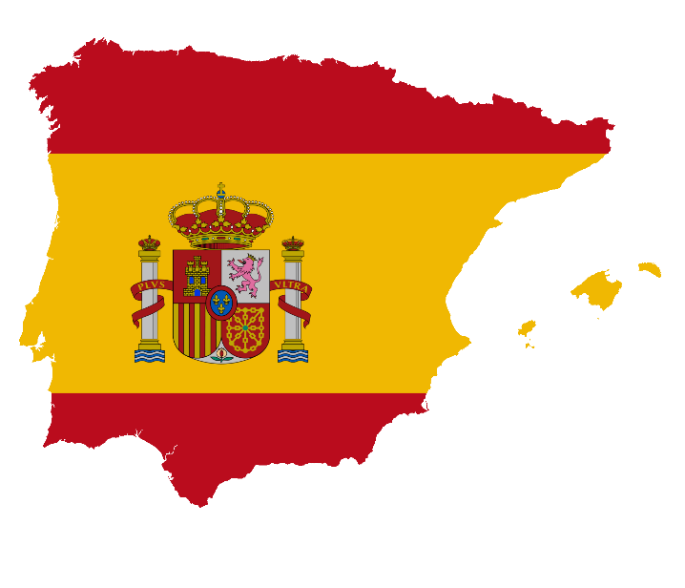

GCSE Spanish Speaking Booklet

Theme 1 Module 3 – Me, my family and friends; Technology in everyday life
- ¿Cómo es tu mejor amigo/a descríbelo/a:
……………………………………………………………………………………………………………………………………………………………………………………………………………………………………………………………………………………………………………………………………………………………………………………………………………………………………………………………………………………………………………………
- ¿Qué planes tienes para el futuro en tu vida personal?
……………………………………………………………………………………………………………………………………………………………………………………………………………………………………………………………………………………………………………………………………………………………………………………………………………………………………………………………………………………………………………………
- ¿Cómo usaste las redes sociales el fin de semana pasado?
……………………………………………………………………………………………………………………………………………………………………………………………………………………………………………………………………………………………………………………………………………………………………………………………………………………………………………………………………………………………………………………
- ¿Te llevas bien con tu familia? ¿Por qué (no)?
……………………………………………………………………………………………………………………………………………………………………………………………………………………………………………………………………………………………………………………………………………………………………………………………………………………………………………………………………………………………………………………
……………………………………………………………………………………………………………………………………………………………………………………………………………………………………………………………………………………………………………………………………………………………………………………………………………………………………………………………………………………………………………………

Module 4 – Free-time activities (music, cinema and TV, sport)
- ¿Qué sueles hacer en tus ratos libres?
……………………………………………………………………………………………………………………………………………………………………………………………………………………………………………………………………………………………………………………………………………………………………………………………………………………………………………………………………………………………………………………
- ¿Qué película viste la semana pasada? Descríbela
……………………………………………………………………………………………………………………………………………………………………………………………………………………………………………………………………………………………………………………………………………………………………………………………………………………………………………………………………………………………………………………
- Háblame de un concierto al que vas a ir en el futuro.
……………………………………………………………………………………………………………………………………………………………………………………………………………………………………………………………………………………………………………………………………………………………………………………………………………………………………………………………………………………………………………
- ¿Qué deportes te gustaría practicar en el fututo? ¿Por qué?
……………………………………………………………………………………………………………………………………………………………………………………………………………………………………………………………………………………………………………………………………………………………………………………………………………………………………………………………………………………………………………………
- ¿Qué deportes solías practicar cuando eras niño/a?
……………………………………………………………………………………………………………………………………………………………………………………………………………………………………………………………………………………………………………………………………………………………………………………………………………………………………………………………………………………………………………………

Module 6 –Festivals and celebrations- Food and eating out
- ¿Qué te gusta comer? ¿Qué no te gusta comer ¿Por qué?
……………………………………………………………………………………………………………………………………………………………………………………………………………………………………………………………………………………………………………………………………………………………………………………………………………………………………………………………………………………………………………………

- Háblame de una mala visita a un restaurante en el pasado
……………………………………………………………………………………………………………………………………………………………………………………………………………………………………………………………………………………………………………………………………………………………………………………………………………………………………………………………………………………………………………………
- ¿Por qué son importantes las celebraciones tradicionales?
……………………………………………………………………………………………………………………………………………………………………………………………………………………………………………………………………………………………………………………………………………………………………………………………………………………………………………………………………………………………………………………
- Háblame de una fiesta o celebración a la que te gustaría ir en el futuro y por qué
……………………………………………………………………………………………………………………………………………………………………………………………………………………………………………………………………………………………………………………………………………………………………………………………………………………………………………………………………………………………………………………

Theme 2
Module 1 – Holidays
- ¿Qué haces en tus vacaciones normalmente?
……………………………………………………………………………………………………………………………………………………………………………………………………………………………………………………………………………………………………………………………………………………………………………………………………………………………………………………………………………………………………………………
- ¿Adónde fuiste de vacaciones el año pasado?
……………………………………………………………………………………………………………………………………………………………………………………………………………………………………………………………………………………………………………………………………………………………………………………………………………………………………………………………………………………………………………………

- ¿Adónde te gustaría ir de vacaciones el año próximo?
……………………………………………………………………………………………………………………………………………………………………………………………………………………………………………………………………………………………………………………………………………………………………………………………………………………………………………………………………………………………………………………
- ¿Cuáles serían tus vacaciones ideales? Descríbelas
……………………………………………………………………………………………………………………………………………………………………………………………………………………………………………………………………………………………………………………………………………………………………………………………………………………………………………………………………………………………………………………

Module 5 – Home, town, neighbourhood and region
- Describe la ciudad o el pueblo dónde vives
……………………………………………………………………………………………………………………………………………………………………………………………………………………………………………………………………………………………………………………………………………………………………………………………………………………………………………………………………………………………………………………
- ¿Qué cosas cambiarías de tu ciudad? ¿Por qué?
……………………………………………………………………………………………………………………………………………………………………………………………………………………………………………………………………………………………………………………………………………………………………………………………………………………………………………………………………………………………………………………

- ¿Cuál es la ciudad más bonita que has visitado en el Reino Unido? ¿Por qué?
……………………………………………………………………………………………………………………………………………………………………………………………………………………………………………………………………………………………………………………………………………………………………………………………………………………………………………………………………………………………………………………
- ¿A dónde te gustaría vivir en el futuro? ¿Por qué?
……………………………………………………………………………………………………………………………………………………………………………………………………………………………………………………………………………………………………………………………………………………………………………………………………………………………………………………………………………………………………………………

Module 8 – Home and global issues- El medio ambiente
- ¿Cómo te vas a mantener saludable en el futuro?
……………………………………………………………………………………………………………………………………………………………………………………………………………………………………………………………………………………………………………………………………………………………………………………………………………………………………………………………………………………………………………………
- ¿Qué haces en casa para proteger el medio ambiente?
……………………………………………………………………………………………………………………………………………………………………………………………………………………………………………………………………………………………………………………………………………………………………………………………………………………………………………………………………………………………………………………
- En tu opinión: ¿Cuáles son los problemas globales más serios hoy en día?
……………………………………………………………………………………………………………………………………………………………………………………………………………………………………………………………………………………………………………………………………………………………………………………………………………………………………………………………………………………………………………………
- ¿Qué hiciste para proteger al medio ambiente el mes pasado?
……………………………………………………………………………………………………………………………………………………………………………………………………………………………………………………………………………………………………………………………………………………………………………………………………………………………………………………………………………………………………………………

Theme 3 Module 2 – My studies; Life at school/college
- Describe tu instituto y sus instalaciones
……………………………………………………………………………………………………………………………………………………………………………………………………………………………………………………………………………………………………………………………………………………………………………………………………………………………………………………………………………………………………………………
- ¿Qué asignaturas te gustan y no te gustan? ¿Por qué?
……………………………………………………………………………………………………………………………………………………………………………………………………………………………………………………………………………………………………………………………………………………………………………………………………………………………………………………………………………………………………………………
- ¿Cómo era tu escuela primaria?
……………………………………………………………………………………………………………………………………………………………………………………………………………………………………………………………………………………………………………………………………………………………………………………………………………………………………………………………………………………………………………………
- Describe un viaje escolar que vas a hacer con tu escuela en el futuro
……………………………………………………………………………………………………………………………………………………………………………………………………………………………………………………………………………………………………………………………………………………………………………………………………………………………………………………………………………………………………………………

Module 7 – Education post-16; jobs, career choices and ambitions
- ¿Dónde hiciste tus prácticas laborales?
……………………………………………………………………………………………………………………………………………………………………………………………………………………………………………………………………………………………………………………………………………………………………………………………………………………………………………………………………………………………………………………
- ¿Qué planes tienes para seguir estudiando en el futuro?
……………………………………………………………………………………………………………………………………………………………………………………………………………………………………………………………………………………………………………………………………………………………………………………………………………………………………………………………………………………………………………………
- ¿En qué te gustaría trabajar en el futuro? ¿Por qué?
……………………………………………………………………………………………………………………………………………………………………………………………………………………………………………………………………………………………………………………………………………………………………………………………………………………………………………………………………………………………………………………

- ¿Qué otras ambiciones tienes para el futuro?
……………………………………………………………………………………………………………………………………………………………………………………………………………………………………………………………………………………………………………………………………………………………………………………………………………………………………………………………………………………………………………………

