Year 11 Spanish TERM 4: Lessons Outline

- Pupils have 2 lessons of Spanish a week (one single and one double).
- Pupils have been given their own copy of the GCSE Viva textbook they also have access to online resources to accompany the textbook https://pearsonactivelearn.com/
- For extension they could also look at lessons on BBC Bitesize or Oak Academy where there are a range of topic areas to extend their learning. Pupils can also use the Linguascope or Quizlet websites.
AQA GCSE Spanish | Quizlet
- Homework will be set on Show my Homework.

PUPILS SHOULD ALSO BE LEARNING THE ANSWERS TO THEIR SPEAKING QUESTIONS OFF BY HEART READY FOR THEIR SPEAKING EXAM AT THE END OF APRIL. THE QUESTIONS ARE BELOW THIS WEEKLY PLAN AND SPEAKING BOOKLETS ARE IN THE PUPIL WORK AREA FOR ROLEPLAY AND PHOTOCARD PRACTICE.

Week | Work Set  (Viva GCSE- Starting to revise previous modules) | Link to pages in On- line textbook where possible  Or alternative activity
Week 1 | Speaking focus week  Roleplay, photocard and general conversation work. | Speaking question booklets (questions are on the next page too).  Photo card and roleplay booklets are in the pupil work section.
Week 2 | Vocabulary revision week  Practise speaking questions | Pupils have been given a vocabulary revision book or can contact your teacher if they have misplaced it. They can also revise from their textbook or follow the Quizlet link above.
Week 3 | Writing focus week  Practise speaking questions | Pupils have been given a writing workbook and can contact your teacher if they have misplaced it.
Week 4 | Mock exams in double lesson  Writing paper only  Practise speaking questions/roleplays/photocards in single lesson or if ill at home. Mock exam will be done at another date in school if pupils are absent.
Week 5 | Past paper week  Practise speaking questions | Contact your teacher for resources
Week 6 | Speaking focus week  Roleplay, photocard and general conversation work. | Speaking question booklets (questions are on the next page too).  Photo card and roleplay booklets are in the pupil work section.

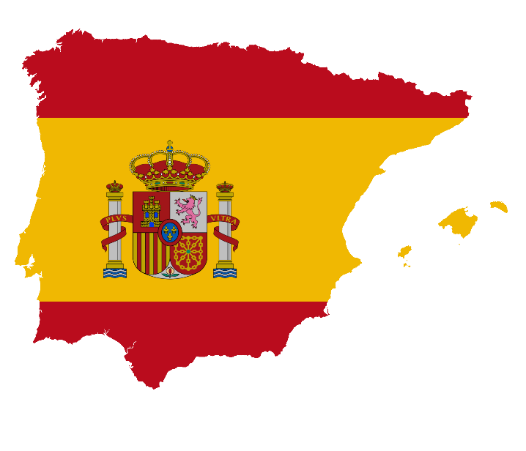

GCSE Spanish Speaking Booklet

Theme 1
Module 3 – Me, my family and friends; Technology in everyday life
¿Describe a un buen amigo tuyo/una buena amiga tuya.
……………………………………………………………………………………………………………………………………………………………………………………………………………………………………………………………………………………………………………………………………………………………………………………………………………………………………………………………………………………………………………………
¿Qué aplicaciones usas para estar en contacto con tus amigos y con tu familia?
……………………………………………………………………………………………………………………………………………………………………………………………………………………………………………………………………………………………………………………………………………………………………………………………………………………………………………………………………………………………………………………
¿Qué piensas de las redes sociales?
……………………………………………………………………………………………………………………………………………………………………………………………………………………………………………………………………………………………………………………………………………………………………………………………………………………………………………………………………………………………………………………
¿Te llevas bien con tu familia? ¿Por qué (no)?
……………………………………………………………………………………………………………………………………………………………………………………………………………………………………………………………………………………………………………………………………………………………………………………………………………………………………………………………………………………………………………………

¿Qué planes tienes con tus amigos o con tu familia este fin de semana?
……………………………………………………………………………………………………………………………………………………………………………………………………………………………………………………………………………………………………………………………………………………………………………………………………………………………………………………………………………………………………………………

Module 4 – Free-time activities (music, cinema and TV, sport)
¿Qué sueles hacer en tus ratos libres?
……………………………………………………………………………………………………………………………………………………………………………………………………………………………………………………………………………………………………………………………………………………………………………………………………………………………………………………………………………………………………………………
¿Prefieres ver películas en casa o en el cine? ¿Por qué?
……………………………………………………………………………………………………………………………………………………………………………………………………………………………………………………………………………………………………………………………………………………………………………………………………………………………………………………………………………………………………………………
¿Te gusta la música? ¿Por qué (no)?
……………………………………………………………………………………………………………………………………………………………………………………………………………………………………………………………………………………………………………………………………………………………………………………………………………………………………………………………………………………………………………………
Háblame de la última vez que participaste en un deporte.
……………………………………………………………………………………………………………………………………………………………………………………………………………………………………………………………………………………………………………………………………………………………………………………………………………………………………………………………………………………………………………………
¿Quién es tu modelo a seguir?
……………………………………………………………………………………………………………………………………………………………………………………………………………………………………………………………………………………………………………………………………………………………………………………………………………………………………………………………………………………………………………………

Module 6 – Customs and festivals in Spanish-speaking countries; Free-time activities (food and eating out)
¿Qué te gusta comer? ¿Por qué?
……………………………………………………………………………………………………………………………………………………………………………………………………………………………………………………………………………………………………………………………………………………………………………………………………………………………………………………………………………………………………………………

¿Prefieres cenar en casa o en un restaurante? ¿Por qué?
……………………………………………………………………………………………………………………………………………………………………………………………………………………………………………………………………………………………………………………………………………………………………………………………………………………………………………………………………………………………………………………
¿Has asistido a un festival de música? ¿Puedes describirlo?
……………………………………………………………………………………………………………………………………………………………………………………………………………………………………………………………………………………………………………………………………………………………………………………………………………………………………………………………………………………………………………………
¿Crees que las fiestas tradicionales son importantes? ¿Por qué (no)?
……………………………………………………………………………………………………………………………………………………………………………………………………………………………………………………………………………………………………………………………………………………………………………………………………………………………………………………………………………………………………………………
Háblame de una fiesta a la que te gustaría asistir.
……………………………………………………………………………………………………………………………………………………………………………………………………………………………………………………………………………………………………………………………………………………………………………………………………………………………………………………………………………………………………………………

Theme 2
Module 1 – Travel and tourism
¿Por qué son importantes las vacaciones?
……………………………………………………………………………………………………………………………………………………………………………………………………………………………………………………………………………………………………………………………………………………………………………………………………………………………………………………………………………………………………………………
¿Adónde fuiste de vacaciones el año pasado?
……………………………………………………………………………………………………………………………………………………………………………………………………………………………………………………………………………………………………………………………………………………………………………………………………………………………………………………………………………………………………………………
¿Dónde te alojaste?
……………………………………………………………………………………………………………………………………………………………………………………………………………………………………………………………………………………………………………………………………………………………………………………………………………………………………………………………………………………………………………………
¿Qué fue lo mejor de tus vacaciones?
……………………………………………………………………………………………………………………………………………………………………………………………………………………………………………………………………………………………………………………………………………………………………………………………………………………………………………………………………………………………………………………
¿Qué planes tienes para el próximo verano?
……………………………………………………………………………………………………………………………………………………………………………………………………………………………………………………………………………………………………………………………………………………………………………………………………………………………………………………………………………………………………………………

Module 5 – Home, town, neighbourhood and region
¿Cómo es la ciudad o el pueblo donde vives?
……………………………………………………………………………………………………………………………………………………………………………………………………………………………………………………………………………………………………………………………………………………………………………………………………………………………………………………………………………………………………………………
¿Cuál es tu ciudad favorita? ¿Por qué?
……………………………………………………………………………………………………………………………………………………………………………………………………………………………………………………………………………………………………………………………………………………………………………………………………………………………………………………………………………………………………………………
¿Qué es mejor, vivir en la ciudad o en el campo?
……………………………………………………………………………………………………………………………………………………………………………………………………………………………………………………………………………………………………………………………………………………………………………………………………………………………………………………………………………………………………………………
¿Qué hay para turistas en tu zona? ¿Qué se puede hacer?
……………………………………………………………………………………………………………………………………………………………………………………………………………………………………………………………………………………………………………………………………………………………………………………………………………………………………………………………………………………………………………………
¿Cómo cambiarías tu zona?
……………………………………………………………………………………………………………………………………………………………………………………………………………………………………………………………………………………………………………………………………………………………………………………………………………………………………………………………………………………………………………………

Module 8 – Home; social issues; global issues
¿Cómo te puedes mantener en forma?
……………………………………………………………………………………………………………………………………………………………………………………………………………………………………………………………………………………………………………………………………………………………………………………………………………………………………………………………………………………………………………………
¿Qué opinas de fumar?
……………………………………………………………………………………………………………………………………………………………………………………………………………………………………………………………………………………………………………………………………………………………………………………………………………………………………………………………………………………………………………………
¿Qué haces en casa para proteger el medio ambiente?
……………………………………………………………………………………………………………………………………………………………………………………………………………………………………………………………………………………………………………………………………………………………………………………………………………………………………………………………………………………………………………………
¿Cuál es son los problemas globales más serios hoy en dia?
……………………………………………………………………………………………………………………………………………………………………………………………………………………………………………………………………………………………………………………………………………………………………………………………………………………………………………………………………………………………………………………
¿Para qué sirven los eventos deportivos internacionales?
……………………………………………………………………………………………………………………………………………………………………………………………………………………………………………………………………………………………………………………………………………………………………………………………………………………………………………………………………………………………………………………

Theme 3
Module 2 – My studies; Life at school/college
¿Cómo es tu instituto? ¿Qué instalaciones tiene/no tiene?
……………………………………………………………………………………………………………………………………………………………………………………………………………………………………………………………………………………………………………………………………………………………………………………………………………………………………………………………………………………………………………………
¿Qué asignaturas te gustan y no te gustan? ¿Por qué?
……………………………………………………………………………………………………………………………………………………………………………………………………………………………………………………………………………………………………………………………………………………………………………………………………………………………………………………………………………………………………………………
¿Qué opinas del uniforme escolar?
……………………………………………………………………………………………………………………………………………………………………………………………………………………………………………………………………………………………………………………………………………………………………………………………………………………………………………………………………………………………………………………
¿Qué piensas de las normas de tu insti?
……………………………………………………………………………………………………………………………………………………………………………………………………………………………………………………………………………………………………………………………………………………………………………………………………………………………………………………………………………………………………………………
¿Qué actividades extraescolares haces?
……………………………………………………………………………………………………………………………………………………………………………………………………………………………………………………………………………………………………………………………………………………………………………………………………………………………………………………………………………………………………………………
¿Qué es lo bueno/lo malo de tu insti?
……………………………………………………………………………………………………………………………………………………………………………………………………………………………………………………………………………………………………………………………………………………………………………………………………………………………………………………………………………………………………………………
Compara tu escuela primaria con tu instituto.
……………………………………………………………………………………………………………………………………………………………………………………………………………………………………………………………………………………………………………………………………………………………………………………………………………………………………………………………………………………………………………………
¿Puedes describir un intercambio o un viaje escolar que hiciste en el pasado?
……………………………………………………………………………………………………………………………………………………………………………………………………………………………………………………………………………………………………………………………………………………………………………………………………………………………………………………………………………………………………………………

Module 7 – Education post-16; jobs, career choices and ambitions
¿Tienes un trabajo a tiempo parcial? Que haces?
……………………………………………………………………………………………………………………………………………………………………………………………………………………………………………………………………………………………………………………………………………………………………………………………………………………………………………………………………………………………………………………
¿Qué planes para seguir estudiando en el futuro?
……………………………………………………………………………………………………………………………………………………………………………………………………………………………………………………………………………………………………………………………………………………………………………………………………………………………………………………………………………………………………………………
¿Dónde hiciste tus prácticas laborales?
……………………………………………………………………………………………………………………………………………………………………………………………………………………………………………………………………………………………………………………………………………………………………………………………………………………………………………………………………………………………………………………
¿En que te gustaría trabajar? ¿Por qué?
……………………………………………………………………………………………………………………………………………………………………………………………………………………………………………………………………………………………………………………………………………………………………………………………………………………………………………………………………………………………………………………
¿Crees que es importante aprender otras lenguas? ¿Por qué (no)?
……………………………………………………………………………………………………………………………………………………………………………………………………………………………………………………………………………………………………………………………………………………………………………………………………………………………………………………………………………………………………………………
¿Qué otras ambiciones tienes?
……………………………………………………………………………………………………………………………………………………………………………………………………………………………………………………………………………………………………………………………………………………………………………………………………………………………………………………………………………………………………………………
¿Qué cosas te importan más en la vida? ¿Por qué?
……………………………………………………………………………………………………………………………………………………………………………………………………………………………………………………………………………………………………………………………………………………………………………………………………………………………………………………………………………………………………………………

