Health and the People c1000-Present Day Workbook
- Medieval Doctor

  - Complete the fact file below outlining the work of a Medieval doctor:
Topic | Medieval Doctor Details
Training
Natural Treatments
Supernatural Treatments
Who did Ordinary People Turn To?

  - Draw a diagram below to show how the four humours and Galen’s theory of opposites worked:

The Theory of the Four Humours

- Christianity and Medicine

- Complete the table identifying three ways that Christianity helped medicine (led to progression) and three ways it hindered medicine (led to regression):

Christianity Helped Medicine | Christianity Hindered Medicine

- Why do people argue that Christianity hindered more than it helped medicine during the Medieval period: ____________
_______________________________________________________________________________________________________________________________________________________________________________________________________________________________________________________________________________________________________________________________________________________________________________________________________________________________________________________________________________________________________________

- Islam and Medicine

- Complete the following spider diagram, outlining the key features of Islamic Medicine:

Key people (Rhazes, Ibn Sinna, Ibn Nafis Abulcasis)
Hospitals

Islamic Medicine

Treatments
How they got their knowledge.

Helped or Hindered?

- Medieval Surgery

- Match the following medieval surgeons to their key discoveries:

Surgeon | Discoveries
Abulcasis | Produced the standard dissection manual for medieval surgeons.
Frugardi | Most famous surgeon. Wrote a manual Practica which contained illustrations of operations. He used opium and henbane to dull pain and operated on anal abscesses which was a common complaint from knights on horseback.
Hugh of Lucca and his son Theodoric | Wrote a book, the Practice of Surgery. Tried operations on the chest as well as attempted to remove bladder stones.
Mondino | Wrote a famous book Great Surgery which contained reverence to famous Greek and Islamic writers. Criticised Hugh of Lucca’s ideas.
Guy De Chauliac | Wrote a 30-volume book, invented 26 new surgical instruments. Made cauterisation popular and used ligatures to tie off blood vessels.
John of Arderne | Wrote a book criticising the idea that pus was needed for a wound to heal. Used wine on wounds and made new ways to remove arrows.

- Describe some of the main treatments used by a medieval surgeon and how successful they were. Include: bloodletting, amputation, shock, infection, bleeding, cauterisation, trepanning. _________________________
__________________________________________________________________________________________________________________________________________________________________________________________________________________________________________________________________________________________________________________________________________________________________________________________________________________________________________________________________

- Public Health in Medieval Towns

- Make a list of 5 reasons why Medieval Towns could be considered unhygienic:
    - ________________________________________________________________________________________
    - ________________________________________________________________________________________
    - ________________________________________________________________________________________
    - ________________________________________________________________________________________
    - ________________________________________________________________________________________

  - Label the diagram of a medieval monastery below to identify 5 reasons why these were more hygienic:

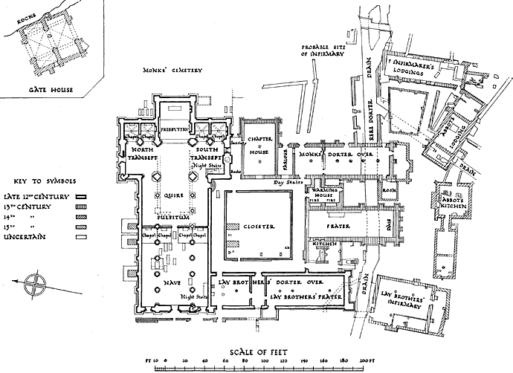

- The Black Death

- Describe the symptoms of the two types of plague:
    - Bubonic Plague ________________________________________________________________________
_______________________________________________________________________________________________________________________________________________________________________________________________________________________________________________________________
    - Pneumonic Plague: ____________________________________________________________________
_______________________________________________________________________________________________________________________________________________________________________________________________________________________________________________________________

- Fill in the gaps in the following paragraph to identify what people thought caused the Black Death and how they tried to treat it:
In the fourteenth century, people did not know that r___________ were the actual cause of the plague. Instead they had many other theories. For example, many thought that they were being p___________________ by G_________ for their s_________. Others believed it was to do with the i________________ of the h________________ in the body. Furthermore, other people had s_____________________ beliefs about the Black Death such as the position of the p____________ and s_________. In Germany, some people blamed the J___________, saying that they had p________________ water wells. However, one of the most popular theories was m______________ or b_________ a_________. As people did not understand exactly what caused the Black Death, there were many weird treatments. P____________ and apologising to G_______ was common as was trying to q_____________ infected places by locking up infected houses. Some more unusual treatments included strapping a s____________ c___________ to each of the buboes, drinking m__________ (a poisonous metal) or even eating c___________ e___________. None of these were effective however as the actual cause of dirty s____________ attracting r___________ was not addressed.
- Try to give an example of one impact that the plague had on society in each category:

    - Social impact: ____________________________________________________________________________
________________________________________________________________________________________
    - Political impact: ___________________________________________________________________________
________________________________________________________________________________________
    - Religious impact: __________________________________________________________________________
________________________________________________________________________________________
    - Economic impact: _________________________________________________________________________
________________________________________________________________________________________

- What was the Renaissance?

- Define what the word Renaissance means: ________________________________________________________________
______________________________________________________________________________________________________________________________________________________________________________________________________

- What were some of the consequences of the Renaissance? Include: the printing press, new lands/voyages, art, inventions and new scientific methods. ____________________________________________________________________________
____________________________________________________________________________________________________________________________________________________________________________________________________________________________________________________________________________________________________________________________________________________________________________________________________________
_________________________________________________________________________________________________________________________________________________________________________________________________________________________________________________________________________________________________________
_________________________________________________________________________________________________________________________________________________________________________________________________________________________________________________________________________________________________________

- Andreas Vesalius

- Brainstorm the main points about Vesalius’ achievements. Include: understanding of anatomy before Vesalius, what he did/key discoveries, impact of his work (especially in Britain).

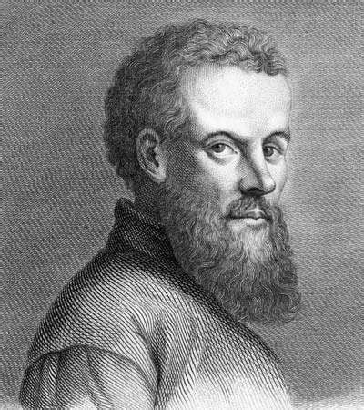

- Ambroise Paré
  - Complete the table to describe what Paré discovered and its impact:
Before Paré’s Discoveries (Old Methods) | What Paré Discovered | After Paré’s Discoveries (Impact)
 |  | Paré’s patients’ wounds healed well. He then wrote a book about how to treat similar wounds.
Wounds were cauterised to stop bleeding using a red hot iron.
 | He designed false limbs to help out wounded soldiers.

  - Identify three ways that Paré contributed to medical progress in England:
    - ________________________________________________________________________________________________________________________________________________________________________________
    - ________________________________________________________________________________________________________________________________________________________________________________
    - ________________________________________________________________________________________________________________________________________________________________________________
- William Harvey
  - Complete the flow-diagram below which outlines the work of William Harvey:
Background
Harvey was born in England in 1578. He studied medicine first at Cambridge………………………….
Harvey’s Methods and Discoveries
Harvey carried out many experiments. These included dissections on………………………..
Harvey’s Limitations
Despite all of his ground-breaking work, there was much that Harvey still did not know about the heart. For example he was unable to …………………..
Reaction to Harvey’s Discoveries
However, despite being able to prove via demonstrations and experiments he was right many people refused to believe him. Many of these people chose to ……………

- How Scientific was the Renaissance?
  - Make a brainstorm using the headings provided and colour code as shown by the key:

New Lands Discovered
King Charles II

How scientific was the Renaissance?

The King’s Evil (Scrofula)
Treatments for Ordinary People

Key
 | Scientific Improvement |  | Old Treatment/Supernatural Idea

- The Great Plague 1665

  - Fill in the gaps in the following paragraph to identify what people thought caused the Plague and how they tried to treat it:
In the seventeenth century, the p_____________ returned to Britain. In L__________ it is estimated to have killed 100,000 people (around a q_______________ of the population of the city). People generally had the same ideas for what c________________ the Plague as they had when the B____________ D__________ had infection Britain. However, people seem to have begun to make the connection between d_________ and d_________________. There seems to be recognition that most d____________ occurred in the d_______________ areas of the cities. Treatments still included old ideas such as b_____________ people using leeches or using h______________ on fires to remove dirty smells (m________________). Furthermore, people also continued to use s___________________ treatments such as relying on charms or spells, believing it was caused by G____________. However, there was a more organised approach than before. P_______________ victims were examined and put into q_______________. This meant that sufferers were l_____________ in their houses and banned from leaving. Bodies were removed from the city at n_____________ and buried in m______________ g______________. Orders were given to c_____________ the s____________ and animals were banned. These measures helped reduce the number of deaths, although the plague ultimately ended as more r____________ survived due to greater resistance to the disease meaning that f____________ did not need to find human hosts.
- Renaissance/17th Century Hospitals

  - Fill in the following table below, comparing the features of a Medieval Hospital to a Renaissance hospital. Aim for 5 differences (or similarities). Be specific with examples e.g. London’s Lock Hospital for venereal disease:
No. | Medieval Hospital | Renaissance Hospital
1
2
3
4
5
- John Hunter

  - Complete the diagram below to outline the significance and discoveries of John Hunter:
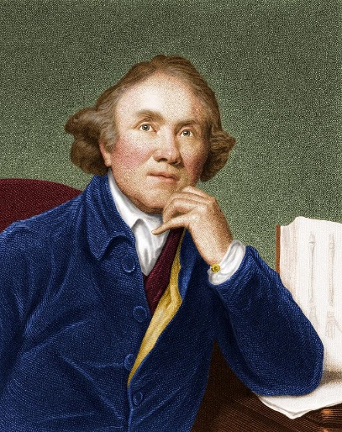
Hunter’s Collection
Hunter’s Books
Hunter’s Teaching
Hunter’s Methods

- Edward Jenner

  - Define the following key terms:
    - Inoculation: ______________________________________________________________________________
________________________________________________________________________________________
    - Vaccination: ______________________________________________________________________
________________________________________________________________________________
    - Immunity: _______________________________________________________________________
________________________________________________________________________________

  - What were some of the main problems with inoculation? ________________________________________________
______________________________________________________________________________________________________________________________________________________________________________________________

  - What did Edward Jenner discover? ___________________________________________________________________
__________________________________________________________________________________________________________________________________________________________________________________________________________________________________________________________________________________________________________________________________________________________________________________________________________________________________________________________________________________________________________________________________________________________________________________________
  - Identify three reasons why people opposed Jenner and vaccination:
    - ________________________________________________________________________________________________________________________________________________________________________________
    - ________________________________________________________________________________________________________________________________________________________________________________
    - ________________________________________________________________________________________________________________________________________________________________________________

  - How did Jenner overcome opposition? Include: vaccination clinic, scientific experiment, survival rate, important supporters who were influential (royal family): _________________________________________________________
____________________________________________________________________________________________________________________________________________________________________________________________________________________________________________________________________________________________________________________________________________________________________________________________

- Pain and Anaesthetics

  - Describe the three main reasons that surgery in the early 1800s was dangerous:
    - ________________________________________________________________________________________________________________________________________________________________________________
    - ________________________________________________________________________________________________________________________________________________________________________________
    - ________________________________________________________________________________________________________________________________________________________________________________

  - Complete the table about the three main anaesthetics (leave the greyed out boxes blank, chloroform needs most detail):

Anaesthetic | Who Discovered It/When/How | Reasons It Was Opposed | Reason It Was Accepted
 | Humphry Davy, 1799. He was testing out and sniffing difference chemicals and said the gas made him laugh, feel giddy and relaxed. 1844 American dentist, Horace Wells, used it to extract teeth.
 |  | It was hard to regulate the dosage that was given, made the patient cough and produced a vapour that was explosive (open fires in surgeries were typical).
Chloroform

- Spontaneous Generation v 1861 ‘Germ Theory’

  - Draw and annotate a diagram in the box below to show the theory of spontaneous generation (the idea that microbes were produced by decay):

  - Draw and annotate a diagram in the box below to show germ theory, discovered by Louis Pasteur in 1861 (the idea that microbes caused disease):

- Joseph Lister
  - Complete the brainstorm about Lister and his work using the headings to help you:

Background | Why He Was Significant In Britain
What He Discovered (Antiseptic Surgery and  Aseptic Surgery) | 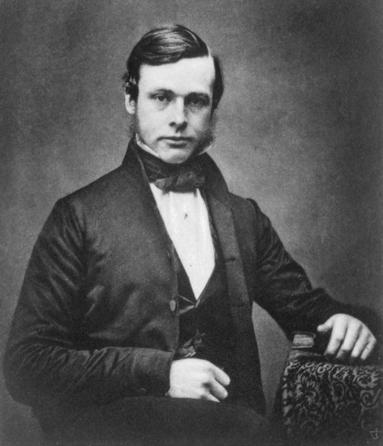  Why He Was Opposed
- Why People Began to Accept Germ Theory

  - Fill in the flow diagram below to show why people began to change their minds, beginning to accept germ theory:
Cattle Plague 1866

John Tyndall

Typhoid Fever 1876

- Robert Koch and Louis Pasteur – Discovering Vaccinations

  - Fill in the gaps in the following paragraph to describe how Koch and Pasteur developed further vaccinations:
Despite discovering g____________ t_____________ in 1________, Pasteur was unable to cure a human of a disease. This is because he could not i_____________ which germs were making people in, all he saw under the m____________ was a huge number of different m________________. G____________ doctor Robert Koch was able to i_________________ , g___________, s____________ and p_____________ the specific bacteria that caused a________________ in sheep. Later on he managed to identify the bacteria which caused c_______________ and t______________________. Using this information Pasteur was able to develop further v________________. He used Koch’s work to create a v____________ for c________________ c______________ He also used Koch’s work on a________________ to create a v____________ to protect sheep. Finally, Pasteur managed to develop a v_________________ for a human disease, r_______________. This was the second vaccine to save human lives following E_________________ J_______________’s discovery of the s______________ v_________________.

  - Complete the spider diagram below, describing how each factor helped Pasteur and Koch to develop new vaccines between 1880 and 1900.
The Development of Vaccines by Pasteur and Koch between 1880 and 1900.
Individual Brilliance

Communication

Teamwork

Luck

Government and Finance

War

- Public Health in the Early 1800s

  - Annotate the image below, describing the main issues/threats to health that existed in the 1800s. Include: Common diseases as well as descriptions of the streets, why there was a lack of government intervention.

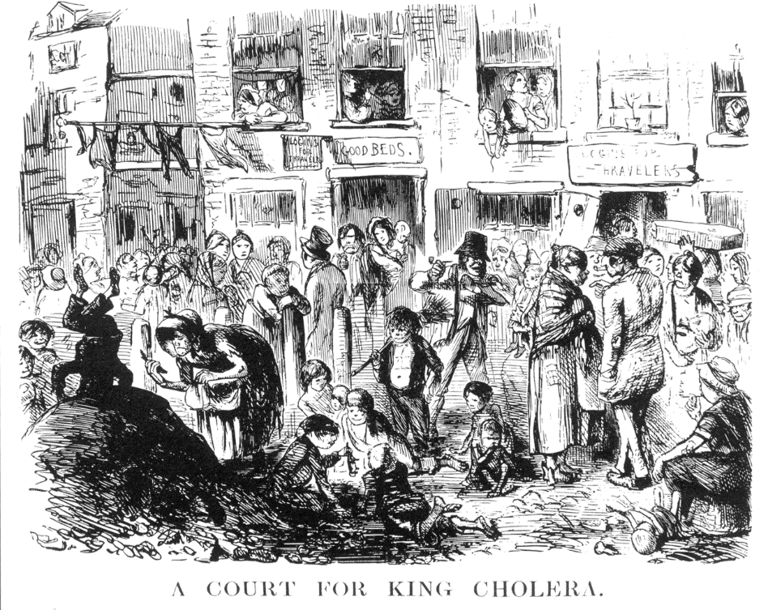

- The Work of Chadwick and Snow and the Public Health Acts

  - Identify whether the following statements refer to Chadwick or Snow:
Person | Statement
 | 1842 report called for clean water supplies, better housing and a medical officer for health to look after every people in every district in Britain.
 | Civil servant and lawyer who studied rural Rutland and compared this to urban Liverpool.
 | Showed people who got water from other sources (e.g. brewery) did not get cholera.
 | Surgeon who worked in Broad Street, Soho, London.
 | Wrote report in 1842 discussing his findings but mistakenly blamed miasmas.
 | Carried out a survey identifying where people got their water from and how many had died from cholera.
 | Showed cholera was not caused by miasmas but instead it was caused by polluted water.
 | Found that life expectancy was far lower and poverty was far higher for all social classes in urban areas.
 | Found that people who died from cholera used the Broad Street pump, the handle was removed.
 | Discovered a cracked lining in a street toilet which allowed sewage to leak into the water supply.
 | Studied the impact of the 1854 cholera epidemic which killed 700 in Broad Street.
  - What did the 1848 First Public Health Act introduce and why did it fail? _____________________________________
____________________________________________________________________________________________________________________________________________________________________________________________________________________________________________________________________________________________________________________________________________________________________________________________
  - What was the Great Stink and what did Bazalgette to do solve this? ________________________________________
____________________________________________________________________________________________________________________________________________________________________________________________________________________________________________________________________________________________________________________________________________________________________________________________
  - In 1867 working-class men were given the vote. How does this lead to the Second Public Health Act in 1875? _______________________________________________________________________________________________
_____________________________________________________________________________________________________________________________________________________________________________________________________________________________________________________________________________________________
  - Why was the 1875 Second Public Health Act a success? __________________________________________________
_____________________________________________________________________________________________________________________________________________________________________________________________________________________________________________________________________________________________

  - Number the following statements so that they are in chronological order, summarising why public health improved in the 19th century:

Number | Statement
 | Chadwick’s report highlighted how poor conditions were in industrial cities.
 | Joseph Bazalgette builds a new sewer system for London following the Great Stink
 | People moved from the country to towns to find jobs in new industrial factories.
 | John Snow recognises the link between contaminated water and cholera in Broad Street, Soho, London.
 | At this time people thought that politicians should not meddle in the lives of ordinary people (laissez-faire)
 | The Second Public Health Act ordered local councils to appoint Medical Officers for health, clean streets and supply fresh water. This was compulsory, unlike the first act.
 | Cities became very overcrowded. Diseases like typhoid and cholera were common.
 | The First Public Health Act was introduced. A Central Board of Health was set up, towns could set up their own Local Boards of Health.
 | People believed these diseases were caused by miasma, given off by rotting waste.

- Magic Bullets and Penicillin
  - What were magic bullets and how were they developed? _______________________________________________
________________________________________________________________________________________________________________________________________________________________________________________________________________________________________________________________________________________________________________________________________________________________________________________________________________________________________________________________________________________________________________________________________________________________________________________________________________________________________________________________________________________________________________________________________________________________________________________

  - Complete the table below, describing the work done by Fleming, Florey and Chain during the discovery and development of penicillin:
Alexander Fleming - Discovery | Howard Florey & Ernst Chain - Development
- In the 1920s scientists had been working hard to defeat the highly-resistant staphylococcus bacteria (blood/food poisoning). No magic bullet could defeat it.  - Fleming had seen first-hand the effects of staphylococcus during WWI when he had observed soldiers suffering as a result of it. | - In the 1930s Florey and Chain read about Fleming’s research on penicillin and felt that it needed further investigation.  - They were given £25 by the British government, and used this to produce enough to test on 8 mice (Britain was involved in WWII at this point so had little money to spend).

  - Below, complete the spider-diagram describing how all of the factors helped with the discovery and development of penicillin:

Science
Individual Brilliance

Factors Leading to the Discovery and Development of Penicillin
Communications

Government

Technology
War

  - How did the successful development of penicillin lead to the growth of the pharmaceutical industry and the development of other antibiotics? Include: companies like GSK (GlaxoSmithKline) or Beecham. ___________________________________________________________________________________________________________________________________________________________________________________________________________________________________________________________________________________________________________________________________________________________________________________________________________________________________________________________________________________________

- Drugs and Treatments Since 1945

  - Complete the table adding three examples of how surgery, treatment and understanding of body and disease have changed since 1945 (include the dates): Choose from: human liver grown from stem cells (2013), cyclosporine used to stop the body rejecting transplanted organs (1970), DNA mapped out by Crick and Watson (1953), first open-heart operation to repair a hole (1950), thalidomide developed to treat morning sickness (1957), CAT scanner which produces 3D images developed (1973), IVF used for the first time to help childless women conceive (1978), first pacemaker fitted (1958), first hip replacements (1972).
Surgery | Treatment | Understanding of Body and Disease

- Alternative Treatments

  - Fill in the gaps to describe why more people are turning to alternative treatments:
Penicillin and other a_______________ have been shown to be effective against many major diseases such as p__________, measles, m____________ and w_______________ c_______________. However, a major concern in the 21st century is a________________ r_______________. This means that drugs like penicillin are unable to k___________________ certain diseases such as M___________ as they have become r_____________ to the drugs. This is partly due to the o______________ of antibiotics where too many are being p___________________ to patients. Also it is down to misuse of antibiotics where they are being given to patients for v_______________ infections which they cannot treat. This means that a growing number of people are turning to a____________________ t______________________ like acupuncture.

  - Complete the diagram below, summarising some of the alternative treatments that are available:

Aromatherapy | Acupuncture
Homeopathy | Hypnotherapy

- Why Has Health Improved In The 20th and 21st Centuries

  - Brainstorm some key ideas for each of the factors below to say why health has improved greatly since 1945:

Attitudes
Individuals
Communication

Why Has Health Improved Greatly Since 1945?

Government and Finance
War
Technology

- WWI and WWII on Medicine and Health

  - Complete the table below, outlining reasons that each war helped and hindered medicine:
Helped or Hindered | WWI | WWII
Hindered Medicine | Include: disruption to doctors, research and destruction of places of learning | Include: Airstrikes, doctor disruption, research stopped.
Helped Medicine | Include: experimentation, blood transfusions, x-rays, plastic surgery, mental health, infections and broken bone treatments. | Include: experimentation, blood transfusions, penicillin, heart surgery, rationing, NHS, evacuation and diet.

  - Briefly outline what the following three surgical techniques are and how they treat people:
    - Keyhole surgery: __________________________________________________________________________
________________________________________________________________________________________________________________________________________________________________________________
    - Radiation therapy: ________________________________________________________________________
________________________________________________________________________________________________________________________________________________________________________________
    - Laser surgery: ____________________________________________________________________________
________________________________________________________________________________________________________________________________________________________________________________

- Public Health Since 1900
  - What did the Boer War tell the government about health in Britain in 1899? _________________________________
___________________________________________________________________________________________________________________________________________________________________________________________________________________________________________________________________________________________________________________________________________________________________________________________________________________________________________________________________________________________
  - Describe the work of the following two people:
    - Charles Booth: ____________________________________________________________________________
________________________________________________________________________________________________________________________________________________________________________________________________________________________________________________________________________
    - Seebohm Rowntree: _______________________________________________________________________
________________________________________________________________________________________________________________________________________________________________________________________________________________________________________________________________________

  - Complete the table outlining how each of the Liberal Social Reforms helped improve the health of people in Britain:
Reform | How it Helped Health
1906 – Free School Meals
1907 – School Medical Service Set Up
1908 – Children and Young Person’s Act
1908 – Old Age Pensions
1909 – First Job Centre
1911 – National Insurance Introduced

- The Welfare State and the NHS
  - Complete the flow diagram describing how the NHS was developed and introduced:
1942 – Beveridge Report

1948 – The NHS Introduced After Nye Bevan Overcomes Opposition

21st Century Concerns About The NHS

