An Annotated Map to Show Some of the Countries and Territories within the British Empire.
Key
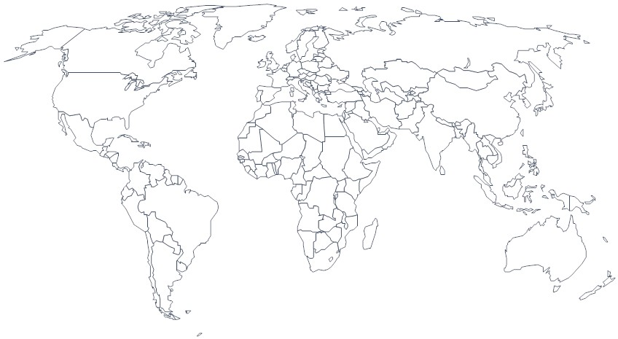
Countries/Territories in the British Empire

