Name___________

Geography

Resource Management

Revision Guide

2023

Paper 2: Challenges in the human environment
Section C: The challenge of resource management

A resource is a stock or supply of something that has a value or purpose. Food, energy & water are the most important. Adequate supplies of these are essential for a country to develop. | Resources are unevenly distributed across the world. HICs have plentiful resources whilst LICs lack resources. Population growth will put increased pressure on resources. |  |  |  |  |  | Social well-being - Access to items which improve quality of life e.g. health, sanitation, education, transport and community.  Economic well-being – A person’s standard of living based upon their income.
Food – Global  Health is affected by nutritional value of food. World Health Organisation (WHO) suggests people need 2000-2400 calories per day. Over 1 billion people in the world today fall below this level and are described as malnourished.  According to the WHO malnutrition refers to deficiencies, excesses, or imbalances in a person’s intake of food.  Undernutrition is a form of malnutrition. Undernutrition is often caused by lack of food and leads to wasting, stunting and being underweight. | Water – Global  Quantity and quality of water are important for personal well-being & economic development.  Water is essential for drinking, agriculture, energy production & industry.  Water supply is influenced by variations in climate & weather. Quality of water is influenced by the ability of a country to store, treat & distributed clean water. This is an economic issue. Without adequate clean water supply countries become trapped in a cycle of poverty. |  |  |  |  | Energy – Global  Energy is required for economic development – industry, transport & education.  Global energy demand is increasing due to population growth, development and the rapid industrialisation of NEEs.  Energy mix – The different sources from which energy is created e.g. coal, oil, wind etc.  Non-renewable energy – Energy that has a finite amount (it will run out in the future) e.g. coal – usually releases C0².  Renewable energy – Energy that has an infinite amount (it will not run out in the future) e.g. wind. It is not harmful to the environment.  Fracking – The process of drilling into the earth to release gas.
Food – UK  The UK has an efficient & productive farming sector but is not self-sufficient for food supplies. The UK imports 40% of its food consumed & this proportion is increasing. UK reliance on food imports is due to:  - Cost of UK food production – feed, fuel, poor harvests  - Cheap foreign imports available in supermarkets  - Demand for food not suited to being grown in the UK  - Demand for seasonal produce all year (strawberries)  - Increasing population  Importing food increases carbon footprint due to food miles.  Attempts to reduce dependence on foreign food imports involve two main trends – agri-business & organic produce.  Agri-business is intensive farming aimed at maximising food produced. Lynford House Farm in East Anglia is a large 570 hectare farm that uses pesticides, fertilisers & hi-tech machinery.  Organic produce is grown without the use of chemicals. Organic food is increasingly popular & is associated with local quality & healthy produce. Riverford Organic Farms began as an organic food & dairy farm in Devon. They provide local people with fresh food boxes. The company has now expanded to different regional operations across the UK. |  | Water – UK  The Environment Agency in the UK estimates that the demand for water in the UK will rise by 5% by 2020 because of:  - Growing population  - More houses being built  - Increase in use of water-intensive domestic appliances  Water supply & demand varies across the UK:  - North & west of the UK has a water surplus where supply exceeds demand.  - South & east of the UK has a water deficit where demand exceeds supply.  Managing water supply can be achieved through:  - Saving water – water meters, efficient domestic appliances, fixing leaks, using recycled water/grey water.  - Water transfer – transfer water from areas of surplus to deficit. An example is Kielder Water Kielder water in Northumberland. Water from the reservoir is released into the rivers Tyne, Derwent, Wear and Tees to be used in South Yorkshire. There is opposition to large-scale water transfer schemes due to economic & environmental reasons.  - Managing water quality - The Environment Agency manages water quality by:  - Monitoring water.  - Filtering water.  - Purifying water.  - Restricting recreational use of water sources.  - Imposing strict regulations on the uses of water. |  |  |  |  |  |  |  | Energy – UK  Despite an increase in population, the UK’s energy consumption has decreased in recent years, due to a decline in heavy industry and improved energy conservation e.g. low-energy appliances, fuel-efficient cars, etc.  - The UK is no longer self-sufficient in energy (approximately 75% of the UK’s oil and natural gas reserves have been exhausted).  - In the future, the UK will become increasingly dependent on importing energy.  - To help combat this reliance, the UK has started to use more renewable energy sources, including wind, solar and HEP.  UK Fracking issue  The UK has rich reserves of natural gas trapped deep underground in shale rocks. This can be extracted using high pressure liquids, a process known as fracking.  - Fracking could improve the future energy security of the UK, by reducing the need for imports. It will be very profitable for the government through fuel tax.  - Fracking is controversial; people are concerned with water pollution, local disruption, and high costs of extraction.
Global food supply  Food surplus – Countries that produce more food that is needed for their population.  Food deficit - Countries in the world that do not produce enough food to feed its population, become dependent on importing food.  Food security - Having access to enough safe affordable nutritious food to maintain a healthy and active life.  Food insecurity – Being without reliable access to enough affordable, nutritious food.  Sustainable food supply – ensures fertile soil, water & environmental resources are available for future generations. |  |  |  | Global food consumption varies  Global food consumption is increasing due to:  - Increasing levels of development & higher standards of living  - Population growth  - Availability of food |  |  |  |  |  |  | The world produces TWICE the amount of food that is needed to feed every single person. Global food supply varies – countries in sub-Saharan Africa produce less food due to many factors: low investment, unreliable rainfall, drought, lack of education and training. Countries such as USA, Brazil and the UK have high agricultural outputs due to intensive farming.
Food insecurity occurs when a country can’t supply enough food to feed its population. This can have significant economic, social and environmental impacts:  - Famine – Ethiopia 1980s  - Malnutrition (undernutrition) – over 1 billion people are malnourished  - Soil erosion  - Rising prices  - Social unrest |  |  | Factors affecting food supply include human & natural factors:  - Climate affects productivity  - Climate change – suitability of crops, pests, disease  - Technology  - Water supply  - Conflicts  - Poverty |  |  |  |  | Benefits of seasonal food:  - It reduces the energy needed to grow and transport food (food miles), and reduces CO² emissions (carbon footprint).  - It gives support to the local economy.  - Locally-produced food often tastes better as it is fresher and is likely to be more nutritious.  - Excessive packaging is rarely used, unlike supermarkets.
Food supply can be increased by:
- Irrigation is the artificial watering of the land; there are 3 main types – gravity flow, sprinklers & drip systems.
- Aeroponics – plants are sprayed with fine water. Hydroponics – plants are grown in gravel or mineral rich water. The process reduces need for water, speeds up plant growth, enabling seasonal produce to be grown throughout the year, reduces the need for chemicals & reduces risk of disease.
- The ‘new’ green revolution focuses on sustainability and community. It involves a combination of modern technology, traditional knowledge and an emphasis on farming, especially in the poor countries of Africa.
- Biotechnology involves genetically modified crops to improve production. Genetically Modified (GM) crops allow more food to be grown in smaller areas, they are drought, disease and pest resistant.
- Appropriate technology means using skills or materials that are cheap and easily available to increase output without putting people out of work. This form of technology typically involves small-scale water harvesting equipment, irrigation methods or farming techniques.
Large scale agricultural development. The Indus Basin Irrigation Scheme (IBIS).  ● In 1960 the Indus water Treaty was agreed so India & Pakistan could benefit from the drainage basin.  ● It is the largest continuous irrigation scheme in the world – 3 large dams & 100 small dams.  Advantages of IBIS:  - Improves food security for Pakistan, making 40% more land available for cultivation  - Diets have improved.  - Economic boost from agricultural exports and HEP  Disadvantages of IBIS:  - Some farmers take an unfair share of water.  - High levels of evaporation in the summer  - Salinisation of soil |  |  |  |  | Sustainable food supply strategies include:  - Organic farming – no chemicals used  - Permaculture – food production which follows patterns & features of natural systems; harvesting rainwater, composting waste & increasing biodiversity.  - Fish from sustainable sources – setting quotas, monitoring fish breeding and fishing practices.  - Meat from sustainable sources – minimises environmental impact with small-scale livestock farms following free-range or organic methods.  - Urban farming – cultivation, processing & distribution of foods in & around settlements.
Sustainable food production HIC - Michigan Urban Farming Initiative  - Improved diet and food security in Detroit. The lack of fresh food previously available resulted in limited choice for residents.  - Urban communities have worked together turning wasteland into productive farmland.  - Jobs have been created, as local residents are educated on how to grow fresh produce that can be sold at local farmers markets. |  | Sustainbale food production LIC - Makueni County, Kenya. In April 2014, 2 charities ‘Just a Drop,’ and the African Sand Dam Foundation, provided direct help to two small villages:  - Improving access to a clean and safe water supply by building sand dams for each village. These provide a cost effective & sustainable way to provide water supply to rural areas.  - Increasing food security by providing a reliable source of water for crops and keeping livestock.  - A training programme to support local famers. |  |  |  |  |  |  | Every year, approximately 4 billion tonnes of food is produced & 50% of this is thrown away. Food waste can be reduced by:  - Improved food storage – sealed packets, refrigeration, cooling  - Process surplus food – preserving (pickling, salting, jam)  - Sensible approach to food labelling (sell by date/ use-by)  - Plan meals in advance  - Supermarkets to stock misshapen fruit & veg

The Challenge of Resource Management

I can describe the importance of food, water and energy to the economic and social wellbeing.
I can describe the distribution of resources around world.
I can explain why resources are unevenly distributed around the world.
Resource management core content
I can describe the distribution of resources around the UK.
I can explain the changing demand for different foods in the UK.
I can explain why food miles are increasing in the UK.
I can explain how food miles can be reduced in the UK.
I can describe agribusiness and explain how agriculture is are changing in the UK.
I can explain the changing demand for water in the UK.
I can describe the problems with water quality and pollution in the UK and how they can be managed.
I can explain how the UK is trying to manage water to meet supply and demand.
I can describe the UKs energy mix and how it has changed over time.
I can explain how the UK can reduce its reliance on fossil fuels.
I can describe and explain the economic and environmental issues with exploitation of energy sources.
Resource management option: Food
I can describe the global distribution of Food resources both surplus and deficit
I can explain why food consumption is increasing
I can explain and evaluate the different factors which effect food security including:

Climate, climate change (changing temperature and rainfall patterns), poverty, lack of technology, conflict
I can analyse the impacts of food insecurity including:

Famine, undernutrition, soil erosion and desertification, rapidly rising prices, social unrest

I can explain and evaluate how food supplies can be managed to increase supply in certain areas
Irrigation, aeroponics and hydroponics, the “new” green revolution, biotechnology, appropriate technology
I can use an example (IBIS scheme) to show how increasing production food through a large scale scheme has both advantages and disadvantages
I can explain how food resources can be managed sustainably:
Organic farming, permaculture, urban farming, fish and meat from sustainable sources, seasonal food consumption and reducing waste
I can use an example (Makueni Kenya) of a local scheme which has managed food sustainably to increase food supplies.
Resource Management Workbook

Food, water and energy are fundamental to human development.

1. Explain why access to safe and reliable water is necessary for people to enjoy a decent standard of living.
________________________________________________________________________________________________________________________________________________________________________________________________________________________________________________________________
2. Create flow charts to show the social and economic benefits of access to nutritious food.

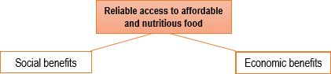

Study the model below. Access to energy affects social and economic wellbeing.
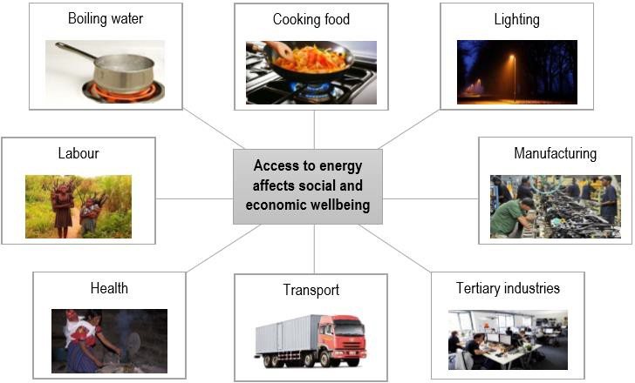
3. Outline some of the ways that poor access to energy limits social and economic wellbeing.
________________________________________________________________________________________________________________________________________________________________________________________________________________________________________________________________________________________________________________________________________________________________________________________________

Study Figures A and B.

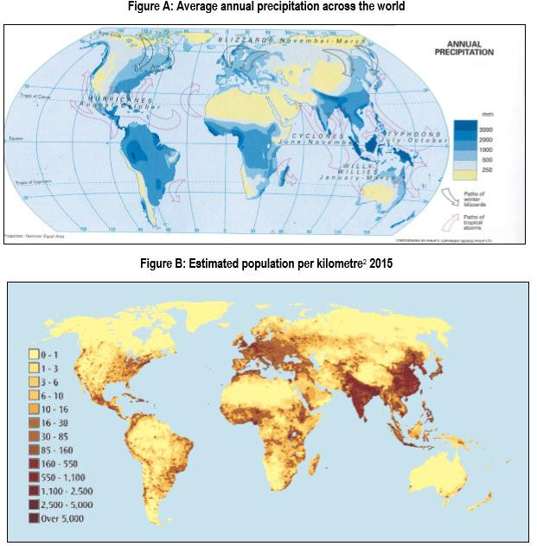

4. Using Figures A and B and your own knowledge, suggest why some places with high precipitation experience water scarcity.
________________________________________________________________________________________________________________________________________________________________________________________________________________________________________________________________________________________________________________________________

5.Using the vocabulary provided, complete the paragraph on resource demand and consumption.
Vocabulary: unsuitable, buy, electricity, import, NEEs, Venezuela, food, wealth, long-term, standard, greater, desalination, expensive, availability, barrels, none, dry, extract, technological, manufacturing, wind, exported, reserves, cars, USA, fuel, afford.

The global distribution of resources such as water, energy and ________is very uneven. Some countries don’t have their own natural energy_________ while others have enormous reserves. For example,____________has an estimated 297 billion ___________of oil while the USA has 36 billion and some countries have_____________.
Some countries have large food supplies, while other have _______climates or environments that are __________for food production. To access more resources, some countries have to _____________them or find ___________ solutions to produce more. For example, some countries invest in _________ farms to harness renewable energy, while others pay for ______________ plants (e.g. Spain). Others import oil (e.g. _______________ ). Importing resources is very _____________. Investing in renewable technologies is also expensive, but can provide a ____________solution. Consequently, consumption of resources is dependent on a country’s level of ___________, as well as resource ____________. It is little surprise that resource consumption is _________ in HICs, because they can afford to ____________ resources. Also, people in HICs are used to a certain ___________ of living. For example in the UK people expect to have ___________in their homes and ___________ to drive their cars.
Consumption is increasing rapidly in _______. In China, there are approximately 300 million _____________ on the roads and this is rapidly increasing as wealth rises. In NEEs industries such as __________ are expanding and this requires a lot of energy. In general, as wealth increases in NEEs, people can _________ to buy more food and water, which increases consumption.
Resource consumption is lower in LICs for various reasons: they may not be able to afford to ____________ their existing resources, or they may have to buy expensive imports which they can’t afford, or foreign companies may own their natural resources so they are ______________ out of the country.

The changing demand and provision of resources in the UK create opportunities and challenges.

6. Explain two reasons why demand for high-value foods such as exotic fruits and vegetables has increased in the UK in recent decades.
Reason 1. ________________________________________________________________________________________________________________________________________________________________________________________________________________________________________________________________________________________________________________________________
Reason 2. ________________________________________________________________________________________________________________________________________________________________________________________________________________________________________________________________________________________________________________________________
Study Figure C, showing distances travelled by a range of food imports to the UK.

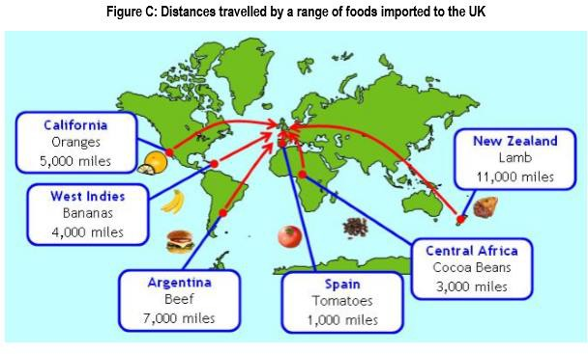

7. Using Figure C and your own knowledge, explain why the carbon footprint associated with UK food consumption is increasing.
________________________________________________________________________________________________________________________________________________________________________________________________________________________________________________________________________________________________________________________________8. A variety of strategies exist to reduce food miles. Create a spider diagram to briefly explain a range of these strategies.

Strategies to reduce food miles in the UK.

9. Outline one change in UK farming practices since the 1960’s.
________________________________________________________________________________________________________________________________________________________________________________________________________________________________________________________________

10. Annotate Figures D and E below with the following information:
a. Places with high annual rainfall
b. Places with low annual rainfall
c. Places with dense populations
d. Places with scarce populations

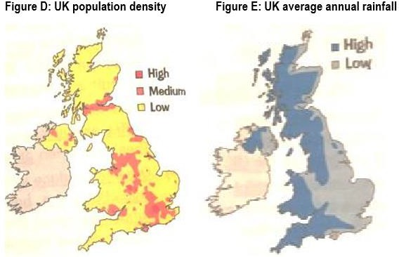
11. Using Figures D and E and your own knowledge, explain why water may need to be transported from some parts of the UK to other parts.
________________________________________________________________________________________________________________________________________________________________________________________________________________________________________________________________________________________________________________________________
12. Using Figures D and E and your annotations, circle the correct fact in each sentence below.
a. The UK’s population is predicted to increase by 1 million / 10 million / 100 million by 2040
b. Most new homes will be built in the north-east / north-west / south-east
c. Wales, northern Scotland and south-west England have dense populations / sparse populations
d. London, Manchester and Glasgow have dense populations / sparse populations
e. The north of England and all of Scotland tends to have a water surplus / water deficit
f. The south-east of England and the east of Northern Ireland tend to have a water surplus / water deficit
g. Areas that are likely to suffer water deficits are those with dense populations and low rainfall / those with sparse populations and high rain

13. Transferring water from areas of surplus to areas of deficit has a range of impacts. Annotate the pictures of the dam and aqueduct below with issues or conflicts that can arise over water transfer (e.g. economic, social, environmental, political).

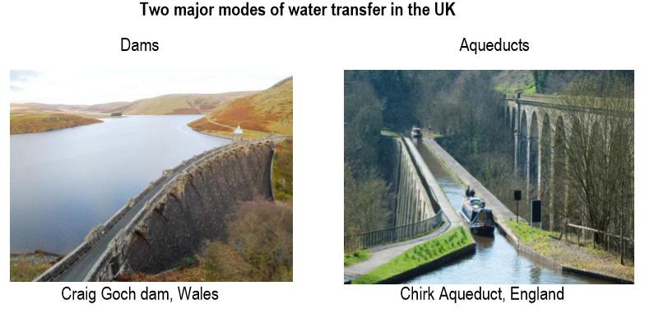

14. Offer two reasons why the demand for water in the UK is increasing.
Reason 1. ________________________________________________________________________________________________________________________________________________________________________________________________
Reason 2. ________________________________________________________________________________________________________________________________________________________________________________________________

Study the graph below, which shows how the UK’s energy
mix has changed over time.

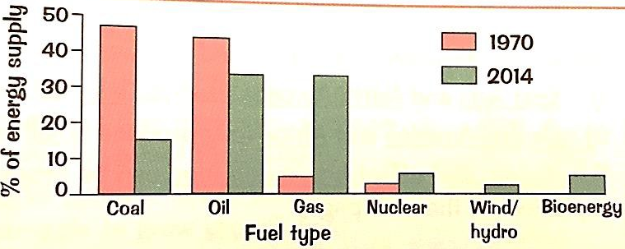

15. Compare the UK’s 1970 and 2014 energy mixes.
________________________________________________________________________________________________________________________________________________________________________________________________
________________________________________________________________________________________________________________________________
________________________________________________________________________________________________________________________________

16. Describe how the UK’s reliance on coal changed between 1970 and 2014.
________________________________________________________________________________________________________________________________________________________________________________________________
________________________________________________________________________________________________________________________________
________________________________________________________________________________________________________________________________

17. Using the graph below, describe how the UK’s reliance on imported coal has changed, and explain these changes.

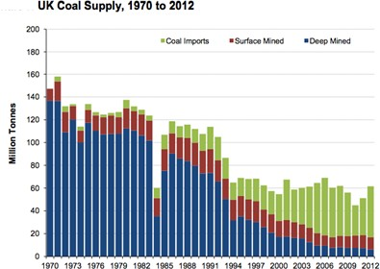
________________________________________________________________________________________________________________________________________________________________________________________________
________________________________________________________________________________________________________________________________
________________________________________________________________________________________________________________________________

18. Which of the following statements is true? Shade three ovals only.
- The UK’s reliance on domestic coal is increasing.
- The UK’s reliance on gas has increased in recent decades.
- Renewable energies such as wind are slowly increasing in use.
- Nuclear energy has no environmental risks.
- Burning fossil fuels emits greenhouse gases.

19. Economic issues result from the exploitation of both renewable and non-renewable energy sources in the UK. Beneath the model below, note down some of the issues/problems/conflicts that occur.

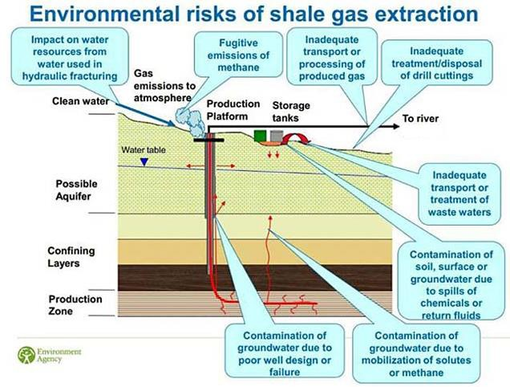

20. Study the ‘Environmental risks of shale gas extraction’ (fracking) diagram, created by the Environment Agency. Select two of the environmental risks from the diagram, and explain how each could affect the environment. An example has been done for you.

Example: Fugitive emissions of methane are likely to affect the environment because methane is easily trapped in the atmosphere, trapping the sun’s radiation and contributing to rising temperatures.
This can affect fragile species that require cold climates to survive and upset food chains as certain species thrive whilst others die out.

a. __________________ is likely to affect the environment because…
________________________________________________________________________________________________________________________________________________________________________________________________
b. __________________ is likely to affect the environment because…
________________________________________________________________________________________________________________________________________________________________________________________________

Demand for food resources is rising globally but supply can be insecure, which may lead to conflict.

21. Define ‘food security’.
________________________________________________________________________________________________________________________________

Study the food security risk index (below).

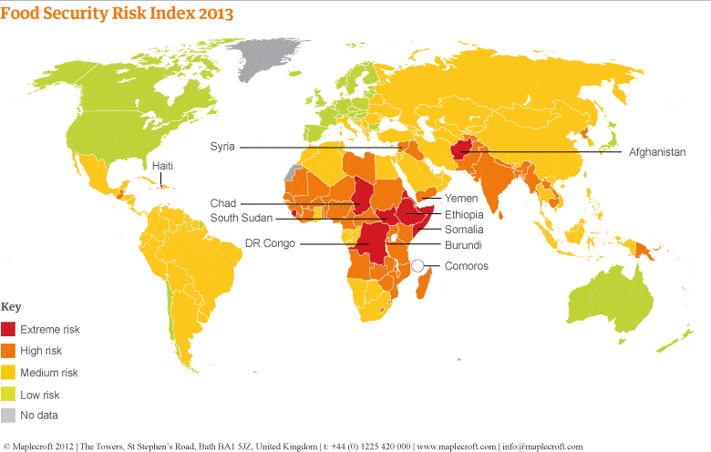

22. Describe the global distribution of places with medium risk of food insecurity.
________________________________________________________________________________________________________________________________________________________________________________________________________________________________________________________________

23. List three countries with low risk of food insecurity.
a. ____________________________
b. ____________________________
c. ____________________________

24. Using the map, complete the following sentences:
The continent with the highest number of countries with extreme risk of food insecurity is _____________________. A country in the Middle East with extreme risk of food insecurity is ___________________. Syria, India and Madagascar have a ________________________ risk of food insecurity.
25. Complete the paragraph below on food production and consumption, using the vocabulary provided.
Vocabulary: Africa, varies, wealth, calorie intake, import, Less, primary, available, USA, eat, income.

The amount of food that countries produce _____________ dramatically. East Asia and the _____________ produce a lot of food, while Central America and ________________ only produce small amounts. (This may seem surprising considering that you have already learnt that LICs tend to rely on the exporting of ________________ goods to make money- this indicates how small their economies are). The amount of food people ________ also varies across the world.
HICs such as the USA and UK can afford to __________lots of food and most people have a high enough ___________to purchase lots of food.
___________ developed areas such as central Africa cannot afford to import lots of food and less food is ______________ . People in NEEs consume less than those in HICs, but consumption in NEEs is growing rapidly as __________ increases. You can see why ____________________ is a useful development indicator.

26. Using Figures A and B suggest why global food consumption is increasing rapidly.
________________________________________________________________________________________________________________________________________________________________________________________________________________________________________________________________
________________________________________________________________________________________________________________________________

27. A number of factors affect food supply, and we can categorise these as physical or human. Complete the tables below to help you revise these factors. Some examples have been done for you.

 | PHYSICAL FACTORS AFFECTING FOOD SUPPLY
 |  | Explanation of how it affects food supply | Example
 | Climate
 | Water stress | Water is necessary for crops and livestock to survive. Areas with low rainfall or with limited groundwater availability for irrigation struggle to grow enough food.  Climate change is increasing the degree of water stress in many places, as temperatures rise and rainfall becomes more unreliable. | The Sahel region in northern Africa receives low annual rainfall and the ‘wet season’ is short and unreliable. In 35 of the last 40 years, rainfall in the Sahel has been below the level previously considered normal.
 | Pests and diseases
Poverty
Technology
Conflict |  | Fighting can ruin agricultural land and crops or kill livestock. In some cases, the land is ruined for decades.  When people are forced to flee it is difficult to ensure food supply.  Conflict disrupts trade routes which reduces or stops access to food. Conflict also prevents people working which reduces income and thus their capacity to purchase food.  In some cases, withholding food is used as a weapon of war. |  | In Cambodia and Bosnia landmines made large areas of land too unsafe to use, even decades after the wars ended. Right now (2017) in Somalia, food aid to drought-prone areas is being withheld by al-Shabaab as a way to control the population, so  famine is widespread.
Different strategies can be used to increase food supply.

28. Select two of the strategies below, and explain how each can be used to increase food supply.

Strategies: irrigation, aeroponics and hydroponics, the new green revolution, biotechnology, appropriate technology

Strategy 1 ________________________________________________________________________________________________________________________________
________________________________________________________________________________________________________________________________
Strategy 2
________________________________________________________________________________________________________________________________
________________________________________________________________________________________________________________________________

29. Complete the template below to help you revise your example of a large-scale agricultural development.

An example of a large-scale agricultural development.
Indus Basin Irrigation Scheme (p270-271)
A map to show the location of your chosen large scale agricultural development. | Background information What is produced? Provide details e.g. size of the development, amount of produce.
Advantages social/economic/environmental, statistics, stakeholder views. | Disadvantages social/economic/environmental, statistics, stakeholder views.

You’ve already looked at the idea of sustainability, and now you need to apply it to the challenges of providing enough food to rising populations.

Remember sustainability refers to solving a problem, without damaging the environment, costing too much, or impacting on future generations.
One of the problems with industrial agriculture is that it uses unsustainable amounts of water (70% of the world’s freshwater supply). Another problem is that it uses pesticides and fertilisers, which are toxic chemicals that contaminate soil and water, and can change food chains (e.g. via eutrophication.
There are more sustainable ways to grow and consume food.

30. Write a paragraph to describe and explain each of the three types of sustainable farming listed below, using the questions provided as a guide.

Organic Farming:
a. What sorts of natural processes are used in organic farming in order to cause less environmental damage?
b. Are herbicides, pesticides and vaccinations used? Why/why not?
c. Why do many organic farmers sell their goods close to where they are produced?
________________________________________________________________________________________________________________________________
________________________________________________________________________________________________________________________________
________________________________________________________________________________________________________________________________
Permaculture:
a. What is permaculture?
b. According to permaculture principles, should people grow their own food or buy it? Why?
c. According to permaculture principles, should people attempt to eat more or fewer animal products? Why?
________________________________________________________________________________________________________________________________
________________________________________________________________________________________________________________________________
________________________________________________________________________________________________________________________________

Urban farming initiatives:
a. What sorts of urban spaces are used for urban farming initiatives?
b. How does urban farming reduce food miles?
c. How does urban farming make cities more attractive?
________________________________________________________________________________________________________________________________
________________________________________________________________________________________________________________________________
________________________________________________________________________________________________________________________________

31. Write paragraphs to describe and explain how the strategies below can help us move towards a more sustainable resource future, using the questions provided as a guide.

Fish and meat from sustainable sources:
a. How can fishing quotas help to protect the environment?
b. How can consumers be helped to make informed decisions about purchasing sustainably farmed fish?
c. Why is a more sustainable approach to farming meat needed? How can meat farming practices become less harmful to the environment?
________________________________________________________________________________________________________________________________
________________________________________________________________________________________________________________________________
________________________________________________________________________________________________________________________________

Seasonal food consumption:
a. What does ‘seasonal food consumption’ involve?
b. How is purchasing out-of-season foods harmful to the environment?
c. What does ‘food miles’ mean, and how are food miles reduced by seasonal food consumption?
________________________________________________________________________________________________________________________________
________________________________________________________________________________________________________________________________
________________________________________________________________________________________________________________________________
Reduced waste and losses:
a. How much of the food that is produced is wasted or lost?
b. Why is food waste an environmental problem?
c. What sorts of schemes exist to educate people about food waste?
________________________________________________________________________________________________________________________________
________________________________________________________________________________________________________________________________
________________________________________________________________________________________________________________________________

32. To revise your example, complete the table below.
An example of a local scheme in am LIC or NEE to increase supplies of food.
Makueni Food and Water Security Programme, Kenya
Location (identify the country on the world map. Also, say where the scheme operates within that country) | Describe what the scheme involves
Say how it helps to increase sustainable supplies of food (most important part!) | Are there any problems with the scheme?

