Name___________

Geography

Rivers

Revision Guide

2023

River processes and landforms

1a. Landscape – an extensive area of land regarded as being visually and physically distinct as a result of the action and interaction of natural and human factors.  Relief – the height, shape and steepness of the land. | 1b. The wide range of rock type in the UK explains the varied landscapes found in the country.  The Tees-Exe line is a way of roughly dividing the country into the more rugged north and west and the lower-lying south and east. |  | 2. Drainage basin - area of land drained by a river and its tributaries.  Source – the start of a river.  Tributary – a small stream that joins a larger river.  Confluence – where a tributary joins a larger river.  Watershed – the edge of a river basin.  Mouth – the end of a river; usually where a river joins the sea.
3. The long profile of a river is the gradient of a river from source to mouth. A concave shape is the ideal long profile. The long profile of a river can typically be divided into three sections; the upper, middle and lower course.  A cross profile of a river is an imaginary ‘slice’ across a river channel and its valley.  Upper course – mostly (vertical) erosion landforms – waterfalls, gorges, rapids, v-shaped valley, and interlocking spurs.  Middle course – mostly (lateral) erosion & deposition landforms – meanders, ox-bow lakes.  Lower course – mostly deposition landforms – levees, floodplains, river estuary. |  | 4a. There are 3 fluvial processes:  - Erosion (x4)  - Transportation (x4)  - Deposition (x1)  Erosion:  - Hydraulic action – sheer force of the flow of water.  - Abrasion – Load carried by the river dislodges material from the river bed & banks.  - Attrition – Material carried by the river knocks against each other to become smaller & more rounded.  - Solution – Mildly acidic river water dissolves rock such as limestone & chalk.  Transportation:  - Traction – large particles rolled on the riverbed.  - Saltation – ‘bouncing’ of heavy particles.  - Suspension – small sediment held in the river.  - Solution – dissolved load.  Deposition takes place when the river no longer has the energy to carry the sediment. |  | 5. Interlocking spurs are outcrops of land (fingers) along the river course.  Waterfalls are most commonly formed when a river flows over a band of resistant hard rock.  A gorge is a narrow deep sided valley found immediately downstream of a waterfall.  Meanders are wide bends of a river. They are the most efficient channel for a heavily laden river as it flows over a gentle gradient. Meanders constantly change their shape due to lateral erosion & deposition.  Riffles are shallow turbulent portions whereas pools are deep efficient portions of the river. These lead to the development of meanders.  An ox-bow lake is an arc-shaped lake on a floodplain formed by a cut-off meander.  A floodplain is a wide, flat area of marshy land on either side of a river. They are formed by migration of meanders (lateral erosion) which in turn erodes the valley side. The extent of the erosion is marked by a bluff line. The deposition of silt during times of flood builds up a layer of fertile alluvium.  A levee is a raised bank found on either side of a river. These natural features are often built up by people as a flood defence.  Estuaries are transitional zones between river and coastal environments.
River flooding and management

1a. Flooding is where land that is not normally underwater becomes inundated. |  | 1b. Both physical and human factors increase flood risk. Flood risk increases when stores of water (wetlands, forests) are removed meaning more water will end up in the river channel. In addition flood risk increases when surface runoff is increased.
1c. A river flood occurs when a river channel can no longer hold the amount of water flowing in it. |  | 2a. Physical factors:  - Precipitation –  - Long period of heavy rainfall exceeds the volume of water a river can cope with.  - Torrential rainstorms lead to flash floods.  - Geology (rock type) – Impermeable rock encourages surface runoff and so speeds up water flow reaching the river channel.  - Steep slopes (relief) – Mountain environments with steep slopes encourages rapid transfer of water. |  |  |  |  | 2b. Human factors:  - Urbanisation – Increase in impermeable surfaces and drainage systems speeds up transfer of water reaching the river channel.  - Deforestation – Removal of trees removes a water store from the drainage basin. Trees intercept and slow down the transfer of water into the river channel.  - Agriculture – Surface runoff increases where soil is left exposed. Ploughed furrows can increase surface runoff if directed downslope.
3a. A hydrograph is a graph that shows the discharge of a river, related to rainfall, over a period of time.
Lag time is the time between peak rainfall and peak discharge. This is an important gauge of flood risk as it shows how quickly water is transferred into a river channel.
3b. The shape of a hydrograph is affected by rainfall and drainage basin characteristics. |  |  |  |  |  |  | 4a. When considering flood management options costs need to be weighed against the benefits:  Costs – financial cost & impact on the environment.  Benefits – financial savings made by preventing the flood & environmental improvements.
Characteristic | Short lag time |  |  | Long lag time
Basin size | Small basin |  |  | Large basin
Rock type | Impermeable |  |  | Permeable
Land use | Urban |  |  | Forests
Relief | Steep slopes |  |  | Gentle slopes
Soil moisture | Saturated soil |  |  | Unsaturated
Rainfall intensity | Heavy rain |  |  | Light rain
4b. Hard engineering involves using man-made structures to prevent or control natural processes from taking place. Hard engineering is expensive by the preferred option to protect high value land; housing estates, infrastructure. Hard engineering options include dams & reservoirs, channel straightening, embankments, flood relief channels.
4c Dams & reservoirs:
  - Benefit – Very effective in storing water & regulating water flow. Multi-function as used for irrigation, water supply, HEP, fishing, recreation.
  - Cost – Huge financial cost to build & maintain dams. Creation of reservoir floods habitats and forces people to move home.
- Channel straightening – Involves cutting through meanders to create a straight channel, often reinforced with concrete.
  - Benefit – redirects the water away from high value areas.
  - Cost – May create problems further downriver. Concrete lining is unattractive.
- Embankments – Reinforcing levees and increasing the height of the river bank so it can hold more water. Reinforced with concrete & stone or material dredged from the river.
  - Benefit – Protect high value vulnerable areas.
  - Cost – Use of concrete is unattractive. Embankments can still be breached to create additional damage.
- Flood relief channels – Man made river channel to bypass a vulnerable area.
  - Benefit – creates new waterways for recreation & nature.
  - Cost – Land lost to new channel & can cause problems downriver.
5a. Soft engineering involves working with natural river processes to manage the flood risk. Unlike hard engineering it does not involve building artificial structures or trying to stop natural processes. The aim is to reduce and slow the movement of water into the channel by natural means. There are costs and benefits.
5b. Afforestation: Planting trees in the drainage basin of a river. Trees soak up some of the rainwater. The flow of water to the channel is obstructed and slowed down.  - Benefit - Relatively inexpensive. Adds biodiversity.  - Loss of grazing land. |  |  |  |  | 5c. Wetlands and flood storage areas. Land allowed to deliberately flood. Water can be stored here to reduce risks further downstream.  - Benefit - A cheap solution but uses a lot of land. Keeps green space near town centres.  - Cost - Land is out of use for agriculture during the flood.
5d. Floodplain zoning: Restricting different land uses to different locations. Fewer impermeable surfaces next to the river so less flooding.  - Benefit - Low value land is flooded not houses or industry. The land can be used for recreation or agriculture. Cheap option – just administration.  Not viable where the floodplain has already been developed. |  |  |  |  | 5e. River restoration: Returning a river to its original course. Meanders slow down the flow and wetlands absorb floodwater.  - Benefit - New habitats are created and they are attractive environments.  - Cost - Can be expensive. Not always practical in a built-up area.
5f. Preparing for floods: People can be warned in advance and they can protect their valuables. The Environment Agency is the organisation responsible for this in the UK.  - Benefit - This is a cheap method of flood management.  - Cost - People don’t always listen to advice. People still have to clear up the mess made afterwards and this can be distressing. Response can be slow, inadequate and/or underfunded. |  |  |  |  | 6a. Boscastle is a picturesque, rural village, and is extremely popular with tourists. It is a medieval harbour and village hidden in a steep sided valley. Boscastle is at the confluence of the River Valency and River Jordan, which come from the high hills of Bodmin Moor. A third river, the Paradise, also flows through the village.  Boscastle was hit by a torrential flash flood event on 16th August 2004. The causes of this were both physical and human:
6b. Physical causes:  - Over 60mm of rainfall fell in 2 hours (a typical month’s rainfall).  - The ground was already saturated due to the previous 2 weeks of above average rainfall.  - The drainage basin has many steep slopes.  - The drainage basin has areas of impermeable slate causing rapid surface runoff.  - Boscastle is at the confluence of 3 rivers, Valency, Jordan and Paradise. A large quantity of water all arrived within a short space of time causing the rivers to overflow.  - The flooding coincided with a high tide, making the impact worse. |  |  | 6c. Human causes:  - Old sewer and drainage system with low capacity.  - Lack of any flood control e.g.; raised banks around river and emergency drainage ditches.  - Small, low bridges over river trapped material such as trees and cars acting as a damn and causing more water to flow around the bridge leading to flooding. |  |  | 6d. Effects of Boscastle floods:  - Cars belonging to more than 1,000 people were damaged or swept away.  - Income from tourism was lost. This had an impact on livelihoods and the local economy.  - There were vast numbers of subsequent insurance claims.  - No lives were lost, partly due to the rapid response of the emergency services.  - 25 business properties destroyed.  - 50 buildings damaged.  - 4 footbridges washed away.  - Pavements and gardens damaged by weight of water.  - Roads blocked so rescue by helicopter only.
6e. Short term responses:  - Helicopters rescued stranded people.  - Buildings searched for survivors.  - Cars swept into harbour were removed.  - Roads cleared.  - Trees & debris removed from river channel. |  |  |  |  | 6f. Long term responses:  - Businesses & homes repaired & rebuilt.  - River was widened & lowered – stone embankments.  - Drainage overflow culvert widened and maintained.  - Trash screens installed across culverts.  - Car park raised & given a permeable surface.  - New single span bridge built.  - Water gauging stations were set up.

What do I need to revise?

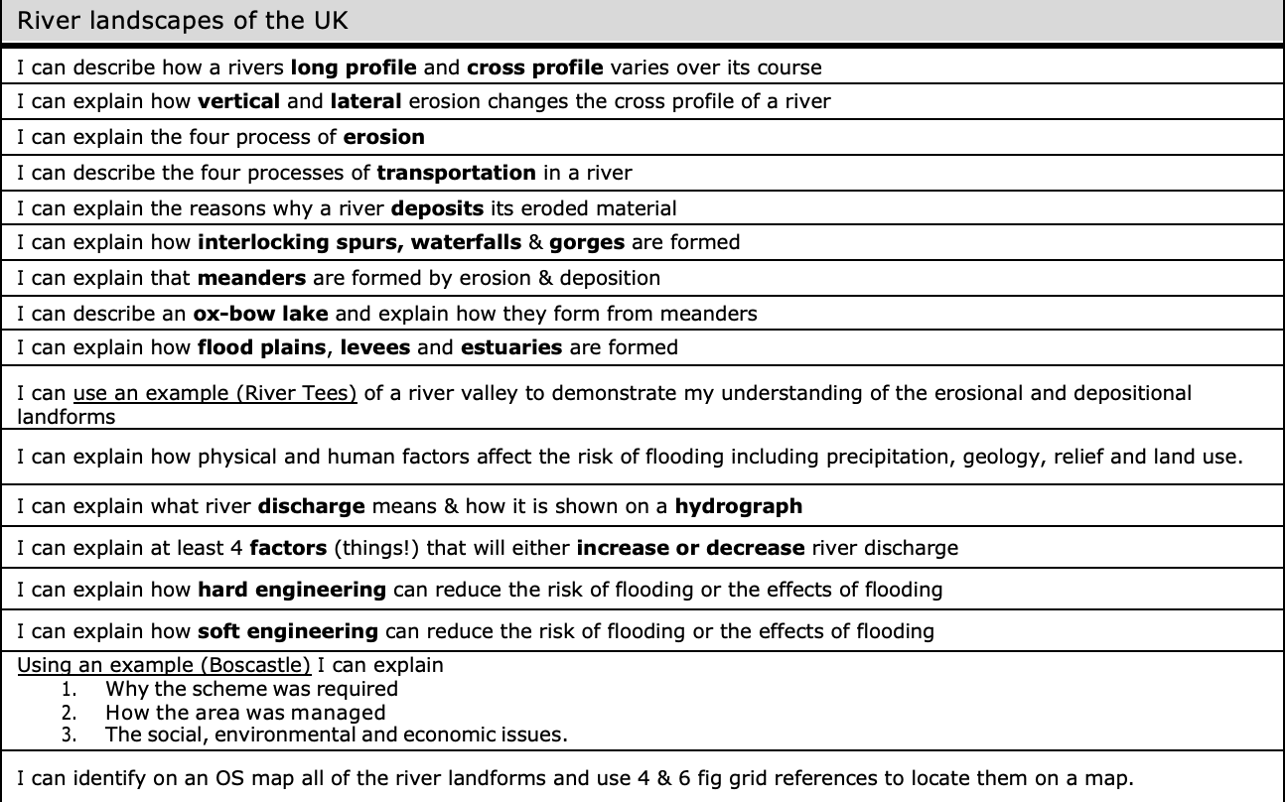

Key idea: The shape of river valleys changes as rivers flow downstream.
- The figure below shows the long profile and cross profile of a typical river. Using the figure and your own knowledge,
compare the width, depth and gradient of the upper and lower courses of a typical river.
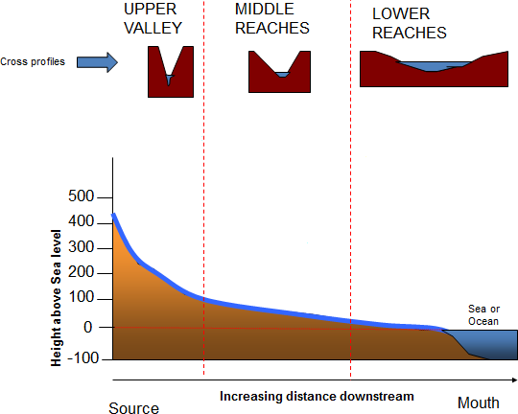
This seems like a complex question because you have to do a lot, but actually it’s simple! Break it down into three parts: first, compare the width of the upper and lower courses, Next, compare the depth. Finally, the gradient (the steepness). Easy!

- Complete the spider diagram below by summarising each of the fluvial (river) processes.
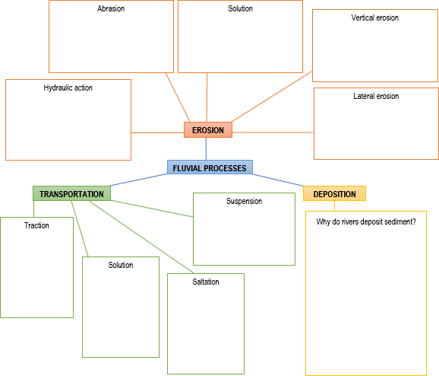

Key idea: Distinctive fluvial landforms result from different physical processes.

- You need to know a range of river landforms resulting from erosion and deposition (their characteristics and formation). In the tables below, complete the blank columns. Under ‘characteristics’, you need to identify the features of the landform (e.g. for flood plain you might write low, flat land on either side of a river in the lower course, fertile soil from alluvium and other deposited sediments, often used for farming). Under ‘formation’ you need to provide a step-by-step explanation of how it forms, referring to specific processes (e.g. simply saying ‘due to erosion’ isn’t specific enough- say whether it is hydraulic action, abrasion or attrition, and how that process creates the landform).

Fluvial (river) landforms resulting from erosion
Landform | Image | Characteristics (and where it is found- upper/middle/lower) | Formation  (step-by-step explanation)
Interlocking spurs | 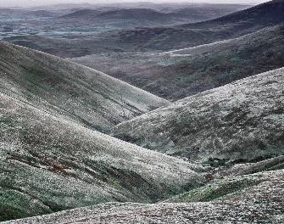
Waterfall | 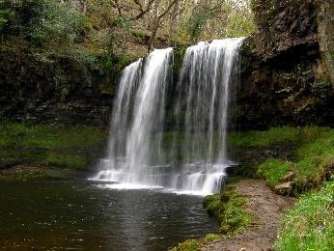
Gorge | 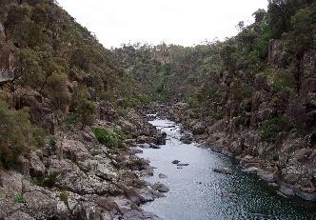

Fluvial (river) landforms resulting from erosion and deposition
Landform | Image | Characteristics (and where it is found- upper/middle/lower) | Formation  (step-by-step explanation)
Meander | 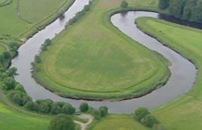
Oxbow lake | 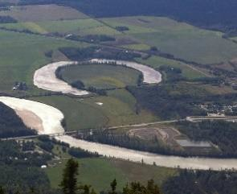

Fluvial (river) landforms resulting from deposition
Landform | Image | Characteristics  (and where it is found- upper/middle/lower) | Formation  (step-by-step explanation)
Levee | 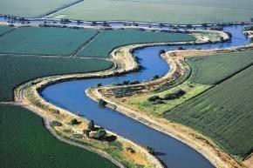
Flood plain | 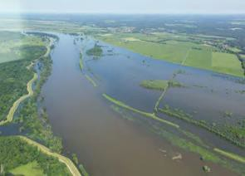
Estuary | 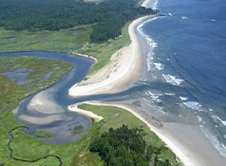

OS MAP FOCUS

- Now you know about river features, but are you confident to identify them on an OS map? The following information will help you to do this. Answer the questions at the end.

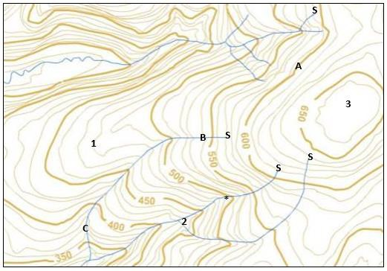
Contour lines are the orange lines that you see on maps. They show the
height (or elevation) of the land in metres (at A the land is 600m high.)

The closer together the lines are, the steeper the land (‘steep relief’). If they are far apart, this indicates that the land is quite flat (‘gentle relief’). Based on this, we can see that the map shows an area of steep land.
This indicates that the rivers shown are in their upper course!

A V shape is formed where the contour lines cross a river (*). The V shape is pointing uphill to where the river came from.

And of course you know that water flows downhill! You should be able to tell the direction that the rivers are flowing in by using the contour lines (the river flows away from B where the land is 540m high, towards
C where the land is 370m high). Also, we know that the source (start) of a river is found inland and flows towards the coast, so we know that where the blue river line begins is the source (e.g. S).

To re-cap: the main evidence on the map above to show that these are rivers in the upper course is- a) the contour lines are close together
showing that land is steep, b- the V-shape points to where the river came from, and c- we can see the sources of the rivers.

Questions based on the map above:

- How high is the land at point 1?
- What is the river feature at point 2?
- What is the difference in land height between points A and B?

- What is the land like at point C?

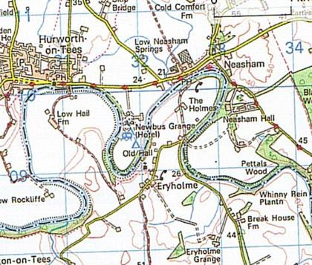
The map to the right shows a river in its lower course. Evidence for this:

- the contour lines are far apart (indicating fairly flat land) and the land elevation is low
- the river has large meanders

- the river meanders across a large flat area (the flood plain), and

- the river is wide (a wide blue line)

Example alert!
The specification says that you need to use an ‘example of a river valley in the UK’ to identify its major landforms of erosion and deposition.

The specification says that you need to use an ‘example of a river valley
in the UK’ to identify its major landforms of erosion and deposition.
- Complete the template below to help you learn/revise your example.

AN EXAMPLE OF A RIVER VALLEY IN THE UK
My example: The Tees
Major landform/s caused by erosion |  | Major landform/s caused by deposition
An example of a landform caused by erosion in the  valley is a:  . It is located:  The characteristics of the landform are: |  | An example of a landform caused by erosion in the  valley is a:  . It is located:  The characteristics of the landform are:
Labelled diagram of the landform |  | Labelled diagram of the landform
Description of how the landform may change in the future and explanation why. |  | Description of how the landform may change in the future and explanation why.

Key idea: Different management strategies can be used to protect river landscapes from the effects of flooding

PHYSICAL factors that affect flood risk include precipitation (rainfall), geology (rock type), relief (land shape).

- Below, explain how each factor affects flood risk, using the key vocabulary provided. An example has been done for you.

Vocabulary: permeable, impermeable, infiltration, steep-sided valley, surface runoff, discharge.

Precipitation: Prolonged rainfall causes soil to become saturated. This means that infiltration cannot occur, so surface runoff increases, and this causes rivers to fill up quickly. In the case of heavy rainfall, the water arrives too quickly for infiltration to occur, so surface runoff carries water to the river channel. As the river discharge increases, a river may spill over its banks, causing a flood.
Geology:

Relief:

The key HUMAN factor that affects flood risk is land use e.g. building on the flood plain and deforestation.

- Below, explain how each factor affects flood risk, using the key vocabulary provided.

Vocabulary: impermeable materials, concrete, tarmac, interception, surface runoff, discharge.

Building on the flood plain:

Deforestation:

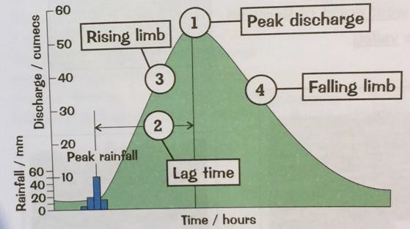
- Study the storm hydrograph to the right to remind you of the key components of a hydrograph. Below, say what each part of the hydrograph tells us about a river:

- Peak discharge:

- Lag time:

- Rising limb:

- Falling limb:

- Using the river discharge data provided, identify the mode, median, mean and range.
Mode: the most common Median: the middle value (when values are in order of size) Mean: the average
Range: the difference between the greatest and smallest values

Sample | 1 | 2 | 3 | 4 | 5 | 6 | 7
River discharge (cumecs) | 184 | 90 | 159 | 142 | 64 | 64 | 95

Mode:

Median:
Mean:

Range:

- The hydrographs below show two instances where the rainfall data is exactly the same, yet the peak discharge and lag time differ. Suggest and explain reasons for these differences. Try to use data in your response.
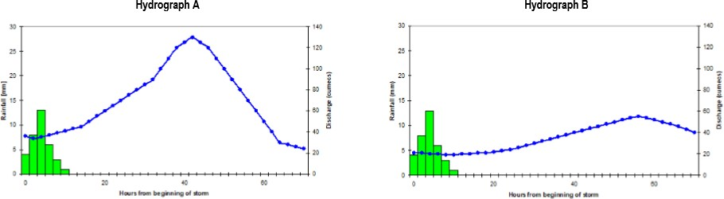

- Give two examples of hard engineering strategies that can be used to manage flood risk other than dams and reservoirs.

- Explain how flood warnings can help to reduce the effects of flooding.

The specification says that you need an ‘example of a flood management scheme in the UK’.

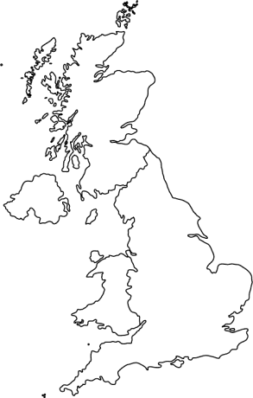
- Complete the template below to help you learn/revise the example.
The specification says that you need an ‘example of a flood management
scheme in the UK’.
Example alert!

AN EXAMPLE OF A FLOOD MANAGEMENT SCHEME IN THE UK
My example:
Identify the location of your chosen flood management scheme on the map. Be sure to label the place name. | Provide a sketch drawing of your chosen flood management scheme.
Explain the reasons why management scheme was needed. | Describe the management scheme and explain how it helps to manage flood risk and its impacts.
Outline the social, economic and environmental issues. Within this section you might also discuss stakeholder opinions and any conflicts.) |  | Evaluate the effectiveness of the management scheme.

