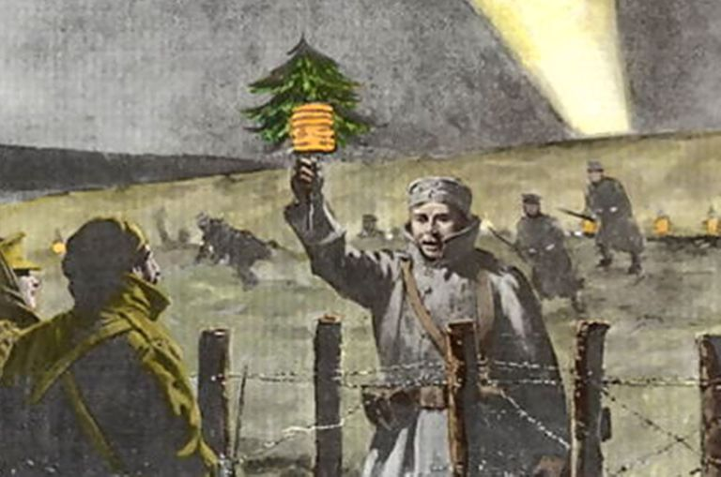
WWI and the Christmas Day Truce

- Copy out the words below and find the definitions for each:
Truce
Official
Respect
Unofficial
Suspicious

- Research what happened with the Christmas Day Truce in 1914. Present your ideas as a poster, a leaflet or a fact file.

- Read the real life letter, written by a soldier from Gloucester, which was published in a British newspaper. Then complete the tasks which follow.

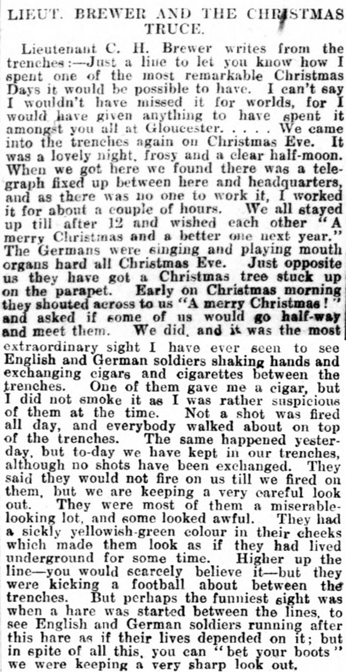
Christmas Day Truce 1914 news report

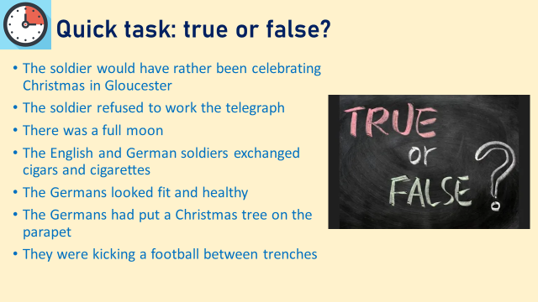
Questions!
- Answer the questions below, which get trickier the further down the list you go, so try to challenge yourself and get them all answered!
- What adjective does the soldier use to describe the day?
- What kind of night is Christmas Eve described as being?
- Why did the soldiers wish each other “A merry Christmas and a better one next year”?
- What had the Germans done to celebrate it being Christmas Eve?
- Who initiated the truce and how did they do it? How does that make you feel?
- What did the soldier get as a gift and what did he think about it? Why did he think that?
- Why was it such a big deal that they were able to walk around on the ground?
- How has the soldier described the Germans’ appearance? How does that make you feel about the German soldiers?
- Why has the soldier used hyphens (-)?
- Why would seeing English and German soldiers chasing a hare be ‘the funniest sight’?

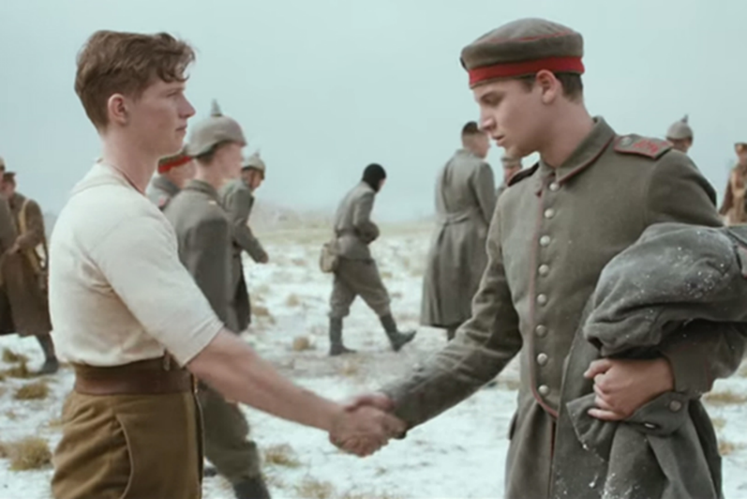
In 2014, one hundred years later, Sainsbury’s released their Christmas advert inspired by this unofficial Christmas Day Truce. It tells the story of two young soldiers involved in the event.

- Watch the advert using the link below
https://www.youtube.com/watch?v=-eJn3j7Qr9A

How does the advert make you feel about the event and why?
Answer in full sentences with plenty of explanation.

Descriptive Writing:
- You are now going to be completing descriptive writing based on this event
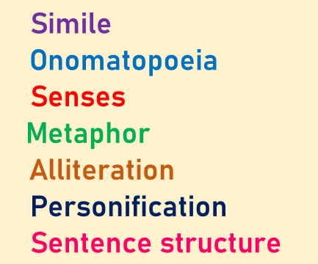
Remind yourself of these techniques, nothing down any you need help remembering.

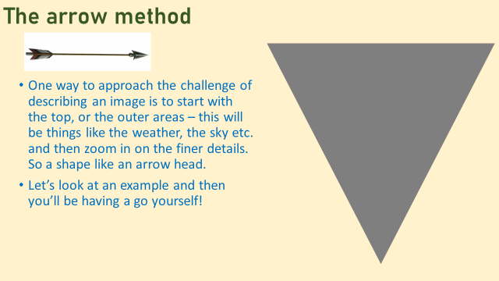

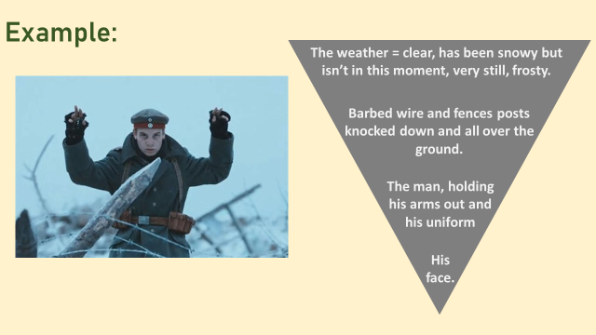
You can also bullet point important details from the picture which will help you write it up:

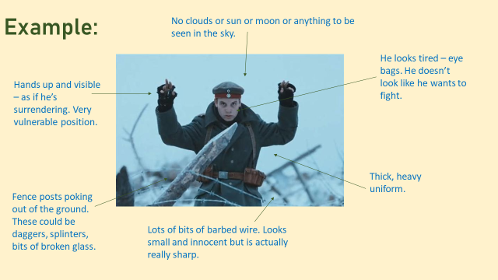
Now look at an example of how this could be written up…

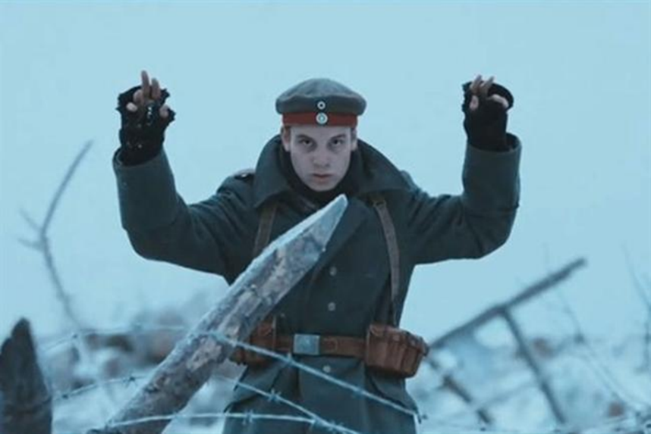

The air felt thick and heavy, but very still. A great weight upon the shoulders of the soldier. There was no wind, but the cold was bitter and biting, nipping at any brave bit of flesh exposed. The ground was hard, rock hard, where an angry frost had clung to every blade of grass and rock edge; the sun too weak and tired to melt it.
Bits of wooden fence post jutted out of the ground likes shards of glass. Intertwined were loops of barbed wire, the glistening points frozen and sparkling. Glistening points which disguised the devilish dagger-sharp edge below.
The soldier stood, like a statue. A statue with trembling hands and a quivering lip. His dark green uniform looked dirty compared to the pure white of the snow around him. His hands were empty in surrender, but his eyes were full. So full. Of sorrow and remorse, of exhaustion and guilt. Deep purple smears under each eye told stories of what he’d been through to get to this point. Every puff of breath which escaped his mouth was a plea for empathy. Truce.

- For the following image you need to draw a triangle and write down everything on the outside of the image and then zoom in to a finer detail
- Then you need to bullet point all the details you need to write up in your description
- Then, when you’re ready, write up a description of the image using your plan and the SOSMAPS techniques. Aim for half a page at least!

Your picture is…..

