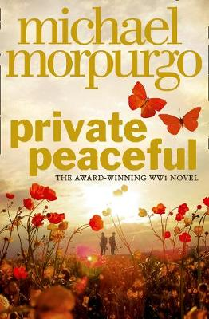
Parts 12 and 13

Part 12 – Five to Five
- Listen to Part 12 through the link on the accompanying PowerPoint
- Create a flow chart of the events of this part using both words and images

In the opening of this part, the present day Tommo tells readers that a Private Peaceful will be killed as a punishment for cowardice. He says that ‘I want it to be where there is sky and clouds and trees, and birds.’
- Thinking back to Tommo and Charlie’s childhood, why would it be important to have the execution in an area filled with nature?

Charlie disobeys Sergeant Hanley:

- Copy out the technique and definition below
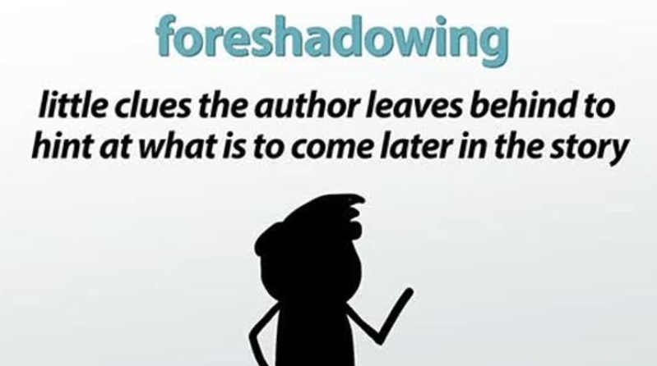

- What events in Tommo and Charlie’s childhood could be an example of foreshadowing, hints which suggested something like this would happen?
Courts Martials in WWI:

- Use the internet to make some bullet point notes or a spider diagram to present some research on what a courts martial was and why they happened.

Part 13 – Twenty-Seven Minutes to Six
- Listen to Part 13 through the link on the accompanying PowerPoint
- Create a flow chart of the events of this part using both words and images
The End

Personal response:

Answer the below questions, focusing on using your own opinions and explaining your ideas clearly.
- Why do you think Charlie would want Tommo to reveal the truth about what happened?
- How do you feel about finding out that Sergeant Hanley died?
- Why do you think Michael Morpurgo has ended the story with Tommo still on the frontline?

What’s next for Tommo?

- Imagine you have been asked to help Michael Morpurgo write a sequel to Private Peaceful.
- In a spider diagram or bullet point list note down as many different ideas about what could happen next for Tommo

