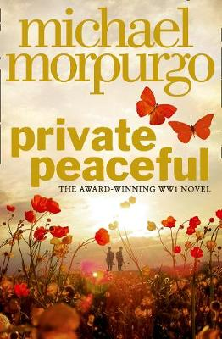
Parts 9, 10 and 11

Part 9 – A Minute past Three
- Listen to Part 9 through the link on the accompanying PowerPoint
- Create a flow chart of the events of this part using both words and images

Tommo regrets falling asleep and the precious lost time. He finds himself singing ‘Oranges and lemons’ like Big Joe to stay awake... Tommo recalls the time when his company left Etaples to move up to the front line. The singing keeps spirits up.

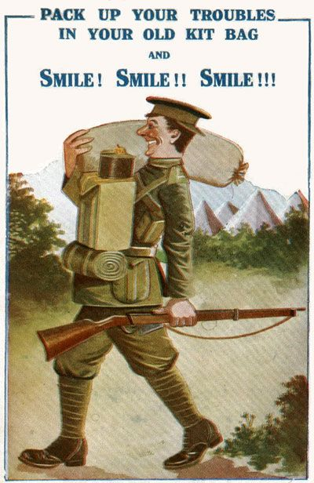
WWI and singing:

‘Pack up your troubles’

This cheery, upbeat marching song was written in 1915 by Welsh brothers Felix Powell (an army staff sergeant) and George Henry Powell (who became a conscientious objector). Wilfred Owen, a famous WWI poet, used the repetition of ‘smile’ in his poem Smile, Smile, Smile (1918), a reference to the false cheer of young soldiers heading out to the front, only to suffer.

Let’s look at the chorus:

Pack up your troubles in your old kit-bag
And smile, smile, smile,
While you've a lucifer to light your fag,
Smile, boys, that's the style.
What's the use of worrying?
It never was worth while
So pack up your troubles in your old kit-bag
And smile, smile, smile

- Why do you think the writers have repeated the word ‘smile’ so much?
- What does it mean to ‘Pack up your troubles in your old kit bag’?
- Who is the writer talking to when he says ‘boys’?
- Why has he used this particular word?
- What does ‘that’s the style’ refer to?

The Other Soldiers:

The soldiers Tommo pass returning from the front are said to look ‘haunted’.
- Write out the adjective ‘haunted’ in the middle of a spider diagram. Around the outside make notes on what this word means and any ideas, images or thoughts which come to mind when you hear/ see this word.

- Answer the question below, in full sentences with plenty of explanation.

What does it suggest if the soldiers Tommo sees look ‘haunted’?

Part 10 – Twenty past Three
- Listen to Part 10 through the link on the accompanying PowerPoint
- Create a flow chart of the events of this part using both words and images
Tommo in the present reveals that he has just turned down offers of help from other soldiers, he is waiting somewhere alone.

- Find and copy out a definition for the word ‘comrade’
- Answer the below in full sentences with explanation:
- Why do you think it is important to have ‘comrades’ in the war?
- Why might living so closely to your comrades be a negative thing too?

Part 11 – Nearly Four O’clock
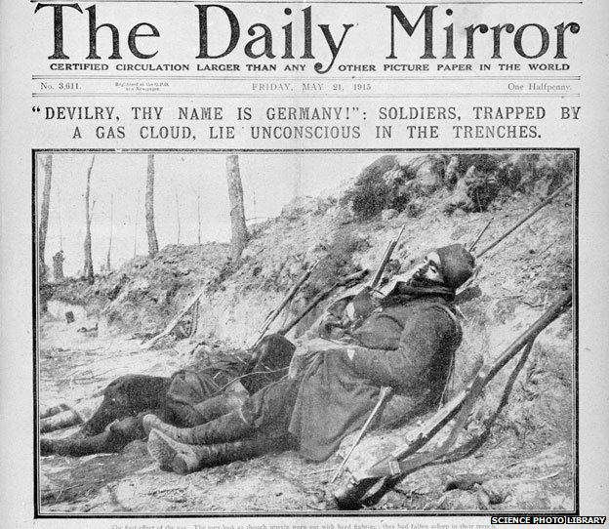
- Listen to Part 11 through the link on the accompanying PowerPoint
- Create a flow chart of the events of this part using both words and images
Gas Attacks:

- A historian states:
"I think its scary science, the thought that it gets into your system and you can't really see it, unlike a piece of shrapnel or a bayonet wound."
- Ian Kikuchi, a historian at the Imperial War Museum in London also sees something insidious about gas.
"Gas, which moves like a vapour, brings to mind ghosts, phantoms and other things associated with death," he says.
"I also think it has something to do with gas masks themselves - to protect yourself from the gas you have to make yourself look and sound frightening."
- The most widely used, mustard gas, could kill by blistering the lungs and throat if inhaled in large quantities. Its effect on masked soldiers, however, was to produce terrible blisters all over the body as it soaked into their woollen uniforms. Contaminated uniforms had to be stripped off as fast as possible and washed - not exactly easy for men under attack on the front line.
- One historical writer says:
"The reason it was banned is because it had been a particularly grotesque weapon. Gas had not worked - and it was considered unsoldierly."

- What makes gas attacks scarier than bayonet attacks, or bomb explosions?
- What has one historian compared gas attacks to, and how does this show how scary they were?
- Why might the protective equipment supplied not be desirable for the soldiers to wear?
- Why would soldiers still be scared of a gas attack, even when wearing one of these masks?
- What adjective has been used by a historical writer to describe a gas attack?

- Based on the notes above, do you think Michael Morpurgo has successfully described the horror of a gas attack in this part of Private Peaceful?
Answer in full sentences with lots of explanation!

Charlie Returns:

Charlie returns home to join Tommo back in France.
- Imagine you are going far away from home, somewhere there is no electricity! You are allowed to take five things with you. Bullet point these five items with a brief explanation.

