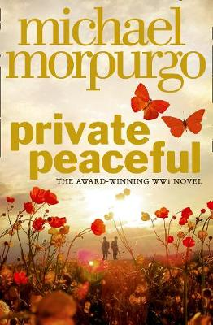
Parts 7 and 8

Part 7 – Twenty-eight Minutes Past One
- Listen to Part 7 through the link on the accompanying PowerPoint
- Create a flow chart of the events of this part using both words and images

Propaganda:
- What does the word ‘propaganda’ mean?
- Why was propaganda used in WWI?
- Find some examples of propaganda posters
Sergeant Major’s Speech:
I shan’t beat about the bush, ladies and gentlemen. I shan’t tell you it’s all tickety-boo out there in France – there’s been too much of that nonsense already in my view. I’ve been there. I’ve seen it for myself. So I’ll tell you straight. It’s no picnic. It’s hard slog, that’s what it is, hard slog.
Only one question to ask yourself about this war. Who would you rather see marching through your streets? Us lot or the Hun? Make up your minds.

Because, mark my words, ladies and gentlemen, if we don’t stop them out in France the Germans will be here, right here in Hatherleigh, right here on your doorstep.
They’ll come marching through here burning your houses, killing your children, and yes, violating your women. They’ve beaten brave little Belgium, swallowed her up in one gulp. And now they’ve taken a fair slice of France too. I’m here to tell you that unless we beat them at their own game, they’ll gobble us up as well.

Well, do you want the Hun here? Do you?

Shall we knock the stuffing out of them then?

Good. Very good. Then we shall need you. You, and you and you.
And you too, my lad.

Your king needs you. Your country needs you. And all the brave lads out in France need you too. And remember one thing, lads – and I can vouch for this – all the girls love a soldier.

So, who’ll be the first brave lad to come up and take the king’s shilling?
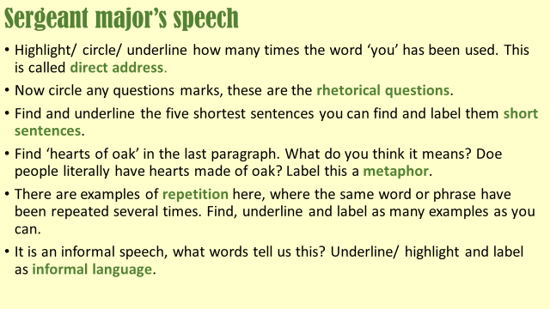
Who’ll lead the way? Come along now. Don’t let me down lads. I’m looking for boys with hearts of oak, lads who love their King and their country, brave boys who hate the lousy Hun.
How persuasive do you think this speech is, and why?
(Make sure you reference the speech and what the sergeant says in it when you explain your ideas.)

Part 8 – Fourteen Minutes past Two
- Listen to Part 8 through the link on the accompanying PowerPoint
- Create a flow chart of the events of this part using both words and images

A Soldier’s Experience:
- Your task is to create two short pieces of work. You need to imagine you are a young soldier in WWI, like Tommo.
- Write a diary entry (1/2 page) detailing the reality of what life was like in the trenches.
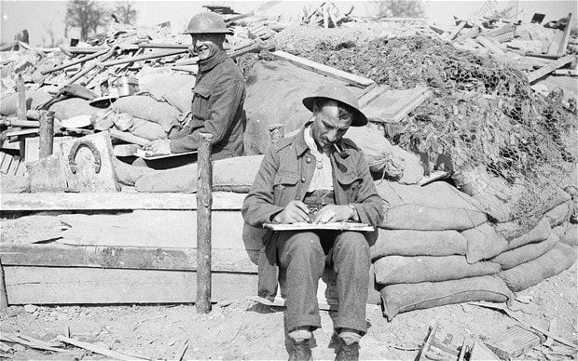
- Then write a letter home (1/2 page) to your family or friend saying what you think a soldier would report home to their loved ones. These should be contrasting accounts, but both should focus around presenting the emotions of a young soldier!

Animals in WWI:
Tommo references the horses being stowed below as they travelled out. Michael Morpurgo explored the use of horses in the war in his book ‘War Horse’ (it’s also a play and a film!)
- Copy the link below into a web browser and read through the information on animals in war.
https://www.bbc.co.uk/newsround/28604874
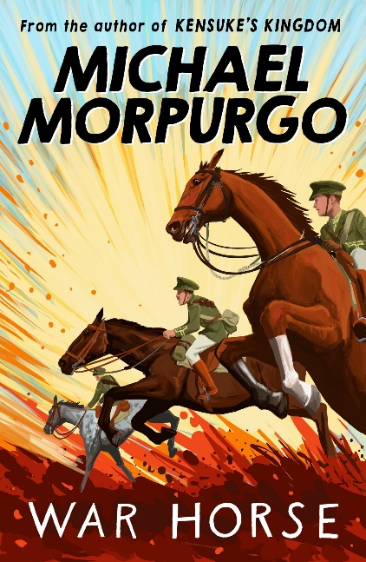
- Create a poster, leaflet or insert from a history textbook presenting what you find out

- Answer the question below, focusing on expressing your own opinion and explaining your thoughts clearly:

Do you think it is right for animals to be used in war, when they can’t consent?

