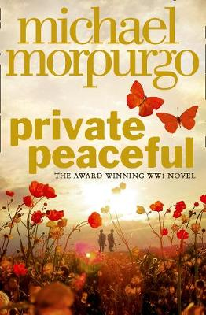
Parts 5 and 6

Part 5 – Twenty-Four Minutes Past Twelve
- Listen to Part 5 through the link on the accompanying PowerPoint
- Create a flow chart of the events of this part using both words and images

The Opening:
- Tommo references ‘no man’s land’. Complete a piece of research and present your findings on what ‘no man’s land’ is and why it is called that. You could bullet point your ideas in a fact file, or in a more interesting way if you wish.

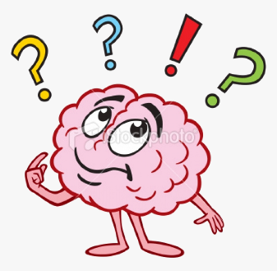
Personal Response:
- How do you feel about Tommo becoming the ‘go-between’ and the messenger delivering letters between Molly and Charlie? Write in full sentences and explain your answer fully.

Then vs Now:
- Charlie and Tommo have a very different education and teenage life to most people today. Complete a piece of research on education and teenage life around 1913 (before WWI.) Note down your ideas in a way which suits you, such as a spider diagram or bullet point list.
- Write a pros and cons table, like the one below, for both life for a teenager back then and life for a teenager today.

Life as a teenager before WWI:
Pros: (Positives ) | Cons: (Negatives )

Life as a teenager today:
Pros: (Positives ) | Cons: (Negatives )

The Big Reveals:
At the end of this part of the story we find out two major things. Firstly, that the Colonel shoots Bertha and secondly, that Molly and Charlie’s secret meeting place has been discovered.
- Note down how each of the following characters will be feeling at the end of this part of the story, with a brief explanation for each:
- Tommo (who loves Molly, looks up to Charlie and has unknowingly been helping them to meet in secret)
- Mother (who defended Charlie when he stole Bertha, and paid to take her from the Colonel)
- Charlie (who feels responsible for Tommo, knowing he is looked up to, but loves Molly and Bertha too)
- Molly (who feel close to Tommo and loves Charlie, and is always acting so kindly)
- The Colonel (who has a vendetta against the Peaceful family and is always trying to catch them out and punish them)

Part 6 – Nearly Five to One
- Listen to Part 6 through the link on the accompanying PowerPoint
- Create a flow chart of the events of this part using both words and images

Personal Response:
Private Peaceful was written in 2003, so a long time after WWI (and WWII.) This means that everyone reading the story will know about the war, what happened and that it wasn’t ‘the war to end all wars’ as those alive then believed.
Dramatic Irony is a technique which means that someone reading a book, or watching a film/ TV programme, knows something which the characters don’t.
An example of this can be found in the Disney film ‘The Lion King’ when the character Simba believes he got his father killed – but viewers know it was actually Scar who killed him!
- Copy out this definition and the example. Can you think of any others?

Deeper thinking questions:
- Answer the following questions in full sentences with detailed explanation.
- When reading Private Peaceful, we as readers know how long and tragic the war was. We also know that Tommo is involved in WWI. How does this affect our feelings towards Tommo?
- Why do you think it is important for authors to write stories set in the past?

Big Joe is Missing:
- Create a ‘missing’ poster for Big Joe, which the Peacefuls could have put out around the village. Use the guide below.
MISSING!
Name:

Appearance:

Reasons he’s missing:

Personality:

Who to contact with information:

How to approach:

