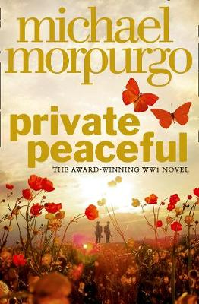
Parts 3 and 4

Part 3 – Nearly Quarter Past Eleven
- Listen to Part 3 through the link on the accompanying PowerPoint
- Create a flow chart of the events of this part using both words and images

Grandma Wolf:
- Create a spider diagram with the word ‘wolf’ in the middle
- Around the outside note down all the characteristics of a wolf
- Now circle all of these which could be applied or adapted to describe the character Grandma Wolf

Animal Symbolism
- Create a poster to present which animal best symbolizes you. Think about the following points to help you decide (there are probably quizzes online to help with this also!) Then pop a picture of your chosen animal in the middle and notes around the edge to help explain your choice.
Are you shy or outgoing?
Are you athletic?
Do you like to be cozy or outdoors?
Do you like to be around lots of people or your own company?

Village Life:
- The village and community which Tommo and the Peacefuls are a part of plays an important role in the story. Research what life was like in rural (countryside) Britain before WWI. You could present your ideas in a variety of ways: poster, leaflet, fact file or even a Power Point presentation.

Part 4 – Ten to Midnight
- Listen to Part 4 through the link on the accompanying PowerPoint
- Create a flow chart of the events of this part using both words and images

Peacefuls and Poaching:
- Write out a definition, in your own words, for what poaching is
- Imagine you are the Colonel, and you have discovered some people have been poaching on your land. Write a letter to the local parish council complaining and asking for help.
Letter Writing Guide:
To whom it may concern
Paragraph One: Introduction
Briefly outline why you are writing this letter
Paragraph Two: Make it personal
Explain how the subject (poaching) affects you
Paragraph Three: Involve the reader
Now you need to make the reader feel like they’ll be impacted too, to get them on your side.
Paragraph Four: Actions
Now explain why you want the parish council to help you, and what will happen to anyone if you catch them yourself!
Paragraph Five: Conclude
Round things off by reminding the reader of the letter why you are writing/ what you want.
Sign off with: Yours sincerely
Use the criteria and guide below to help.
Letter Writing Criteria:
- An engaging opening which will shock or intrigue the reader
- Lots of emotion and opinion
- Facts

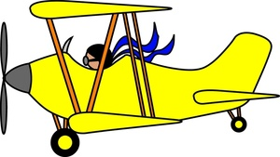
The Yellow Plane:
Most children would still be intrigued by a plane landing in the field they are playing in now, so imagine how children pre WWI would feel, having never seen a plane, and only having seen very few cars.
- Imagine you are one of the children seeing this yellow plane land. Write a paragraph to describe the experience using all five senses.

Mr Munning’s disbelief:
Mr Munning’s doesn’t believe Tommo’s story about the yellow plane, even with the humbugs.
There is a game where a person says two things which are true and one thing which is a lie. The receiver of these has to ask questions and then have a guess at which one is the lie.
- Have a go at writing out two things about yourself which are true and one thing which is a lie. These can be in any order and can be about anything (seethe example below.) The have a go at this game with a member of your household or a friend to see how well you’ve managed to convince them!
Example:
- I broke my arm running away from crazed fox
- My trousers split at a trampoline park
- I shared a taxi with a celebrity

