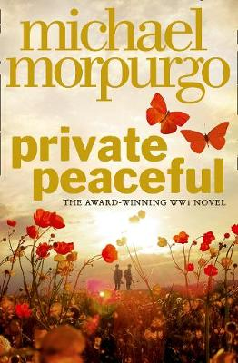
Parts 1 and 2

Part 1 - Five Past Ten
- Listen to Part 1 through the link on the accompanying PowerPoint
- Create a flow chart of the events of this part using both words and images

The Openings:
- What do we learn about the speaker from the opening of this part? Add explanation to your answer, which should be in full sentences

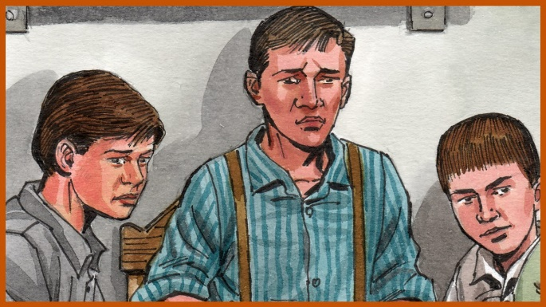
The Characters:
3. Joe Peaceful (‘Big Joe’)
Now have a go at writing a short paragraph about what you think about Big Joe
1. Charlie Peaceful
Use the following quote to explain what the character of Charlie is like.
‘Charlie is taking me by the hand, leading me because he knows I don’t want to go.’
2. Tommo Peaceful
Use the following quote to explain what the character of Tommo is like.
‘my heart is heavy … because I dread what I am going to’

Mr Munnings vs Miss McAllister
- Copy out the below Venn diagram to help compare the two teachers
Mr Munnings
Differences
Differences
Miss McAllister
Similarities

Memories!
- You need to think of just one memory from your past. This could be anything from travelling on holiday, your first day of school, getting a pet, getting injured or making a friend. Create a spider diagram with all the details you can remember about that memory.
- Now go through and number the details in a chronological order (some bits might not need ordering because they just contain information)
- Now use the criteria listed below to write up the story of your memory (remember: this isn’t a diary, so you don’t need to open and close the piece like one.) You should aim for one page of writing.
Sentence Starter Suggestions:
- I will always remember the day when…
- It was years ago now, but I remember it like it was yesterday, the day I…
- When I look back at my younger years, there’s always one day which stands out in my memory…
Memory Writing Criteria:
- First person
- The five senses
- Lots of emotion
- Description
- Paragraphs
- Chronological order
Part 1 – Twenty to Eleven
- Listen to Part 2 through the link on the accompanying PowerPoint
- Create a flow chart of the events of this part using both words and images
The Openings:
- Do we learn anything new about the speaker from the opening of this part? Add explanation to your answer, which should be in full sentences

Childhood:
- Copy out the below Venn diagram to help compare the Peaceful children’s childhood to a modern day childhood
Modern Childhood
The Peaceful’s Childood
Differences
Differences
Similarities

Molly:
- Your task is to write a diary entry from the perspective (point of view) of Molly, and how she feels about becoming ‘part of the family’. You should use the criteria below and be aiming for about half a page to a page of writing. You should open and close your piece like a diary, think back to your diary writing unit at the start of term to help you
Molly’s Diary Criteria:
- First person
- Lots of emotion
- Description
- Paragraphs
Sentence Starter Suggestions:
- From the day that younger Peaceful started in my class I knew things would change…
- Sorry I haven’t written in a while, I’ve been so busy, and it’s all because of those Peacefuls!

The ‘baddies’:
- Complete the following table, noting down your thoughts, opinions and ideas about the characters of The Colonel and Grandma Wolf
The Colonel | Grandma Wolf

- Now answer the following question in full sentences with plenty of explanation:

Why is it interesting for stories have ‘baddies’ in?

