Much Ado About Nothing: Act 4

Task 1: Act 4 Summary
https://www.sparknotes.com/shakespeare/muchado/
- Copy and paste the link above into your web browser (or type Much Acho About Nothing Act 2 Sparknotes)
- Read through the notes for Act 2 Scene i, ii and iii and write a summary in your own words, no longer than half a page, about what happens.

Task 2: The Wedding
This is probably the most dramatic scene of the play! Copy the link below into your web browser to watch it.
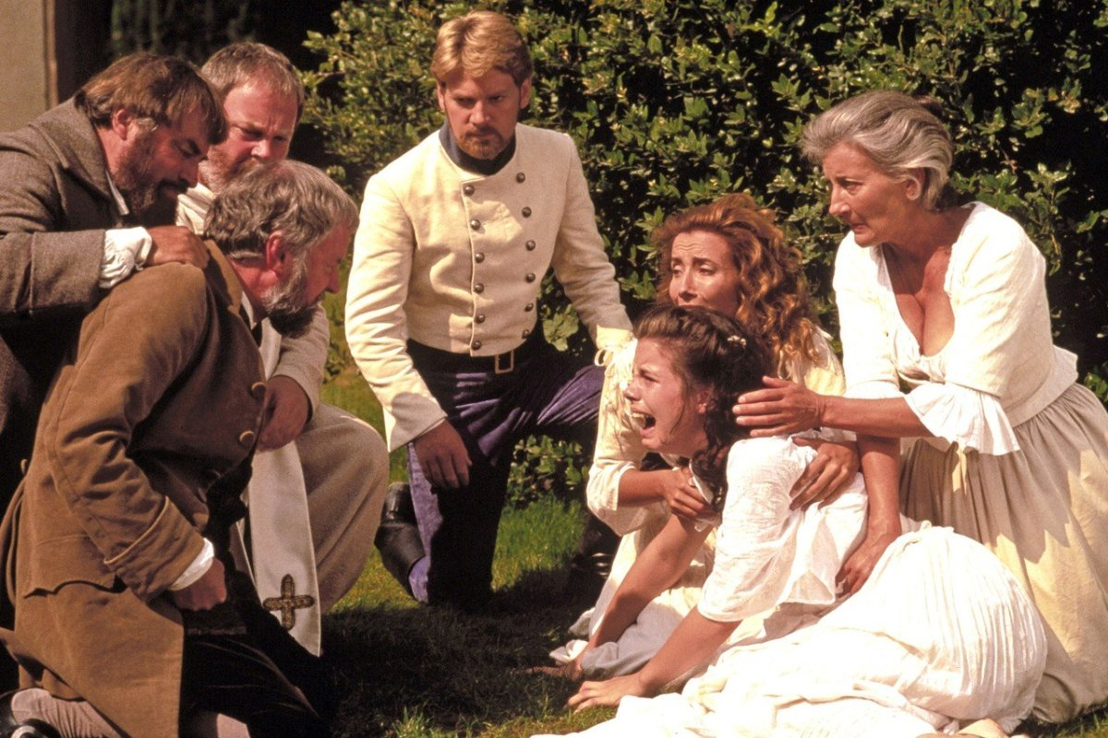
https://www.youtube.com/watch?v=mDah0SGz_oM
Draw a story board of this scene OR write a modern narrative describing what happens (so as if it’s a chapter from a chapter book.) Whichever task you choose make sure you really capture the emotions of the different characters!

Task 3: Claudio’s words
Claudio says that Hero looks like the Roman goddess Diana but acts like the Roman goddess Venus. Split your page in half, one for Diana and one for Venus. Write their names in the centre of their half, research each and make notes.
Use this information to write a paragraph explaining what Claudio means when he says this about Hero, try to include lots of references to historical context.

