**Much Ado About Nothing: Act 3**

**Task 1: Act 3 Summary**

<https://www.sparknotes.com/shakespeare/muchado/>

* Copy and paste the link above into your web browser (or type Much Acho About Nothing Act 2 Sparknotes)
* Read through the notes for Act 2 Scene i, ii and iii and write a summary in your own words, no longer than half a page, about what happens.

**Task 2: Beatrice is tricked**

* Copy the link below into your web browser to watch the scene where Beatrice gets tricked:

<https://www.youtube.com/watch?v=7G2RCM4AdN4>

Answer the question below in full sentences with explanation. You may refer to earlier parts of the play.

**Who do you think would be easier to trick out of Benedick and Beatrice? Why?**

**Task 3: Don John tricks Claudio**

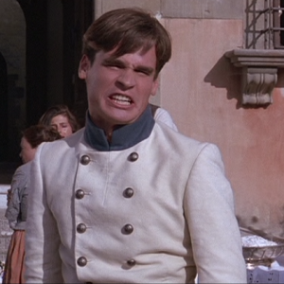Things turn dark when Don John sets up the trick which will lead Claudio to believe that Hero has just cheated on him.

Your task is to write a diary (don’t worry – you can do it in modern English!) which presents Claudio’s feelings and reactions to what he has seen and what he believes to have happened. Try to get in some links to historical context and what life was like in Shakespeare’s day.