Much Ado About Nothing: Act 2

Task 1: Act 2 Summary
https://www.sparknotes.com/shakespeare/muchado/
- Copy and paste the link above into your web browser (or type Much Acho About Nothing Act 2 Sparknotes)
- Read through the notes for Act 2 Scene i, ii and iii and write a summary in your own words, no longer than half a page, about what happens.
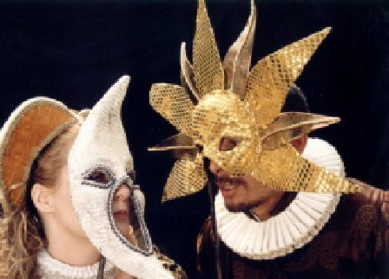
Task 2: Masked Ball
You have been invited to the Governor Leonato’s masked ball! It is being thrown in honour of the visiting soldiers, returning from their victory at war!
Your task is to design a mask represents your personality and interests.
If you’d rather you could design on for one of the characters from Much Ado, that’s fine!
Think about the following:
- Images which represent your interests and hobbies
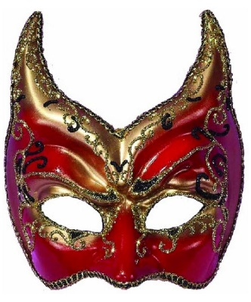
- Bold colours or subtler shades
- Animals which could reflect your personality
- Shapes
- Slogans/ mottos/ words
Add a paragraph briefly explaining your design choices.

Task 3: Benedick gets tricked
- Re-read the Sparknotes summary and Sparknotes No Fear Shakespeare translation of the scene where Benedick gets tricked
- Copy the link below into your web browser to watch the scene
https://www.youtube.com/watch?v=k6z6LfdTNQg
Write the script for a modern version of this scene where Benedick’s friends trick him into thinking Beatrice is in love with him. Think: where could he be hiding? How might he be overhearing them?

