Much Ado About Nothing: Act 1

Task 1: Act 1 Summary
https://www.sparknotes.com/shakespeare/muchado/
- Copy and paste the link above into your web browser (or type Much Acho About Nothing Act 1 Sparknotes)
- Read through the notes for Act 1 Scene i, ii and iii and write a summary in your own words, no longer than half a page, about what happens.
Task 2: Act 1 questions
1. Who is on stage when scene one opens?
2. What relations are Hero and Beatrice to Leonato?
4. Find a quote that shows how bravely Claudio has fought in battle.
5. Leonato tells his niece off for doing what?
7. Why is Don John called ‘the bastard’?
8. How do we know that Beatrice and Benedick do not like each other?
9. What does Claudio talk to Benedick about at the end of Scene one?
10. Claudio uses a metaphor to describe Hero. Find the relevant quotation. What do you think he is saying about Hero?
11. What is Don Pedro’s plan to make Hero fall in love with Claudio?
14. At the end of scene two, what do Antonio and Leonato now (wrongly) think?
15. Why is Don John so depressed?
16. When he finds out the news about Claudio’s intended love affair, Don John decides to seek what?
17. Don John is made to appear as the antagonist in this scene. What is an antagonist and why is Don John one?

Task 3: Quote analysis
Messenger from war discusses Claudio
Shakespeare’s Script: | What does it mean?
Leonato:  I find here, that Don Pedro hath bestowed much honour on a young Florentine called Claudio  Messenger:  Much deserved on his part and equally remembered by Don Pedro: he hath borne himself beyond the  promise of his age, doing, in the figure of a lamb,  the feats of a lion: he hath indeed better  bettered expectation than you must expect of me to  tell you how. | ‘bestowed’ = put on, or given.  ‘Florentine’ = someone from Florence.  So Leonato is saying that he has heard that the prince, Don Pedro, has given great honour to someone called Claudio from Florence.  The messenger agrees, and says that the prince, Don Pedro will remember this and that Claudio has acted better than they would have thought someone of his age could in battle.  ‘figure’ = looks, and ‘feats’ = actions. So Claudio is said to look like a lamb and act like an lion, which is better than their expectations.

- Split your page in half. On one side complete a spider diagram or bullet point list of the connotations of a lamb and on the other your connotations of a lion.
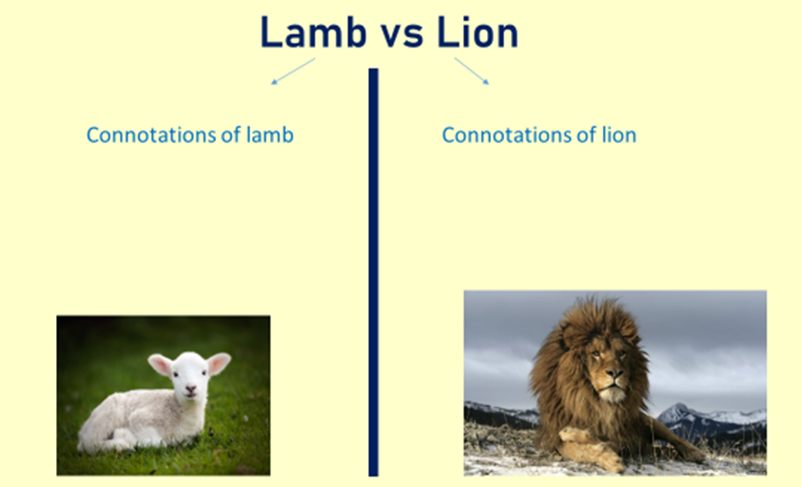

- Now use the sentence starters below to write two PEA paragraphs, one for Claudio looking like a lamb and one for Claudio looking like a lion.
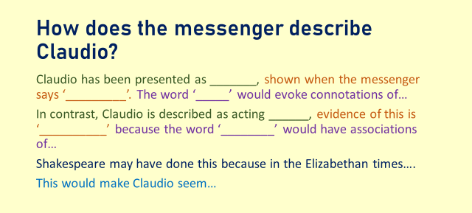

Task 4: Extended writing
- Imagine you are one of the following characters. Write a diary entry from their point of view presenting what has happened to them during Act 1 of the play. Aim for ¾ to 1 page of writing and focus on presenting emotion and knowledge of the plot of the play

- Hero meeting Claudio for the first time and falling in love instantly, or vice versa
- Claudio returning from war having made his prince proud
- The prince winning a war and taking his soldiers to stay in Messina with the Governor
- Benedick or Beatrice meeting at her uncle Leonato, the Governor of Messina’s house, and instantly mocking and hating each other
- Don John, the illegitimate half-brother of Don Pedro who is jealous of this young man Claudio taking all the glory of battle

