Macbeth Home Learning: Part 6
Act 5 – The End

Task 1: Plot and Characters
If you haven’t done this already, copy the link below into your web browser and read the plot summary by clicking on ‘Revise’ and then take the test available. Then do the same for characters.
https://www.bbc.co.uk/bitesize/topics/zp982hv

Task 2: Lady Macbeth
Have a go at drawing an image of Lady Macbeth sleep walking, around the outside make notes on her character using the link below:
https://www.bbc.co.uk/bitesize/guides/zpx39j6/revision/3
When you get to the ‘video’ link, listen carefully before having a go at answering the questions below it

Task 3: The End of Macbeth Plot Sorting Task
Print and cut the sheet at the bottom of this page, or copy them out, and put them in the correct order.

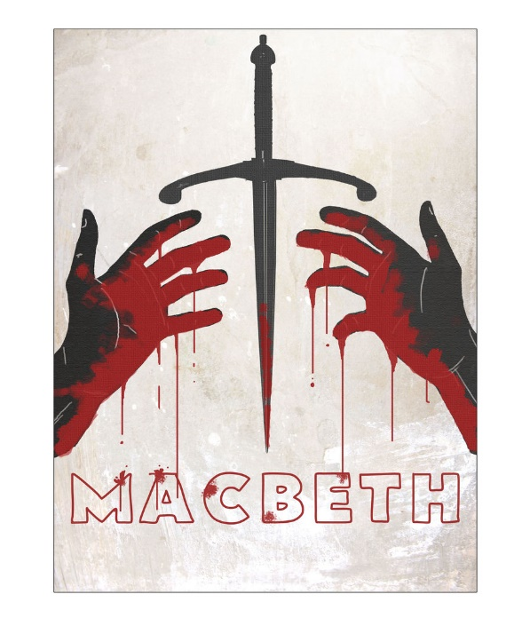
Final task: Creating a new cover
Design and create a new play poster or book cover for Macbeth. Your design should have:
- A clear image or images which represent what happens in the story
- A catchy sentence or two for what it is about
- A quote from yourself reviewing the play
Type ‘Macbeth poster’ or ‘Macbeth book cover’ into Google images for some inspiration.

