Macbeth Home Learning: Part 6
Act 4 – The End

Task 1: Plot and Characters
If you haven’t done this already, copy the link below into your web browser and read the plot summary by clicking on ‘Revise’ and then take the test available. Then do the same for characters.
https://www.bbc.co.uk/bitesize/topics/zp982hv

Task 2: Reading the Scene
Copy the link below into your web browser and read Act 4 of Mabeth, including the column with the translations.
https://www.sparknotes.com/nofear/shakespeare/macbeth/page_30/

Task 3: Questions (Scene by Scene)

Act 4 Summary Questions

Scene 1

- Why do you think Macbeth goes to visit the witches for a second time? What does he want to find out?

- The witches show him three apparitions. What are apparitions?

- What are the three warnings that the witches give Macbeth?

- Does Macbeth listen to these warnings?

Scene 2

- Why is Lady Macduff upset with her husband?

- Why do you think that Macbeth sends murderers to Macduff’s castle? What effect would the brutal killing of Macduff’s family have on the audience?

Scene 3

- Why has Macduff gone to England?

- How does Malcolm test Macduff’s motives? What trick does he play on him?

- How many men are about to invade Scotland under the leadership of Malcolm?

- What does Macduff learn from Ross and what does he threaten to do in revenge?

Extended Question

Below are some characteristics that could some up how we see Macbeth at this point in the play.

cruel cunning secretive untrustworthy mad

Describe in your own words, for each characteristic, what actions have made the audience see him in this way.

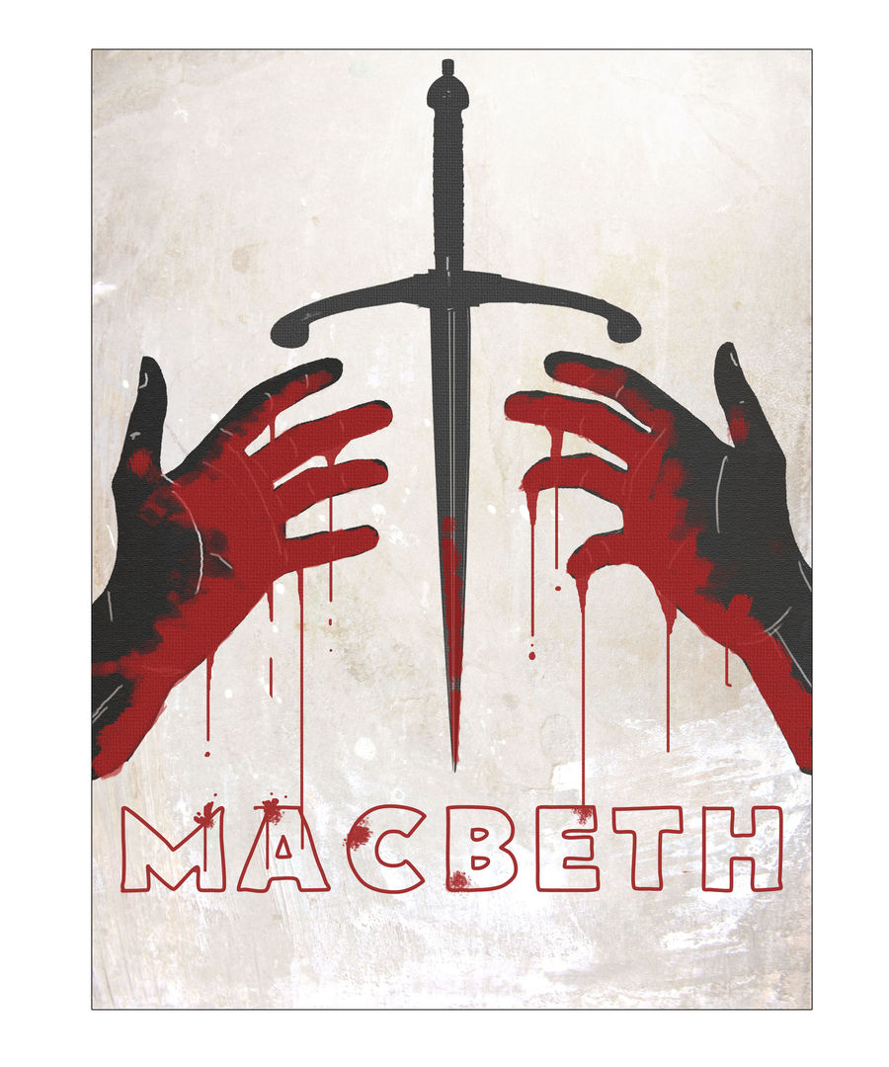
Task 4: Creating a new cover
Design and create a new play poster or book cover for Macbeth. Your design should have:
- A clear image or images which represent what happens in the story
- A catchy sentence or two for what it is about
- A quote from yourself reviewing the play
Type ‘Macbeth poster’ or ‘Macbeth book cover’ into Google images for some inspiration.

