Macbeth Home Learning: Part 3
Act 1 – Lady Macbeth

Task 1: Plot and Characters
If you haven’t done this already, copy the link below into your web browser and read the plot summary by clicking on ‘Revise’ and then take the test available. Then do the same for characters.
https://www.bbc.co.uk/bitesize/topics/zp982hv

Task 2: Lady Macbeth
Copy the link below into your web browser and read Act 1 Scene 5 of Mabeth, including the column with the translations.
https://www.sparknotes.com/nofear/shakespeare/macbeth/page_30/

Now you need to zoom in on some of her lines. Look at the boxes below and answer the questions in the boxes.

- What does the word ‘fatal’ mean? Look up and copy out a definition.
- Now you know what it means, what does it suggest about Duncan’s visit to Macbeth’s castle?

- ‘battlements’ is referring to Lady Macbeth’s home. She also says ‘my battlements’ even though the castle would actually belong to her husband Macbeth. What does this tell us about Lady Macbeth’s personality?

- ‘unsex me here’ means she wants to have her gender taken away from her. This is because women had no power in this time. How does this explain her treatment of Macbeth?

- ‘crown’ here is top of the head, and ‘toe’ is obviously at the very bottom of her body. She wants to then be filled with ‘cruelty’. What does this tell us about what she wants her personality to be like and how she wants to act?

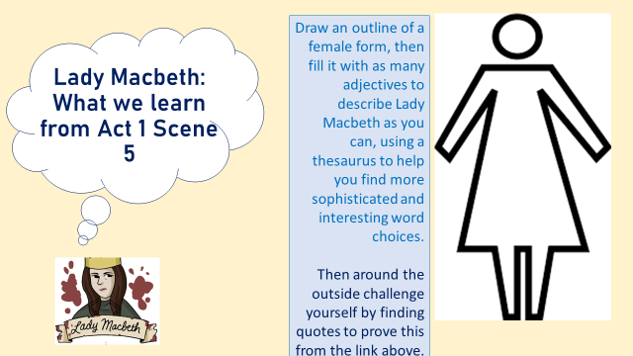

Task 3: Lady Macbeth and Jacobean Women
Complete some brief research on how women were treated in the Jacobean times, which is when this play was written. Then answer the question below:
