Macbeth Home Learning: Part 2
Act 1 – The Witches

Task 1: Plot and Characters
Copy the link below into your web browser and read the plot summary by clicking on ‘Revise’ and then take the test available. Then do the same for characters.
https://www.bbc.co.uk/bitesize/topics/zp982hv

Task 2: The beginning and the three witches

First Witch
When shall we three meet again —
In thunder, lightning, or in rain?

Second Witch
When the hurlyburly's done,
When the battle's lost, and won.

Third Witch
That will be ere the set of sun.

First Witch
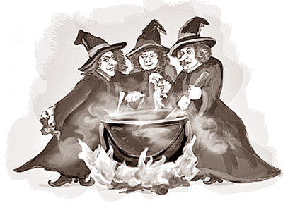
Where the place?

Second Witch
Upon the heath.

Third Witch
There to meet with Macbeth.

First Witch
I come, Graymalkin.

Second Witch
Paddock calls.

Third Witch
Anon.

All
Fair is foul, and foul is fair.
Hover through the fog and filthy air.
[Exit]

Answer the questions which follow

