Macbeth Home Learning: Part 1
Context and Setting

Task 1: Witches and Superstitions
Create a poster which presents information on what witches were thought to be like in Jacobean times (this is the time period when Shakespeare wrote Macbeth, it came after the Elizabethan times) and also what superstitions people believed in and why they believed them.

Task 2: Setting the scene for Act 1
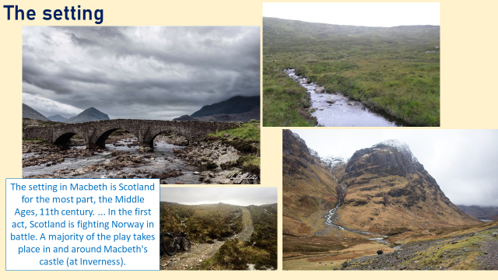

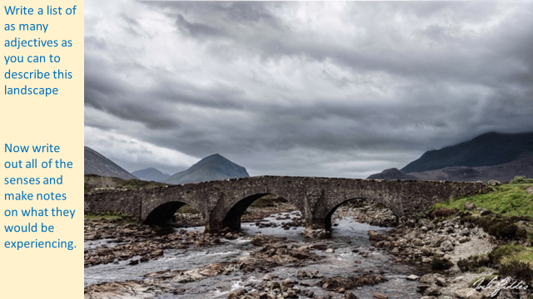
Descriptive writing preparation tasks:
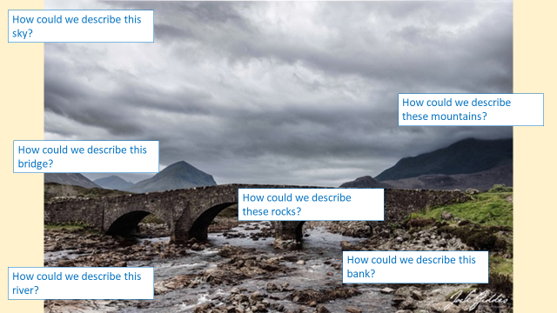
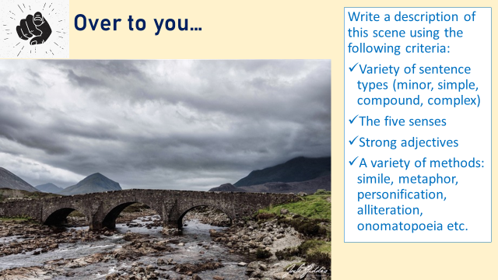

Example answer:
Clouds. Melancholy clouds. They swept in to cast an ever growing shadow over the land below. Charcoal, slate, granite, stone… the only colour they could muster was grey. The wind switching between a whistle and a howl and back again. A rare flash of emerald green could be seen where the grass had managed to survive the bleak winter that had prevailed. It was patchy and etched with weariness. Turbulent and troubled, the river crashed and thrashed about. Rocks littered the shallow river beds causing the short waves to jut and flicker like flames. White whispy foam wings threatened to escape the banks and take to land where they would find life no easier. Even in the distance all the eye could see was mountains shrouded in ice cold air, thick enough to cut with a knife. The air tasting metallic, as if with the blood of the lives this ground has claimed over the years.

So to finish…

