The Story of the Goblins Who Stole a Sexton
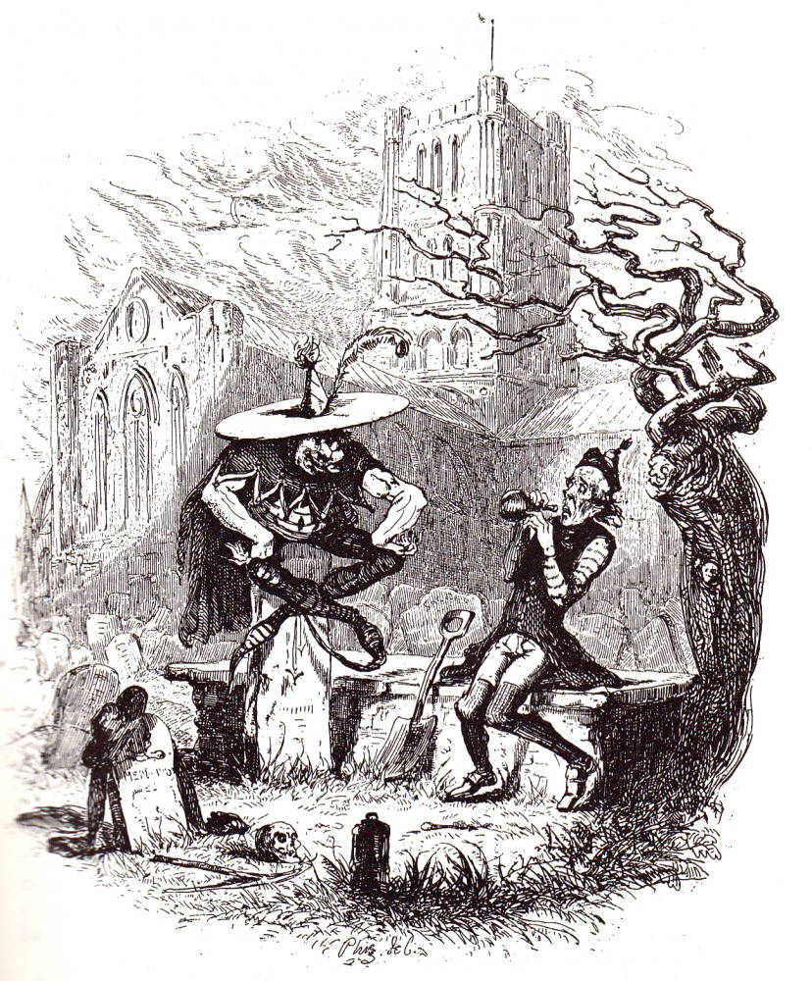
By Charles Dickens
Question 1:
Focusing on the first paragraph, which of these statements are true?
- Gabriel Grub was a vicar
- The story takes place in an old, abbey town
- Gabriel Grub was lonely
- Gabriel Grub carried a bottle of alcohol around in his pocket
- Gabriel Grub was an under taker
- Being an under taker makes you miserable
- The writer says that old stories must be true
Now write out four things you learn in the second paragraph:

Question 2:
Gabriel paused, in some alarm, in the act of raising the wicker bottle to his lips, and looked round. The bottom of the oldest grave about him was not more still and quiet than the churchyard in the pale moonlight. The cold hoar frost glistened on the tombstones, and sparkled like rows of gems, among the stone carvings of the old church. The snow lay hard and crisp upon the ground; and spread over the thickly-strewn mounds of earth, so white and smooth a cover that it seemed as if corpses lay there, hidden only by their winding sheets. Not the faintest rustle broke the profound tranquillity of the solemn scene. Sound itself appeared to be frozen up, all was so cold and still.
"It was the echoes," said Gabriel Grub, raising the bottle to his lips again.
"It was NOT," said a deep voice.
Gabriel started up, and stood rooted to the spot with astonishment and terror; for his eyes rested on a form that made his blood run cold.

Using this extract, how has the writer used language to set the scene for the arrival of the goblins?

You could include the writer’s choice of:

• words and phrases
• language features and techniques
• sentence forms.

Question 3:
As the goblin laughed, the sexton observed, for one instant, a brilliant illumination within the windows of the church, as if the whole building were lighted up; it disappeared, the organ pealed forth a lively air, and whole troops of goblins, the very counterpart of the first one, poured into the churchyard, and began playing at leap-frog with the tombstones, never stopping for an instant to take breath, but "overing" the highest among them, one after the other, with the most marvellous dexterity. The first goblin was a most astonishing leaper, and none of the others could come near him; even in the extremity of his terror the sexton could not help observing, that while his friends were content to leap over the common-sized gravestones, the first one took the family vaults, iron railings and all, with as much ease as if they had been so many street-posts.
At last the game reached to a most exciting pitch; the organ played quicker and quicker, and the goblins leaped faster and faster, coiling themselves up, rolling head over heels upon the ground, and bounding over the tombstones like footballs. The sexton's brain whirled round with the rapidity of the motion he beheld, and his legs reeled beneath him, as the spirits flew before his eyes; when the goblin king, suddenly darting towards him, laid his hand upon his collar, and sank with him through the earth.
When Gabriel Grub had had time to fetch his breath, which the rapidity of his descent had for the moment taken away, he found himself in what appeared to be a large cavern, surrounded on all sides by crowds of goblins, ugly and grim; in the centre of the room, on an elevated seat, was stationed his friend of the churchyard; and close behind him stood Gabriel Grub himself, without power of motion.

How has the writer structured this part of the story to interest the reader?

You could write about:

• what the writer focuses your attention on
• how and why the writer changes this focus as the source develops
• any other structural features that interest you.

Question 4:
The lantern, the spade, and the wicker bottle were found, that day, in the churchyard. There were a great many speculations about the sexton's fate, at first, but it was speedily determined that he had been carried away by the goblins; and there were not wanting some very credible witnesses who had distinctly seen him whisked through the air on the back of a chestnut horse blind of one eye, with the hind-quarters of a lion, and the tail of a bear. At length all this was devoutly believed; and the new sexton used to exhibit to the curious, for a trifling emolument, a good-sized piece of the church weathercock which had been accidentally kicked off by the aforesaid horse in his aerial flight, and picked up by himself in the churchyard, a year or two afterwards.
Unfortunately, these stories were somewhat disturbed by the unlooked-for reappearance of Gabriel Grub himself, some ten years afterwards, a ragged, contented, rheumatic old man. He told his story to the clergyman, and also to the mayor; and in course of time it began to be received as a matter of history, in which form it has continued down to this very day. The believers in the weathercock tale, having misplaced their confidence once, were not easily prevailed upon to part with it again, so they looked as wise as they could, shrugged their shoulders, touched their foreheads, and murmured something about Gabriel Grub having drunk all the Hollands, and then fallen asleep on the flat tombstone; and they affected to explain what he supposed he had witnessed in the goblin's cavern, by saying that he had seen the world, and grown wiser. But this opinion, which was by no means a popular one at any time, gradually died off; and be the matter how it may, as Gabriel Grub was afflicted with rheumatism to the end of his days, this story has at least one moral, if it teach no better one - and that is, that if a man turn sulky and drink by himself at Christmas time, he may make up his mind to be not a bit the better for it: let the spirits be never so good, or let them be even as many degrees beyond proof, as those which Gabriel Grub saw in the goblin's cavern.

A reader said, ‘This part of the story makes me think that Gabriel Grub had a life changing experience, and people only didn’t believe him because they didn’t want to accept that Christmas was a good time to change.’

To what extent do you agree?

In your response, you could:

• consider the reasons why you think Gabriel has changed but others won’t
• evaluate how the writer creates a sense of redemption
• support your response with references to the text

Question 5:

EITHER
Write a description of the image below
OR
Write the opening of a Christmas horror story
OR
Write a short Christmas story with a moral message

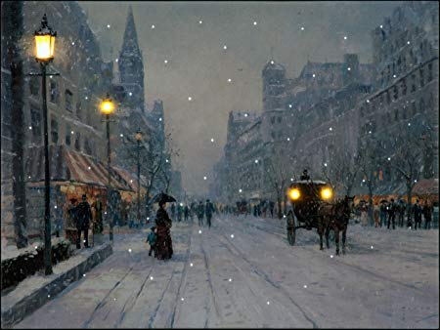

Editing your creative writing
Descriptive writing:
- Circle all the words you could improve. These could be repeated words or just basic language choices. Use a thesaurus to edit.
- Circle all the nouns and add in adjectives where needed.
- Highlight and label all the techniques you have used (use SOSMAPS as a guide) to see which ones to add in and where.
- Read through your sentences and shorten some to create some minor and simple sentences.
- Vary your punctuation so you have at least four different types.
- Add in as many of the senses as you can (sight, smell, sound, taste and touch)
- Edit your sentence structure to change where the clauses sit, for example ‘the snow fell hastily to the ground’ could become ‘hastily, the snow fell to the ground’
- Make sure all your techniques and word choices are suitable for the atmosphere of the piece, for example saying something was ‘as sharp as the tip of an ice cream cone’ wouldn’t suit a horror story! But ‘as sharp as a shard of smashed glass’ might be.

Narrative writing:
- Highlight/ circle any words you could improve and use a thesaurus to edit. E.g. ‘I went home, I was feeling so hungry’ could become ‘I ambled home, I was feeling so famished.’
- Look at every verb you have used and see if you can in any adverbs. E.g. I slowly and dejectedly ambled along home, I was feeling so famished.
- Look at your sentence types and try to vary your sentence structure. E.g. Slowly and dejectedly, I ambled along home. I felt famished.
- Can you add any more emotion? E.g. Slowly and dejectedly, I ambled along home. I felt famished. I wasn’t expecting much though, I had all this space to myself and loneliness was starting to sink through me like a lead balloon.
- Look at your punctuation use, edit to add in a variety of punctuation. E.g. Slowly and dejectedly, I ambled along home. I felt famished! I wasn’t expecting much though, I had all this space to myself… Loneliness was starting to sink through me like a lead balloon. Would I have another ghostly visit tonight? Had the madness only just begun?

Extension tasks:

- Design and draw a Victorian Christmas card with an image and message which sums up what Victorians thought was the most important part of Christmas
- Design a set of Christmas tree decorations which symbolise key images and ideas of a Victorian Christmas
- Design the front and back book cover for The Goblins Who Stole a Sexton
- Imagine you are turning your story into a film. Cast the characters and create a storyboard for a film trailer for it

