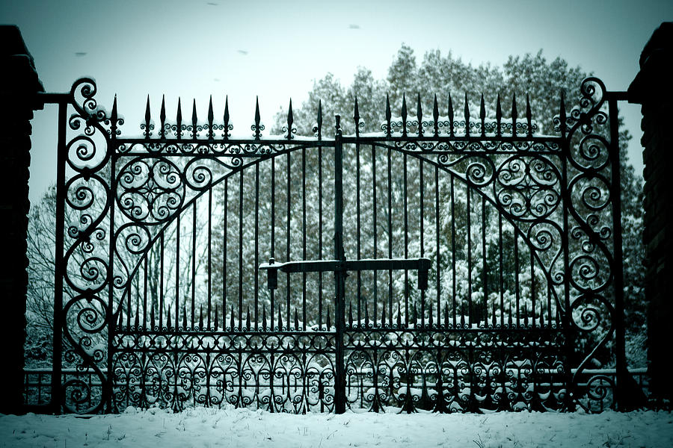
In an old abbey town, down in this part of the country, a long, long while ago - so long, that the story must be a true one, because our great-grandfathers implicitly believed it - there officiated as sexton and grave-digger in the churchyard, one Gabriel Grub. It by no means follows that because a man is a sexton, and constantly surrounded by the emblems of mortality, therefore he should be a morose and melancholy man; your undertakers are the merriest fellows in the world; and I once had the honour of being on intimate terms with a mute, who in private life, and off duty, was as comical and jocose a little fellow as ever chirped out a devil-may-care song, without a hitch in his memory, or drained off a good stiff glass without stopping for breath. But notwithstanding these precedents to the contrary, Gabriel Grub was an ill-conditioned, cross-grained, surly fellow - a morose and lonely man, who consorted with nobody but himself, and an old wicker bottle which fitted into his large deep waistcoat pocket - and who eyed each merry face, as it passed him by, with such a deep scowl of malice and ill-humour, as it was difficult to meet without feeling something the worse for.
The Story of the Goblins Who Stole a Sexton, by Charles Dickens
A little before twilight, one Christmas Eve, Gabriel shouldered his spade, lighted his lantern, and betook himself towards the old churchyard; for he had got a grave to finish by next morning, and, feeling very low, he thought it might raise his spirits, perhaps, if he went on with his work at once. As he went his way, up the ancient street, he saw the cheerful light of the blazing fires gleam through the old casements, and heard the loud laugh and the cheerful shouts of those who were assembled around them; he marked the bustling preparations for next day's cheer, and smelled the numerous savoury odours consequent thereupon, as they steamed up from the kitchen windows in clouds. All this was gall and wormwood to the heart of Gabriel Grub; and when groups of children bounded out of the houses, tripped across the road, and were met, before they could knock at the opposite door, by half a dozen curly-headed little rascals who crowded round them as they flocked upstairs to spend the evening in their Christmas games, Gabriel smiled grimly, and clutched the handle of his spade with a firmer grasp, as he thought of measles, scarlet fever, thrush, whooping-cough, and a good many other sources of consolation besides.
In this happy frame of mind, Gabriel strode along, returning a short, sullen growl to the good-humoured greetings of such of his neighbours as now and then passed him, until he turned into the dark lane which led to the churchyard. Now, Gabriel had been looking forward to reaching the dark lane, because it was, generally speaking, a nice, gloomy, mournful place, into which the townspeople did not much care to go, except in broad daylight, and when the sun was shining; consequently, he was not a little indignant to hear a young urchin roaring out some jolly song about a merry Christmas, in this very sanctuary which had been called Coffin Lane ever since the days of the old abbey, and the time of the shaven-headed monks. As Gabriel walked on, and the voice drew nearer, he found it proceeded from a small boy, who was hurrying along, to join one of the little parties in the old street, and who, partly to keep himself company, and partly to prepare himself for the occasion, was shouting out the song at the highest pitch of his lungs. So Gabriel waited until the boy came up, and then dodged him into a corner, and rapped him over the head with his lantern five or six times, just to teach him to modulate his voice. And as the boy hurried away with his hand to his head, singing quite a different sort of tune, Gabriel Grub chuckled very heartily to himself, and entered the churchyard, locking the gate behind him.
He took off his coat, set down his lantern, and getting into the unfinished grave, worked at it for an hour or so with right good- will. But the earth was hardened with the frost, and it was no very easy matter to break it up, and shovel it out; and although there was a moon, it was a very young one, and shed little light upon the grave, which was in the shadow of the church. At any other time, these obstacles would have made Gabriel Grub very moody and miserable, but he was so well pleased with having stopped the small boy's singing, that he took little heed of the scanty progress he had made, and looked down into the grave, when he had finished work for the night, with grim satisfaction, murmuring as he gathered up his things-
Brave lodgings for one, brave lodgings for one,
A few feet of cold earth, when life is done;
A stone at the head, a stone at the feet,
A rich, juicy meal for the worms to eat;
Rank grass overhead, and damp clay around,
Brave lodgings for one, these, in holy ground!

"Ho! ho!" laughed Gabriel Grub, as he sat himself down on a flat tombstone which was a favourite resting-place of his, and drew forth his wicker bottle. "A coffin at Christmas! A Christmas box! Ho! ho! ho!"
"Ho! ho! ho!" repeated a voice which sounded close behind him.
Gabriel paused, in some alarm, in the act of raising the wicker bottle to his lips, and looked round. The bottom of the oldest grave about him was not more still and quiet than the churchyard in the pale moonlight. The cold hoar frost glistened on the tombstones, and sparkled like rows of gems, among the stone carvings of the old church. The snow lay hard and crisp upon the ground; and spread over the thickly-strewn mounds of earth, so white and smooth a cover that it seemed as if corpses lay there, hidden only by their winding sheets. Not the faintest rustle broke the profound tranquillity of the solemn scene. Sound itself appeared to be frozen up, all was so cold and still.
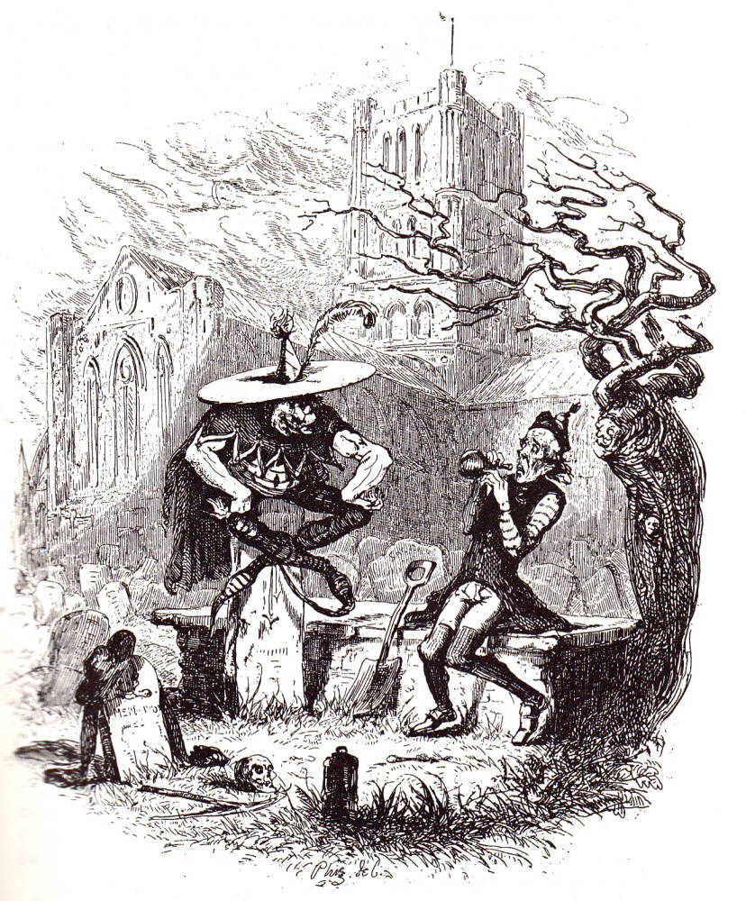
"It was the echoes," said Gabriel Grub, raising the bottle to his lips again.
"It was NOT," said a deep voice.
Gabriel started up, and stood rooted to the spot with astonishment and terror; for his eyes rested on a form that made his blood run cold.
Seated on an upright tombstone, close to him, was a strange, unearthly figure, whom Gabriel felt at once, was no being of this world. His long, fantastic legs which might have reached the ground, were cocked up, and crossed after a quaint, fantastic fashion; his sinewy arms were bare; and his hands rested on his knees. On his short, round body, he wore a close covering, ornamented with small slashes; a short cloak dangled at his back; the collar was cut into curious peaks, which served the goblin in lieu of ruff or neckerchief; and his shoes curled up at his toes into long points. On his head, he wore a broad-brimmed sugar-loaf hat, garnished with a single feather. The hat was covered with the white frost; and the goblin looked as if he had sat on the same tombstone very comfortably, for two or three hundred years. He was sitting perfectly still; his tongue was put out, as if in derision; and he was grinning at Gabriel Grub with such a grin as only a goblin could call up.
"It was NOT the echoes," said the goblin.
Gabriel Grub was paralysed, and could make no reply.
"What do you do here on Christmas Eve?" said the goblin sternly.
"I came to dig a grave, Sir," stammered Gabriel Grub.
"What man wanders among graves and churchyards on such a night as this?" cried the goblin.
"Gabriel Grub! Gabriel Grub!" screamed a wild chorus of voices that seemed to fill the churchyard. Gabriel looked fearfully round - nothing was to be seen.
"What have you got in that bottle?" said the goblin.
"Hollands, sir," replied the sexton, trembling more than ever; for he had bought it of the smugglers, and he thought that perhaps his questioner might be in the excise department of the goblins.
"Who drinks Hollands alone, and in a churchyard, on such a night as this?" said the goblin.
"Gabriel Grub! Gabriel Grub!" exclaimed the wild voices again.
The goblin leered maliciously at the terrified sexton, and then raising his voice, exclaimed -
"And who, then, is our fair and lawful prize?"
To this inquiry the invisible chorus replied, in a strain that sounded like the voices of many choristers singing to the mighty swell of the old church organ - a strain that seemed borne to the sexton's ears upon a wild wind, and to die away as it passed onward; but the burden of the reply was still the same, "Gabriel Grub! Gabriel Grub!"
The goblin grinned a broader grin than before, as he said, "Well, Gabriel, what do you say to this?"
The sexton gasped for breath.
"What do you think of this, Gabriel?" said the goblin, kicking up his feet in the air on either side of the tombstone, and looking at the turned-up points with as much complacency as if he had been contemplating the most fashionable pair of Wellingtons in all Bond Street.
"It's - it's - very curious, Sir," replied the sexton, half dead with fright; "very curious, and very pretty, but I think I'll go back and finish my work, Sir, if you please."
"Work!" said the goblin, "what work?"
"The grave, Sir; making the grave," stammered the sexton.
"Oh, the grave, eh?" said the goblin; "who makes graves at a time when all other men are merry, and takes a pleasure in it?"
Again the mysterious voices replied, "Gabriel Grub! Gabriel Grub!"
"I am afraid my friends want you, Gabriel," said the goblin, thrusting his tongue farther into his cheek than ever - and a most astonishing tongue it was - "I'm afraid my friends want you, Gabriel," said the goblin.
"Under favour, Sir," replied the horror-stricken sexton, "I don't think they can, Sir; they don't know me, Sir; I don't think the gentlemen have ever seen me, Sir."
"Oh, yes, they have," replied the goblin; "we know the man with the sulky face and grim scowl that came down the street to-night, throwing his evil looks at the children, and grasping his burying-spade the tighter. We know the man who struck the boy in the envious malice of his heart, because the boy could be merry, and he could not. We know him, we know him."
Here, the goblin gave a loud, shrill laugh, which the echoes returned twentyfold; and throwing his legs up in the air, stood upon his head, or rather upon the very point of his sugar-loaf hat, on the narrow edge of the tombstone, whence he threw a Somerset with extraordinary agility, right to the sexton's feet, at which he planted himself in the attitude in which tailors generally sit upon the shop-board.
"I - I - am afraid I must leave you, Sir," said the sexton, making an effort to move.
"Leave us!" said the goblin, "Gabriel Grub going to leave us. Ho! ho! ho!"
As the goblin laughed, the sexton observed, for one instant, a brilliant illumination within the windows of the church, as if the whole building were lighted up; it disappeared, the organ pealed forth a lively air, and whole troops of goblins, the very counterpart of the first one, poured into the churchyard, and began playing at leap-frog with the tombstones, never stopping for an instant to take breath, but "overing" the highest among them, one after the other, with the most marvellous dexterity. The first goblin was a most astonishing leaper, and none of the others could come near him; even in the extremity of his terror the sexton could not help observing, that while his friends were content to leap over the common-sized gravestones, the first one took the family vaults, iron railings and all, with as much ease as if they had been so many street-posts.
At last the game reached to a most exciting pitch; the organ played quicker and quicker, and the goblins leaped faster and faster, coiling themselves up, rolling head over heels upon the ground, and bounding over the tombstones like footballs. The sexton's brain whirled round with the rapidity of the motion he beheld, and his legs reeled beneath him, as the spirits flew before his eyes; when the goblin king, suddenly darting towards him, laid his hand upon his collar, and sank with him through the earth.
When Gabriel Grub had had time to fetch his breath, which the rapidity of his descent had for the moment taken away, he found himself in what appeared to be a large cavern, surrounded on all sides by crowds of goblins, ugly and grim; in the centre of the room, on an elevated seat, was stationed his friend of the churchyard; and close behind him stood Gabriel Grub himself, without power of motion.
"Cold to-night," said the king of the goblins, "very cold. A glass of something warm here!"
At this command, half a dozen officious goblins, with a perpetual smile upon their faces, whom Gabriel Grub imagined to be courtiers, on that account, hastily disappeared, and presently returned with a goblet of liquid fire, which they presented to the king.
"Ah!" cried the goblin, whose cheeks and throat were transparent, as he tossed down the flame, "this warms one, indeed! Bring a bumper of the same, for Mr. Grub."
It was in vain for the unfortunate sexton to protest that he was not in the habit of taking anything warm at night; one of the goblins held him while another poured the blazing liquid down his throat; the whole assembly screeched with laughter, as he coughed and choked, and wiped away the tears which gushed plentifully from his eyes, after swallowing the burning draught.
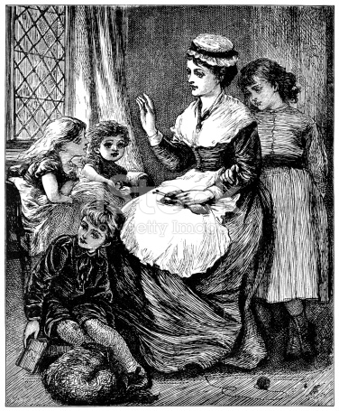
"And now," said the king, fantastically poking the taper corner of his sugar-loaf hat into the sexton's eye, and thereby occasioning him the most exquisite pain; "and now, show the man of misery and gloom, a few of the pictures from our own great storehouse!"
As the goblin said this, a thick cloud which obscured the remoter end of the cavern rolled gradually away, and disclosed, apparently at a great distance, a small and scantily furnished, but neat and clean apartment. A crowd of little children were gathered round a bright fire, clinging to their mother's gown, and gambolling around her chair. The mother occasionally rose, and drew aside the window-curtain, as if to look for some expected object; a frugal meal was ready spread upon the table; and an elbow chair was placed near the fire. A knock was heard at the door; the mother opened it, and the children crowded round her, and clapped their hands for joy, as their father entered. He was wet and weary, and shook the snow from his garments, as the children crowded round him, and seizing his cloak, hat, stick, and gloves, with busy zeal, ran with them from the room. Then, as he sat down to his meal before the fire, the children climbed about his knee, and the mother sat by his side, and all seemed happiness and comfort.
But a change came upon the view, almost imperceptibly. The scene was altered to a small bedroom, where the fairest and youngest child lay dying; the roses had fled from his cheek, and the light from his eye; and even as the sexton looked upon him with an interest he had never felt or known before, he died. His young brothers and sisters crowded round his little bed, and seized his tiny hand, so cold and heavy; but they shrank back from its touch, and looked with awe on his infant face; for calm and tranquil as it was, and sleeping in rest and peace as the beautiful child seemed to be, they saw that he was dead, and they knew that he was an angel looking down upon, and blessing them, from a bright and happy Heaven.
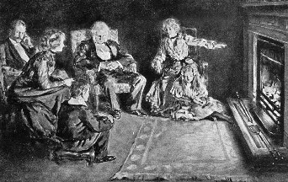
Again the light cloud passed across the picture, and again the subject changed. The father and mother were old and helpless now, and the number of those about them was diminished more than half; but content and cheerfulness sat on every face, and beamed in every eye, as they crowded round the fireside, and told and listened to old stories of earlier and bygone days. Slowly and peacefully, the father sank into the grave, and, soon after, the sharer of all his cares and troubles followed him to a place of rest. The few who yet survived them, kneeled by their tomb, and watered the green turf which covered it with their tears; then rose, and turned away, sadly and mournfully, but not with bitter cries, or despairing lamentations, for they knew that they should one day meet again; and once more they mixed with the busy world, and their content and cheerfulness were restored. The cloud settled upon the picture, and concealed it from the sexton's view.
"What do you think of THAT?" said the goblin, turning his large face towards Gabriel Grub.
Gabriel murmured out something about its being very pretty, and looked somewhat ashamed, as the goblin bent his fiery eyes upon him.
“You miserable man!" said the goblin, in a tone of excessive contempt. "You!" He appeared disposed to add more, but indignation choked his utterance, so he lifted up one of his very pliable legs, and, flourishing it above his head a little, to insure his aim, administered a good sound kick to Gabriel Grub; immediately after which, all the goblins in waiting crowded round the wretched sexton, and kicked him without mercy, according to the established and invariable custom of courtiers upon earth, who kick whom royalty kicks, and hug whom royalty hugs.
"Show him some more!" said the king of the goblins.
At these words, the cloud was dispelled, and a rich and beautiful landscape was disclosed to view - there is just such another, to this day, within half a mile of the old abbey town. The sun shone from out the clear blue sky, the water sparkled beneath his rays, and the trees looked greener, and the flowers more gay, beneath its cheering influence. The water rippled on with a pleasant sound, the trees rustled in the light wind that murmured among their leaves, the birds sang upon the boughs, and the lark carolled on high her welcome to the morning. Yes, it was morning; the bright, balmy morning of summer; the minutest leaf, the smallest blade of grass, was instinct with life. The ant crept forth to her daily toil, the butterfly fluttered and basked in the warm rays of the sun; myriads of insects spread their transparent wings, and revelled in their brief but happy existence. Man walked forth, elated with the scene; and all was brightness and splendour.
"YOU a miserable man!" said the king of the goblins, in a more contemptuous tone than before. And again the king of the goblins gave his leg a flourish; again it descended on the shoulders of the sexton; and again the attendant goblins imitated the example of their chief.
Many a time the cloud went and came, and many a lesson it taught to Gabriel Grub, who, although his shoulders smarted with pain from the frequent applications of the goblins' feet thereunto, looked on with an interest that nothing could diminish. He saw that men who worked hard, and earned their scanty bread with lives of labour, were cheerful and happy; and that to the most ignorant, the sweet face of Nature was a never-failing source of cheerfulness and joy. He saw those who had been delicately nurtured, and tenderly brought up, cheerful under privations, and superior to suffering, that would have crushed many of a rougher grain, because they bore within their own bosoms the materials of happiness, contentment, and peace. He saw that women, the tenderest and most fragile of all God's creatures, were the oftenest superior to sorrow, adversity, and distress; and he saw that it was because they bore, in their own hearts, an inexhaustible well-spring of affection and devotion. Above all, he saw that men like himself, who snarled at the mirth and cheerfulness of others, were the foulest weeds on the fair surface of the earth; and setting all the good of the world against the evil, he came to the conclusion that it was a very decent and respectable sort of world after all. No sooner had he formed it, than the cloud which had closed over the last picture, seemed to settle on his senses, and lull him to repose. One by one, the goblins faded from his sight; and, as the last one disappeared, he sank to sleep.
The day had broken when Gabriel Grub awoke, and found himself lying at full length on the flat gravestone in the churchyard, with the wicker bottle lying empty by his side, and his coat, spade, and lantern, all well whitened by the last night's frost, scattered on the ground. The stone on which he had first seen the goblin seated, stood bolt upright before him, and the grave at which he had worked, the night before, was not far off. At first, he began to doubt the reality of his adventures, but the acute pain in his shoulders when he attempted to rise, assured him that the kicking of the goblins was certainly not ideal. He was staggered again, by observing no traces of footsteps in the snow on which the goblins had played at leap-frog with the gravestones, but he speedily accounted for this circumstance when he remembered that, being spirits, they would leave no visible impression behind them. So, Gabriel Grub got on his feet as well as he could, for the pain in his back; and, brushing the frost off his coat, put it on, and turned his face towards the town.
But he was an altered man, and he could not bear the thought of returning to a place where his repentance would be scoffed at, and his reformation disbelieved. He hesitated for a few moments; and then turned away to wander where he might, and seek his bread elsewhere.
The lantern, the spade, and the wicker bottle were found, that day, in the churchyard. There were a great many speculations about the sexton's fate, at first, but it was speedily determined that he had been carried away by the goblins; and there were not wanting some very credible witnesses who had distinctly seen him whisked through the air on the back of a chestnut horse blind of one eye, with the hind-quarters of a lion, and the tail of a bear. At length all this was devoutly believed; and the new sexton used to exhibit to the curious, for a trifling emolument, a good-sized piece of the church weathercock which had been accidentally kicked off by the aforesaid horse in his aerial flight, and picked up by himself in the churchyard, a year or two afterwards.
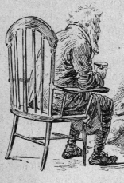
Unfortunately, these stories were somewhat disturbed by the unlooked-for reappearance of Gabriel Grub himself, some ten years afterwards, a ragged, contented, rheumatic old man. He told his story to the clergyman, and also to the mayor; and in course of time it began to be received as a matter of history, in which form it has continued down to this very day. The believers in the weathercock tale, having misplaced their confidence once, were not easily prevailed upon to part with it again, so they looked as wise as they could, shrugged their shoulders, touched their foreheads, and murmured something about Gabriel Grub having drunk all the Hollands, and then fallen asleep on the flat tombstone; and they affected to explain what he supposed he had witnessed in the goblin's cavern, by saying that he had seen the world, and grown wiser. But this opinion, which was by no means a popular one at any time, gradually died off; and be the matter how it may, as Gabriel Grub was afflicted with rheumatism to the end of his days, this story has at least one moral, if it teach no better one - and that is, that if a man turn sulky and drink by himself at Christmas time, he may make up his mind to be not a bit the better for it: let the spirits be never so good, or let them be even as many degrees beyond proof, as those which Gabriel Grub saw in the goblin's cavern.

