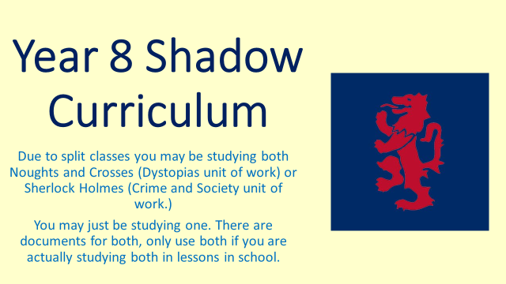
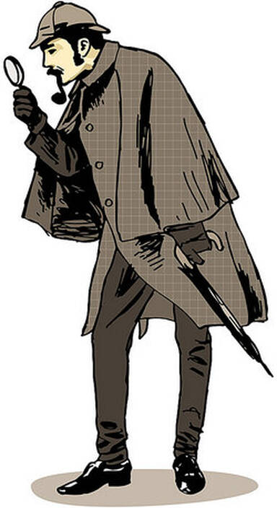
Sherlock Holmes Shadow Curriculum
You do not need to complete all the tasks unless you are away from school for a long period of time. You should add up the amount of time you miss from lessons and homework and work through the tasks accordingly.

Copy and paste the link below into your web browser to access all of Arthur Conan Doyle’s Sherlock Holmes stories:
The 62 Sherlock Holmes stories written by Arthur Conan Doyle - The Arthur Conan Doyle Encyclopedia (arthur-conan-doyle.com)

1. Starting task: Context (complete at start, or at any time during the unit if you haven’t done something similar already)
Create a fact-file or poster with lots of information about what life was like in the Victorian times, including some facts about the creation of detectives and rise in the use of forensic Science.
****
2. ‘The Adventures of the Speckled Band’ (complete if you are missing the lessons in which the class are studying this story)
This is one of the stories we are using in class. Below is a link to a workbook to take you through this story. This will take several ‘lessons’ to go through.
file:///Q:/English/Shadow%20Curriculum%20Work/Archived/Year%208/3.%20Crime%20and%20Society/Accompanying%20Resource%202%20-The%20Speckled%20Band%20Task%20Book.pdf

3. Other Stories (complete if you don’t want to interfere with the story being studied in class)
Copy and paste the link below into your web browser, this will take you to a website with all the Sherlock Holmes short stories on. We study ‘The Adventure of the Speckled Band’ and ‘The Adventure of the Dancing Men’ in class, so choose from the many other options and read a selection of short stories. Once you have read a story complete the table underneath the link.
https://www.arthur-conan-doyle.com/index.php/The_62_Sherlock_Holmes_stories_written_by_Arthur_Conan_Doyle

4. Watching Sherlock Holmes (complete if you don’t want to interfere with the stories being studied in class. Complete once you’ve read a story or if you’re struggling to read one)
There are plenty of versions of Sherlock Holmes stories to watch, follow the link for ClickView on the Moodle homepage and use your usual school log in details to sign in. Type ‘Sherlock Holmes’ into the search bar. Try to watch a Victorian era version, and not the modern Benedict Cumberbatch one! There is also a documentary on the inspiration behind Sherlock Holmes for you to watch.

5. Writing your own Sherlock Holmes story.
Use the sheet below to plan and write a detective story of your oen. Use the characters of Holmes and Watson if you want to.

The victim is:
The murderer is:
The murderer killed the victim because:

The murderer killed the victim by:

The setting for the story is:

The other suspects are: | They might have wanted to kill the victim too because:
The detective is:

The clues that give the murderer away are:

The red herrings that will mislead the reader are:

The final clue that leads the detective to the murderer is:

