Question 4:

- You need to evaluate the text critically and give a personal response.
- Make sure you provide lots of evidence to back up your points – use lots of short quotations.
- You need to write about your opinion.
- You need to write about the methods the writer has used to make you feel this way.

Evaluate your response based the criteria below.
Q4 AO4 Evaluate texts critically
Level 4 | 16-20 | - Critically evaluates the text in a detailed way  - Offers examples to explain views convincingly  - Analyses effects of a range of writer’s choices  - Selects a range of relevant quotations
Level 3 | 11-15 | - Clearly evaluates the text  - Offers examples from the text to explain views clearly  - Clearly explains the effect of writer’s choices  - Selects some relevant quotations
Level 2 | 6-10 | - Attempts evaluative comment on the text  - Offers an example from the text to explain view(s)  - Attempts to comment on writer’s methods  - Selects some quotations
Level 1 | 1-5 | - Simple evaluative comment on the text  - Offers simple example from the text which may explain view  - Simple mention of writer’s methods  - Simple references or textual details

Let’s take a look…

The Extract:

1984, George Orwell, Chapter 1
It was a bright cold day in April, and the clocks were striking thirteen. Winston Smith, his chin nuzzled into his breast in an effort to escape the vile wind, slipped quickly through the glass doors of Victory Mansions, though not quickly enough to prevent a swirl of gritty dust from entering along with him.
The hallway smelt of boiled cabbage and old rag mats. At one end of it a coloured poster, too large for indoor display, had been tacked to the wall. It depicted simply an enormous face, more than a metre wide: the face of a man of about forty-five, with a heavy black moustache and ruggedly handsome features. Winston made for the stairs. It was no use trying the lift. Even at the best of times it was seldom working, and at present the electric current was cut off during daylight hours. It was part of the economy drive in preparation for Hate Week. The flat was seven flights up, and Winston, who was thirty-nine and had a varicose ulcer above his right ankle, went slowly, resting several times on the way. On each landing, opposite the lift-shaft, the poster with the enormous face gazed from the wall. It was one of those pictures which are so contrived that the eyes follow you about when you move. BIG BROTHER IS WATCHING YOU, the caption beneath it ran.
Inside the flat a fruity voice was reading out a list of figures which had something to do with the production of pig-iron. The voice came from an oblong metal plaque like a dulled mirror which formed part of the surface of the right-hand wall. Winston turned a switch and the voice sank somewhat, though the words were still distinguishable. The instrument (the telescreen, it was called) could be dimmed, but there was no way of shutting it off completely. He moved over to the window: a smallish, frail figure, the meagreness of his body merely emphasized by the blue overalls which were the uniform of the party. His hair was very fair, his face naturally sanguine, his skin roughened by coarse soap and blunt razor blades and the cold of the winter that had just ended.
Outside, even through the shut window-pane, the world looked cold. Down in the street little eddies of wind were whirling dust and torn paper into spirals, and though the sun was shining and the sky a harsh blue, there seemed to be no colour in anything, except the posters that were plastered everywhere. The blackmoustachio'd face gazed down from every commanding corner. There was one on the house-front immediately opposite. BIG BROTHER IS WATCHING YOU, the caption said, while the dark eyes looked deep into Winston's own. Down at streetlevel another poster, torn at one corner, flapped fitfully in the wind, alternately covering and uncovering the single word INGSOC. In the far distance a helicopter skimmed down between the roofs, hovered for an instant like a bluebottle, and darted away again with a curving flight. It was the police patrol, snooping into people's windows. The patrols did not matter, however. Only the Thought Police mattered.

The Question:
Focus this part of your answer on the second half of the source, from line 28 to the end.
A student, having read this section of the text said: “The writer skilfully conveys the bleakness of the flat and thestreet outside. It is as if you are actually in Winston’s apartment, looking out of the window with him.”

To what extent do you agree?

In your response, you should:
• write about your own impressions of the street
• evaluate how the writer has created these impressions
• support your opinions with quotations from the text.

The question might ask you for your opinion, but the examiners are setting it up so that you should be agreeing with the statement (of course you can add a balanced idea at the end.)
When you go through the statement given to you, highlight the sections you could agree on:

A student, having read this section of the text said: “The writer skilfully conveys the bleakness of the flat and the street outside. It is as if you are actually in Winston’s apartment, looking out of the window with him.”

- Copy out the table below, filling in the blank column with thoughts on why that particular quote/ extract shows a bleakness:

Impressions of the Flat and Street | Comment on Effect
“The instrument (the telescreen, it was called) could be dimmed, but there was no way of shutting it off completely.”
“little eddies of wind were whirling dust and torn paper into spirals”
“even through the shut window-pane, the world looked cold”
“there seemed to be no colour in anything”
“The blackmoustachio'd face gazed down from every commanding corner.”
“Down at street level another poster, torn at one corner, flapped fitfully in the wind”
“In the far distance a helicopter skimmed down between the roofs, hovered for an instant like a bluebottle”

So how would you present these ideas in an answer?
The easiest way to do this is by using the following structure:
P –POINT
E – EVIDENCE
E – EXPLAIN
L – LINK TO QUESTION
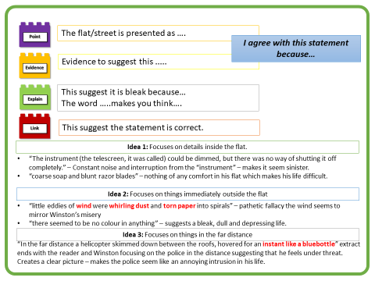
Over to you...!
Have a go at writing three paragraphs to answer this question using the notes so far

