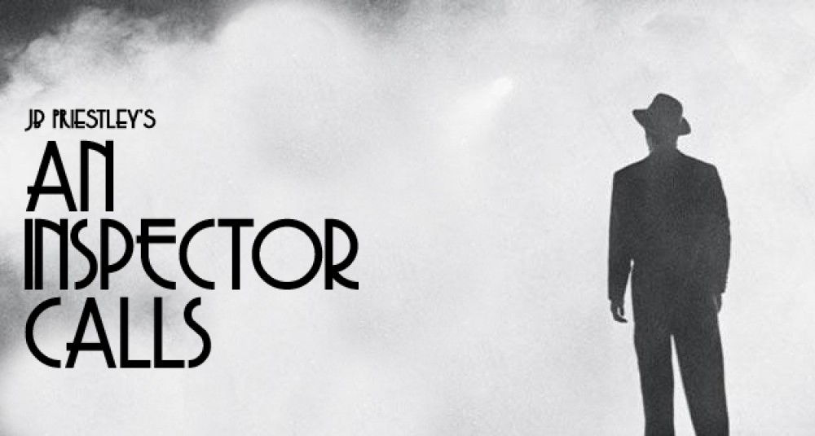
Lesson Set 3: The Inspector
Task 1: Actions
Stage directions are usually only one or two words, and tell us exactly how the writer – Priestley – wants the character to appear so can give us an insight into how he wants the Inspector presented.
This is good for discussing writer’s intentions. It also makes them good quotes to learn or the exam!
- Create three boxes/ columns/ sections for each act and write out all the Inspector’s stage directions.

Task 2: Narration
- Find and write out a definition for what Omniscient Narration means.
- Answer the following question:

Where in the play is there evidence that Inspector Goole is omniscient?

Task 3: Understanding the Inspector
- Copy and paste the link below into your web browser. Read through the notes on the Inspector, and copy out the table (Imposing, Emotive, Prophetic)
- Have a go at answering the question at the bottom of the page yourself before reading the answer they give
- Then log in to GCSE Pod and watch the video about Inspector Goole

