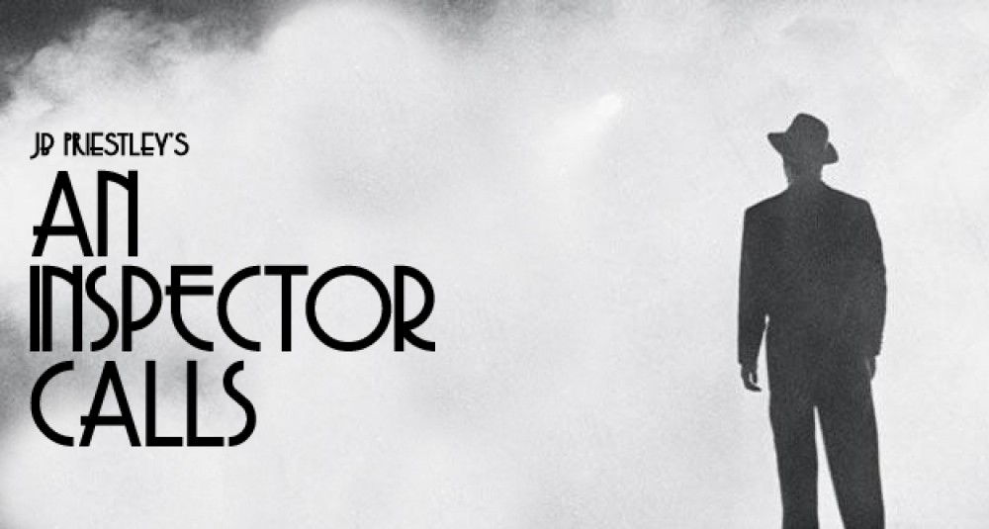
Lesson Set 2: The Birlings
- Use the following link or your own research to make notes on each member of the Birling family. You could create character profiles, or just write them up in a table.
https://www.bbc.co.uk/bitesize/guides/zwscxsg/revision/1
Name: | Notes (e.g. personality, habits, how they treat others, how they’re treated etc.) | Key quotes
Mr Birling

- Politics and ‘An Inspector Calls’: Split an A4 page in half. On one side make notes about the beliefs of ‘Capitalists’ (which is who Mr Birling represents) and ‘Socialists’ (Whom the Inspector represents and the political party which JB Priestley himself belonged to.)

Capitalists/ Capitalism: Socialists/ Socialism:

