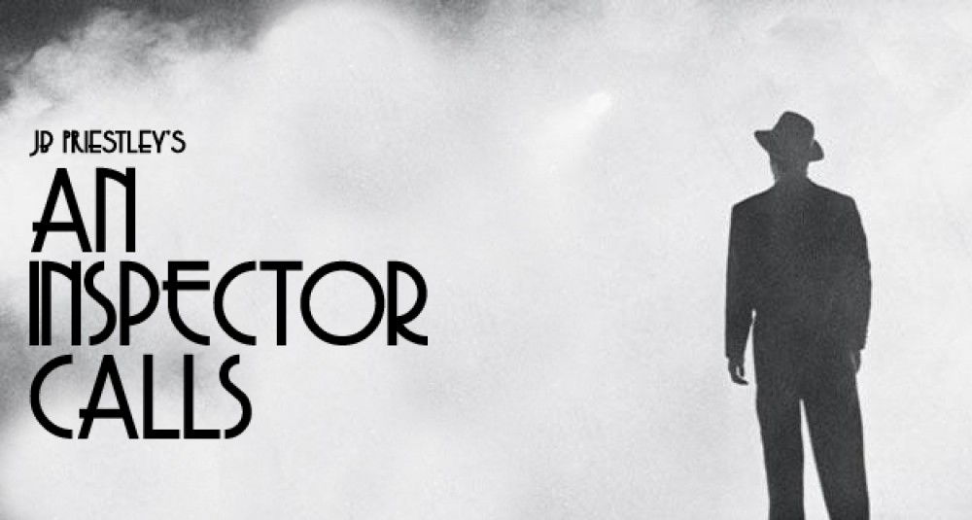
Lesson Set 1: Understanding the play

- Before you begin reading ‘An Inspector Calls’ you need to understand about the context and the time period. The play was written in 1945 but set in 1912. Create a poster with information about what life was like in both these time periods. Use the links below to help if you need them.
https://www.bbc.co.uk/bitesize/guides/z2pc2hv/revision/7
- https://www.bbc.co.uk/bitesize/clips/zk7b4wx
- https://www.bbc.co.uk/bitesize/clips/z82g9j6
- https://www.bbc.co.uk/bitesize/clips/zdmrkqt
https://members.gcsepod.com/shared/podcasts/title/10265/62805

- Read the play and watch the film version via ClickView. (‘ClickView online’ or through the link on Moodle – usual school log in – Type in ‘An Inspector Call’) and it should be the third link.
See image below.

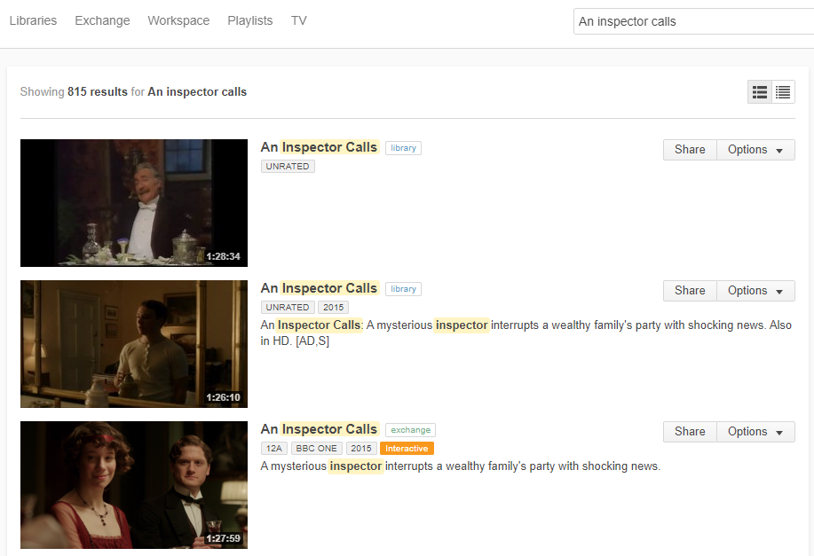
- Create an act-by-act plot flow chart with brief information, key quotes and images (drawn or from the internet.) This will be a useful revision tool for next year. Copy and paste the links below into your we browsers to help you:
https://www.bbc.co.uk/bitesize/guides/zxhsyrd/revision/1
https://members.gcsepod.com/shared/podcasts/title/10265/62803
https://www.youtube.com/results?search_query=mr+bruff+an+inspector+calls+plot+summary

