Year 10
‘An Inspector Calls’
Shadow Curriculum Guide
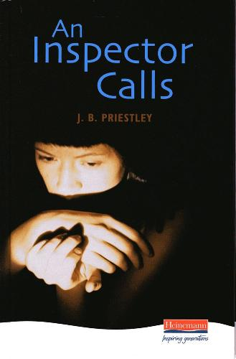
- The first thing you will need to do is make sure you have read the whole text, there is a link for this if you need an electronic version.
- You should find out the general theme of the work you are missing, for example politics, Inspector etc... Then find a task from the list relevant to this.
- You should spend the same amount of time on your work as you would in lessons, so around 3hrs 20 minutes
- Save your work or keep it safe and hand it in to your teacher in your first lesson back
- There is a revision poster and a practice question to complete if you think you’ve been through everything else. You can also find a version of ‘An Inspector Calls to watch on ClickView
- If you’re still looking for work you should use GCSE Pod, Mr Bruff on Youtube or BBC Bitesize to go over ‘An Inspector Calls’ or revise poetry or A Christmas Carol

