Final Assessment Plan:
Whose fault was it that Titanic sank with such a huge loss of life?

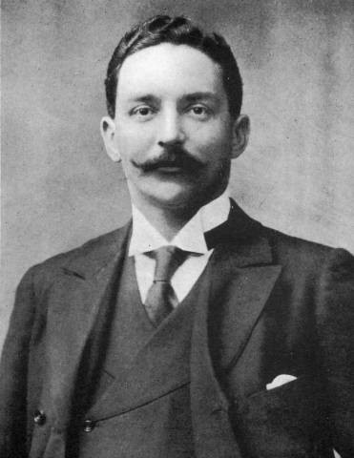
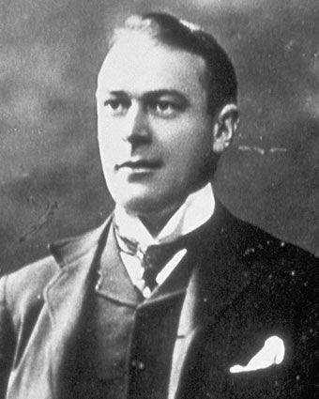
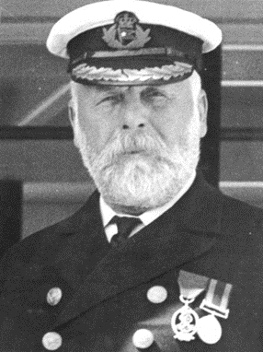

Below you will find a planning sheet to help you organise your ideas to write up your assessment. Use this template or make notes in your book/ on paper using these subheadings.

As soon as you have completed a plan, use this structure and your notes to write up your argument!

- Facts I will use in my assessment:

- Useful connectives and vocabulary to use:

- Useful techniques to use:

Plan:
Paragraph 1: Introduction
Briefly explain in a couple of sentences what you aim to do in this essay.

Paragraph 2: Who is to blame for the sinking?
Here you will introduce the main person you think is to blame for the sinking of the Titanic.
Point: Who it is you think is to blame.
Evidence: Why you think they are to blame, using facts and information as proof.
Analysis: Discuss the affect their actions had on the sinking and explain your information.
Plus: Discuss the effect it would have had on people on the ship, use real life stories and link to time period.

Paragraph 3: Who else could be to blame?
You believe that someone else had an important role to play in why the ship sank and why so many lives were lost. Use this paragraph to explore this.
Point: Who else could be to blame?
Evidence: Use facts and information to provide proof as to why they had something to do with it.
Analysis: Explain this information and why it has helped you come to that conclusion. Think about the effect of their actions on the ship and people’s survival.
Plus: Links to time period and real stories from the Titanic.

Paragraph 4: Who is to blame for the loss of life?
This is slightly different to who is to blame for the sinking, however you may have combined these two points. It’s fine to have someone else to blame for the loss of life than who you blame for the actual sinking.
Point: Who you think it is to blame for the loss of life
Evidence: Why you think they are to blame, using facts and information as proof.
Analysis: Discuss the affect their actions had on the amount of people who died and explain your information.
Plus: Discuss the effect it would have had on people’s lives, use real life stories and link to time period.

Paragraph 5: Who should not be blamed?
There may be someone who is involved in the controversy of the sinking of the Titanic, use this paragraph to explore why we should hold them accountable for happened and why their name should be cleared.
Point: Who it is that we shouldn’t blame.
Evidence: Facts and information used as evidence for why we shouldn’t blame them.
Analysis: Explain the information and how it means they are not at fault. Think about the effect their actions had on the ship and the loss of lives.
Plus: Link to time period, real life Titanic stories.

Paragraph 6: Other factors
There may be some other contributing factors to why the Titanic sank and so many people died. You can use this paragraph to discuss those.

Conclusion:
Briefly, in just a couple of sentences sum up what you have discussed, who you think is mostly to blame and who should not be. This section just rounds up everything you’ve said, so don’t add any new information.

