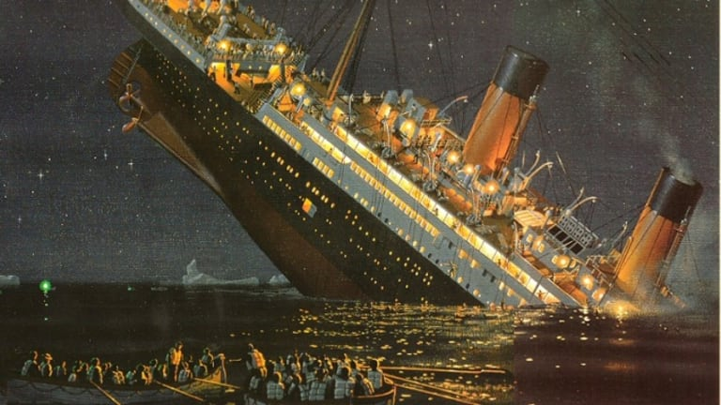
So… who is to blame?!
Your next task is to start to think about who you think is actually to blame for the sinking of the Titanic, and, separately, who is to blame for the amount of deaths.

- First of all you should try to watch the documentary which can be find on the accompanying PowerPoint linked on the website. You should make notes on any facts you learn about how the Titanic was made, reasons it sunk, reasons people died and the actions of people which contributed to what happened. Don’t forget you can pause the documentary to make notes.

- You can use the attached templates or you can use the subheadings to make notes on paper. These guide you through the research you need to complete on the three main suspects which could potentially have caused the tragedy.
Who’s to blame for the sinking of the Titanic and the loss of life?
Research

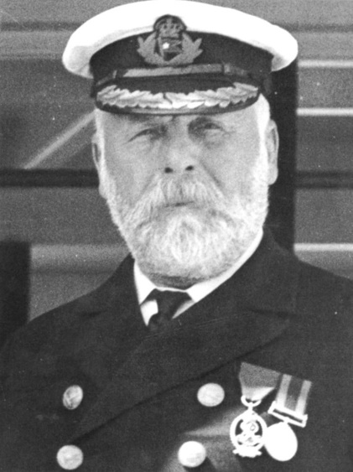
Suspect One: Captain Edward Smith
Why he should not be blamed:
How he contributed to the sinking or loss of life:
Facts about Edward Smith:

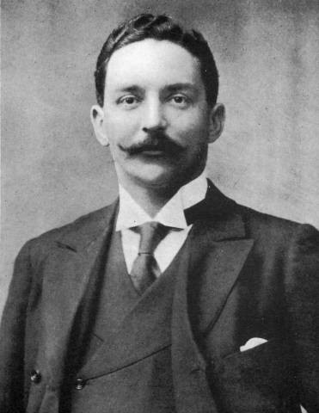
Suspect Two: Joseph Bruce Ismay
Why he should not be blamed:
How he contributed to the sinking or loss of life:
Facts about Joseph Bruce Ismay:

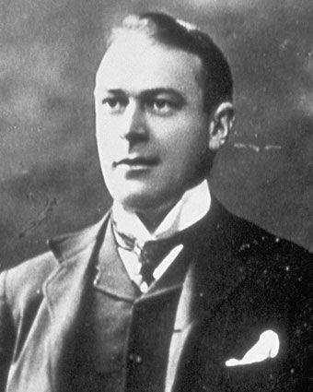
Suspect Three: Thomas Andrews
Why he should not be blamed:
How he contributed to the sinking or loss of life:
Facts about Thomas Andrews:

Other factors which may have caused the sinking or the loss of life:

General facts about the Titanic:

