Titanic Block Two: Writing Task Preparation

You will be creating a piece of writing from the perspective of either a first or third class passenger on board the Titanic.
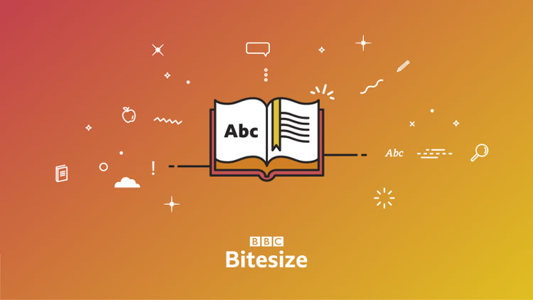
Recapping Techniques:
https://www.bbc.co.uk/bitesize/guides/zwjsyrd/revision/1
- Copy the link or find ‘Creative and Narrative Writing’ under KS3 on BBC Bitesize.
- Work through pages 1-5 and make brief notes under the subheadings given.
- When you’ve completed a page complete the test available before moving on.

Sentences:

https://www.bbc.co.uk/bitesize/guides/zxqnfg8/revision/1
https://www.englishclub.com/grammar/sentence/type.htm

- Copy the links above to find information about the different sentence types and structures. Make brief notes in your own words, making sure you try to write or copy out examples of each one to refer to!

Practicing Techniques:
Rewrite the sentences below making them more interesting. You should be adding in adjectives and adverbs, changing the word choices and changing the sentence structure. You can rewrite the same sentence more than once if you have lots of ideas!

- I walked along the ship, looking up
- I stepped off the walkway and through the door
- I picked up the key to my cabin and made my way downstairs
- I went back outside to get my mother’s attention and show her my room
- I walked about, admiring the view
- I wondered about, trying to find the restaurant
- I stepped outside and onto the deck

